
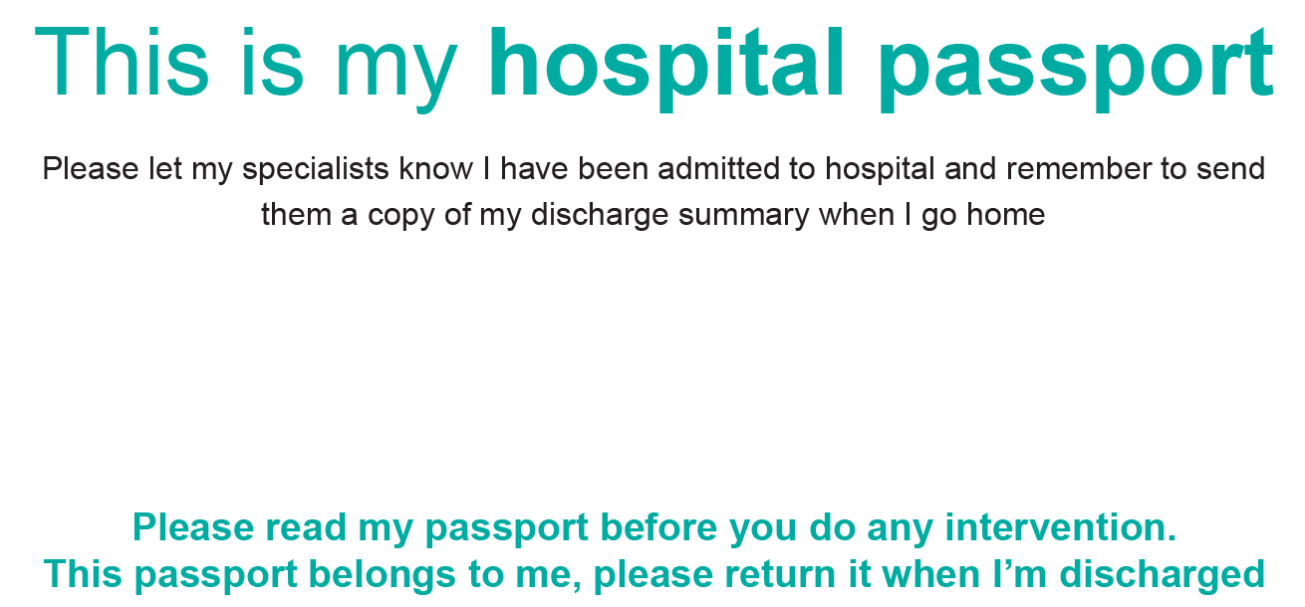
This passport belongs to:

….



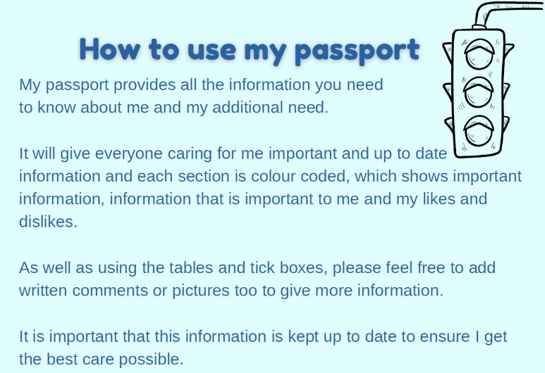

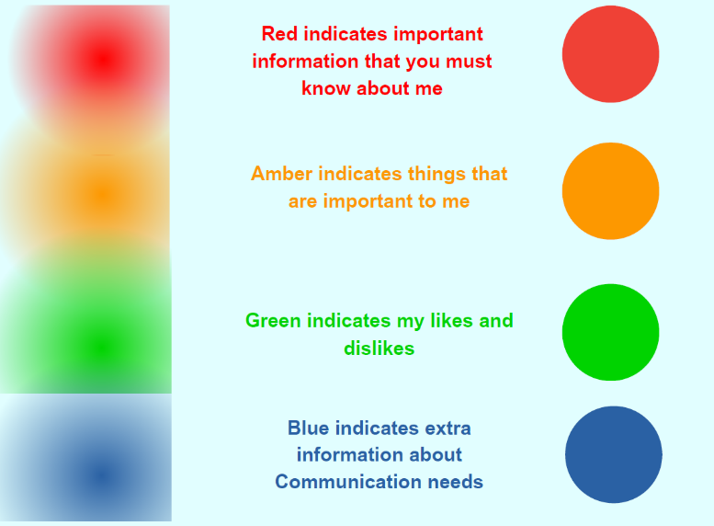

My Details
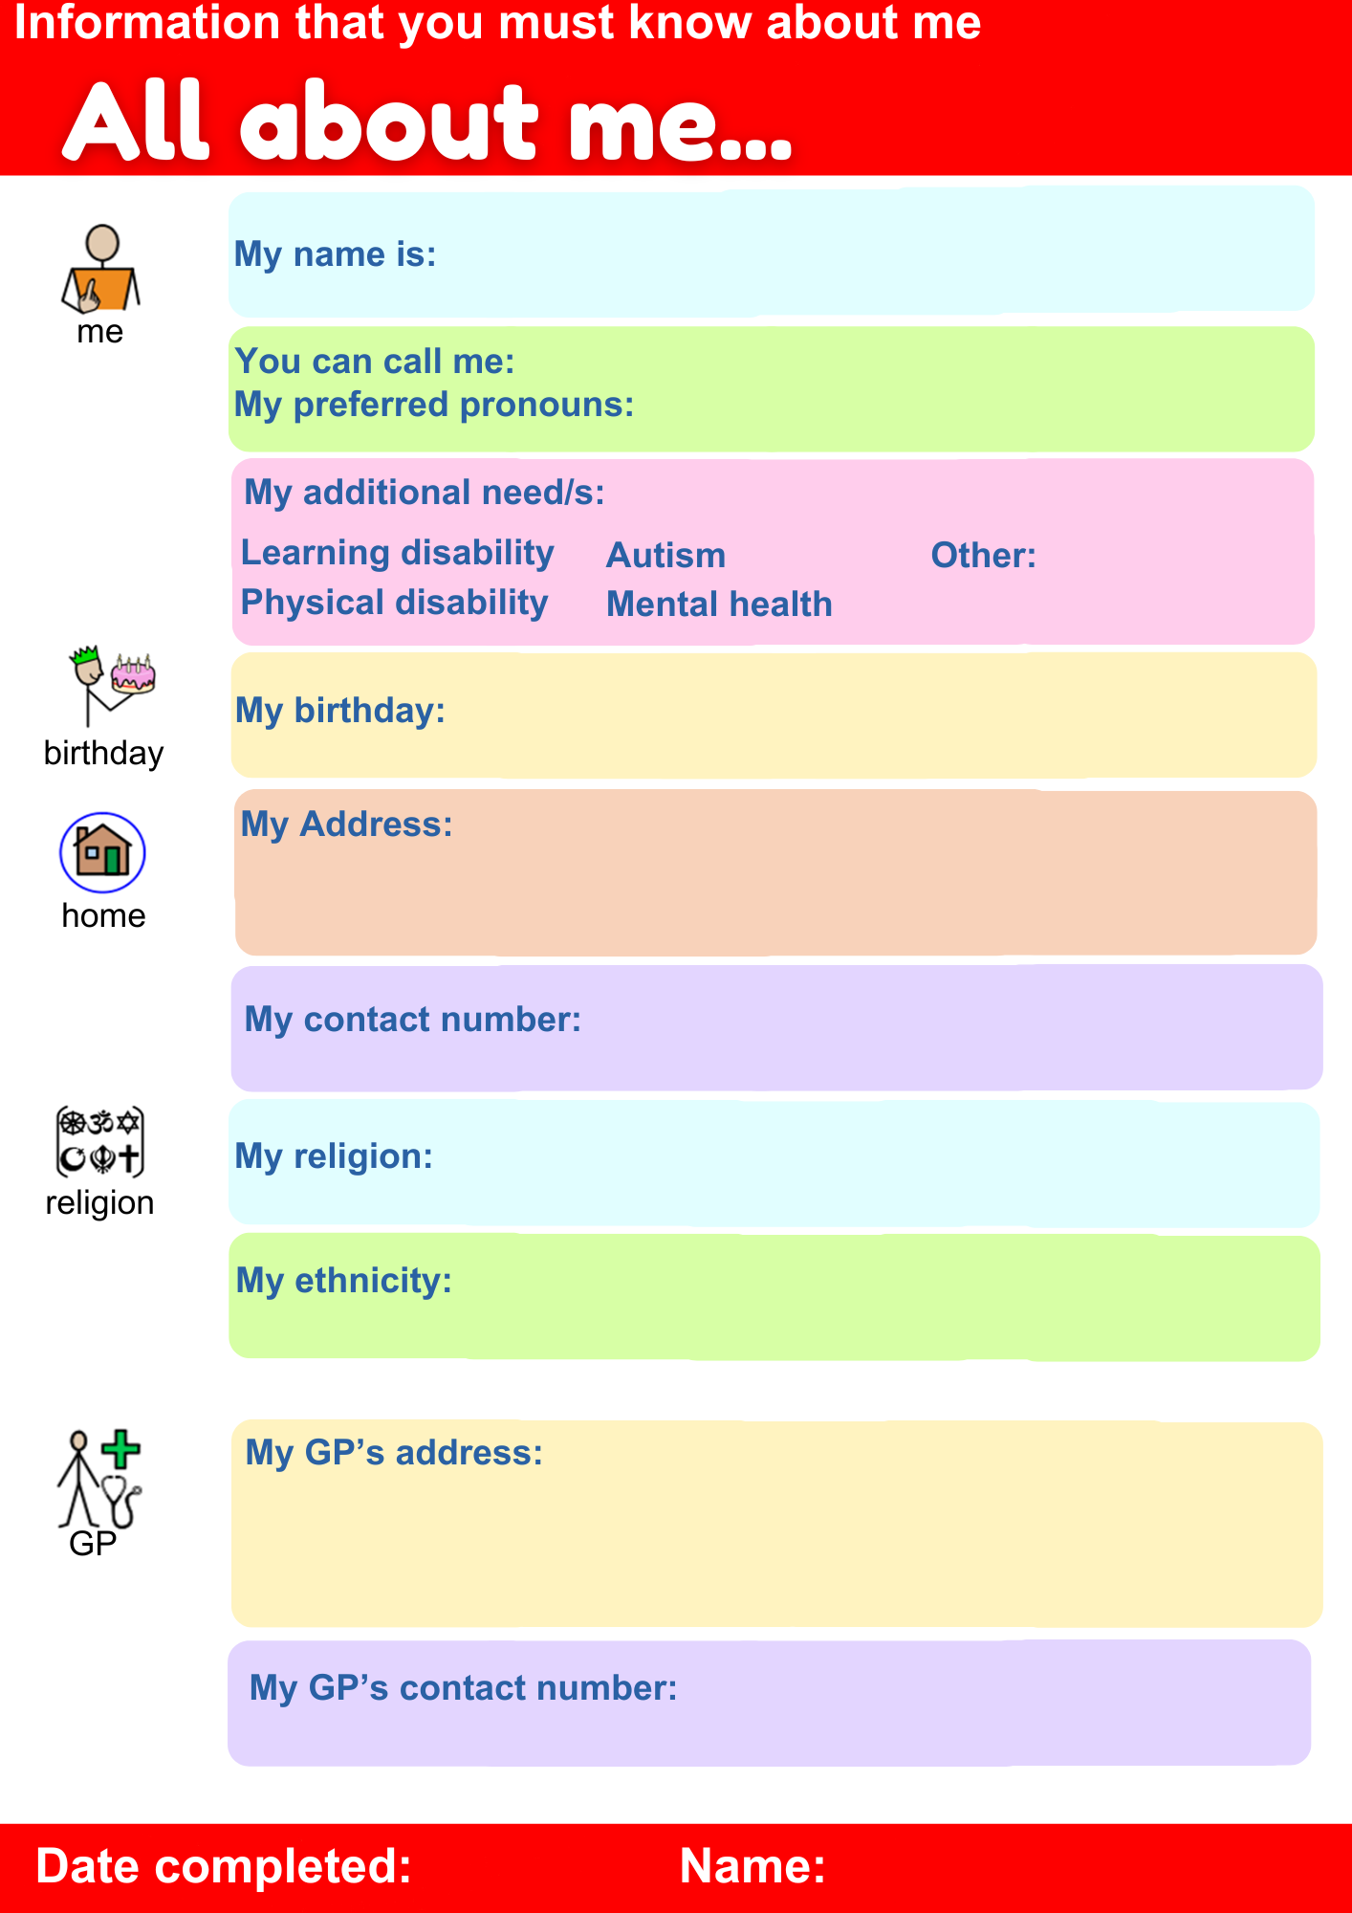 | My name is:  You can call me:  My preferred pronouns:  My Birthday:  My Address:  My Contact Number:
 | My Religion: My Ethnicity:
 | My GP’s Address and contact details:
My important adults
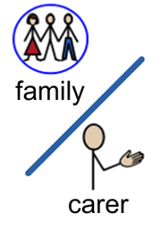 | Their Name(s) is / are:  Relationship to me:  Their address and contact details:
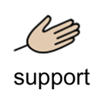 | How this person supports me and what they need  Other important people in my life
Date Completed: Name:

My health at a glance
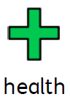 | I have:  Learning Disability ☐ Autism ☐ ADHD☐  Physical Disability ☐ Epilepsy ☐ Mental Health ☐  I also have the following care plans: last updated:  ☐Advanced Care Plan (ACP):  ☐Epilepsy Care plan:  ☐Respiratory Care Plan:  ☐Dysphagia Care Plan:  ☐Other care plans:
Professionals involved in my care
  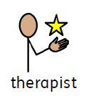 | Please remember to tell my team that I have been admitted to hospital – they may have information to help you.  Please remember to send my discharge summary to my specialists when I go home
  Professional | Name and contact details
  Paediatrician
  SALT
  Community nurse
  School nurse
  Dietician
  O.T
  Care manager
  Social worker
  Behavioural specialist
  Physiotherapist
  Psychologist
  Family support worker
Date Completed: Name:

My likes and dislikes
Just like everyone else, there are lots of things I do and don’t like.
Understanding these will make me more comfortable in hospital.
 | Things I like
 | Things I don’t like
My Anxieties and Worries
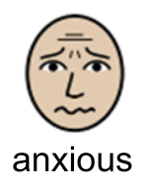 | If I feel anxious I will
Date Completed: Name:

Information you must know about me:
My Medical History
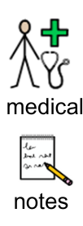 | Or your adult could attach a copy of your recent clinic letters here
Date Completed: Name:

Information you must know about me:
My Medicines and Allergies
Medicines include things by mouth / feeding tube, but also creams, inhalers, nebulisers etc
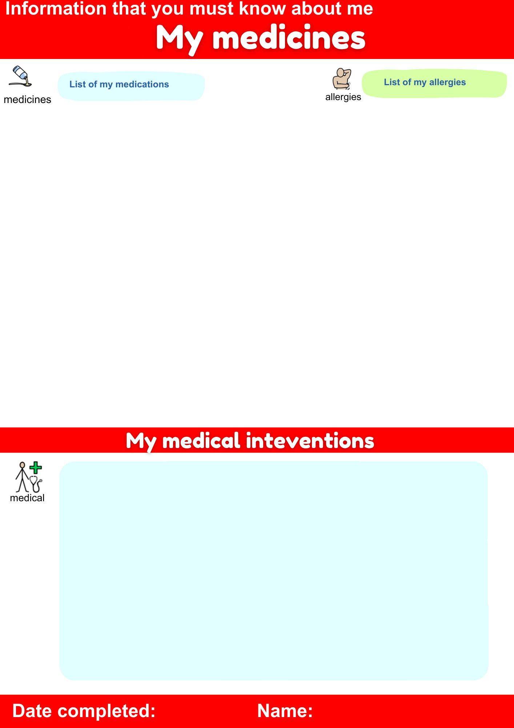 | I need my medicines as:  ☐Tablets by mouth ☐Liquid by mouth  ☐Given down my feeding tube ☐Suitable for ketogenic diet  Your adult could fill in here or attach a copy of your latest clinic letter / repeat prescription slip
Medication | Dose/Time | Route & form

My Allergies
  Allergy | Reaction / treatment needed
Date Completed: Name:

Information that is important to me:
My Communication and mobility
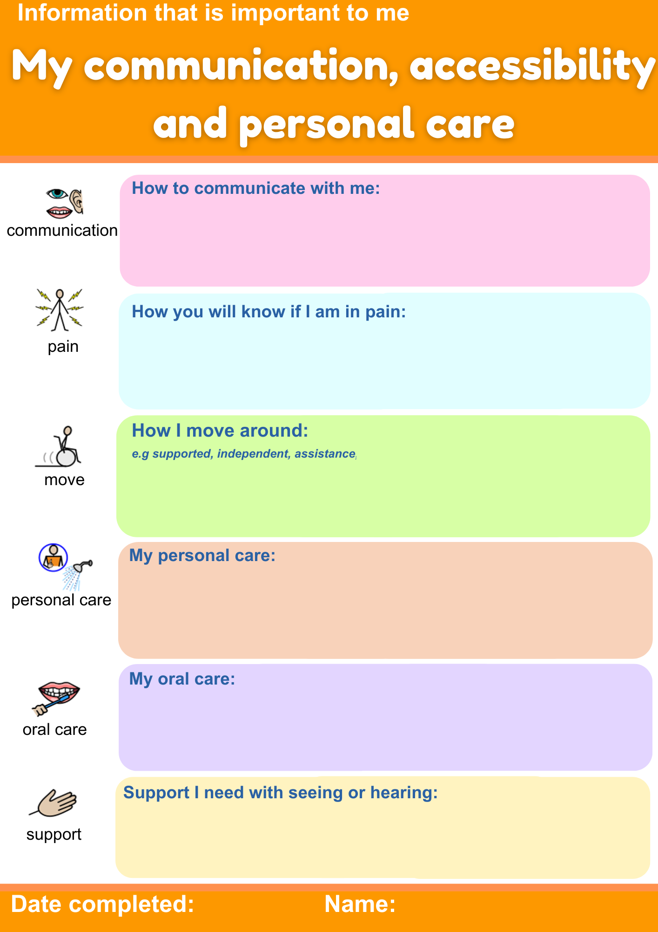  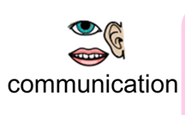 | My communication  ☐ See later page for more information about communication
 | Seeing and hearing
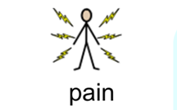 | How will you know if I am in pain?
How I move around

☐ See later page for more information about mobility
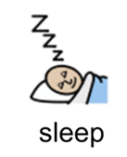 | How I Sleep  Sleep set up: Cot ☐ bed ☐ specialist bed ☐  cuddle bed ☐ sleep system ☐  Positioning  Sleep medication  Sleep Times  White noise / night light  Overnight breathing support
Date Completed: Name:

Information that is important to me:
Personal Care - Eating & Drinking
Eating  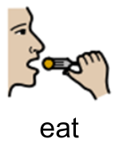 |  | I eat ☐ by mouth  ☐can feed myself ☐need help to be fed  ☐ Regular meals ☐ modified textures IDDSI level:  ☐ By feeding tube (☐NG / ☐PEG / ☐Jejunostomy)
Drinking  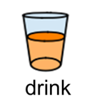 |  | I drink ☐ by mouth  ☐can hold my own cup ☐need help to drink  ☐ thickened fluids IDDSI level:  ☐ By feeding tube (☐NG / ☐PEG / ☐Jejunostomy)
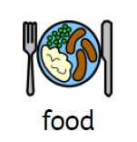 |  | ☐I have an eating and drinking plan from my Speech therapist  ☐I have a meal plan from a dietician  My favourite foods / typical food and fluid for a day is:
 | Date Completed: Name:

Information that is important to me:
Personal Care – Personal Hygiene
 |  | Washing and dressing
 |  | Oral Care
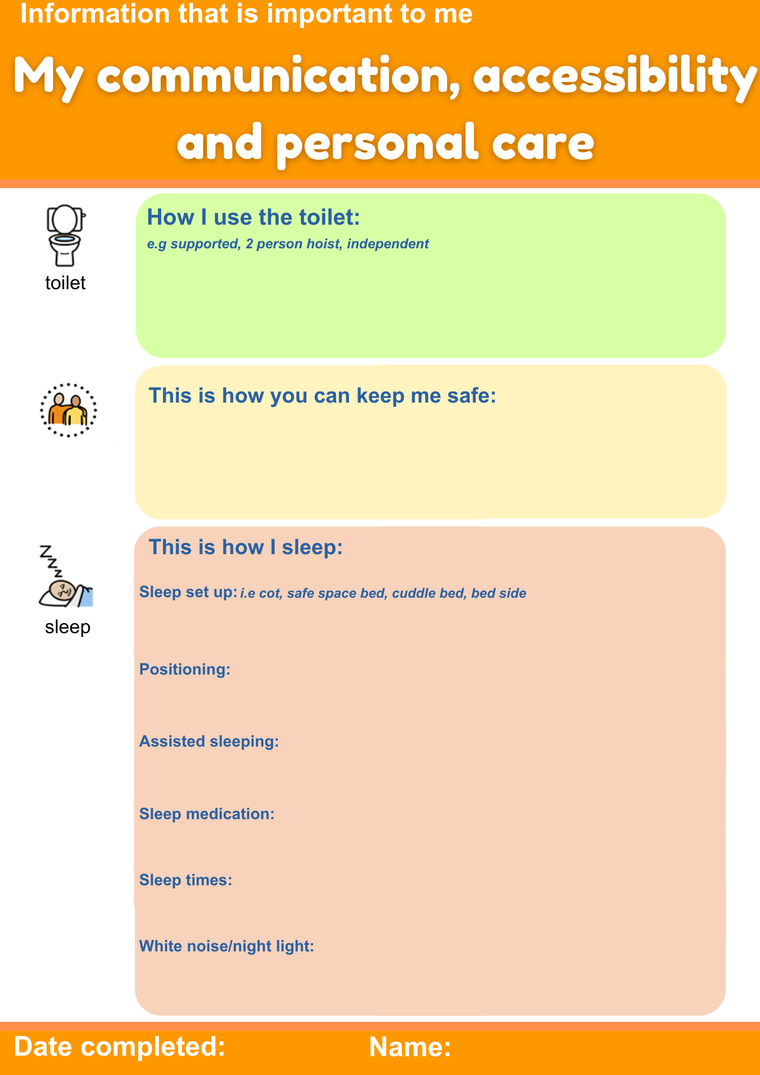 |  | How I use the toilet  ☐Independent ☐supported ☐hoisted ☐in pads / nappies
 |  | Staying safe
 | Date Completed: Name:

Information that is important to me:
My typical day
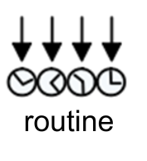 | Or provide a copy if you already have this written out
  Time | Activity | Who helps me with this activity | How long this takes
  e.g 7am | Shower | 2 people - hoist | 45mins
Date Completed: Name:

Information that important to me:
How I Communicate
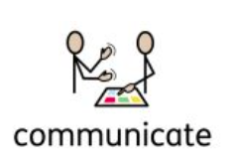 | When speaking to me please:  ☐ Speak to me normally – I can understand you  ☐ Speak to me in simpler terms  ☐ Also use sign / pictures / gestures to be understood  ☐ Make sure I have my hearing aids  Please be aware  ☐ Please be patient I need extra time to think and answer you  ☐ I might say I understand you when I don’t
 | I can communicate to you by:  ☐ Speech  ☐ Sign / Gestures  ☐ Eye pointing / looking to choice  ☐ Using my communication aid  ☐ Facial expression
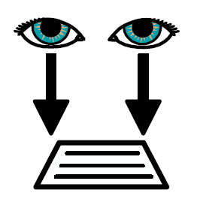 | Written information  ☐ I can read  ☐ I can read with extra support  ☐ I need large font  ☐ I can write I am ☐ right / ☐ left handed
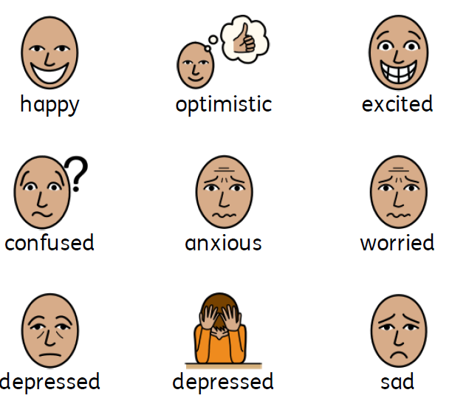 | When I am happy I will  When I am sad or distressed I will
Date Completed: Name:

Information that is important to me:
How I move around
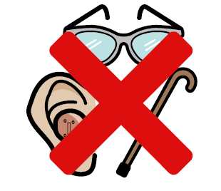 | Without any equipment I can
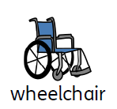  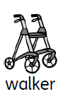 | The equipment I use is:  ☐Splints ☐ Gaiters  ☐Walker frame ☐Wheelchair  ☐Rotunda ☐Hoist
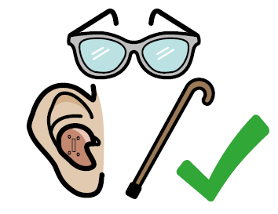 | With my equipment I can:
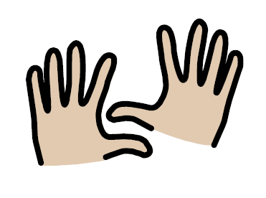 | This is what I can do with my hands
Date Completed: Name:



