

WORCESTERSHIRE ACUTE HOSPITALS NHS TRUST

INFECTION PREVENTION & CONTROL

ANNUAL REPORT 2024-2025

Authors:
Sarah Shingler - Chief Nursing Officer Executive Director Infection Prevention and Control

Liz Watkins - Associate Chief Nursing Officer/ Director of Infection Prevention & Control
Dr Emma Yates - Consultant Microbiologist and Co-Infection Control Doctor
Dr Eftihia Yiannakis - Consultant Microbiologist and Co-Infection Control Doctor
Sadiya Hussain - Antimicrobial Pharmacist.
Emma King – Interim Director for Estates and Facilities
Helen Wealthall - Occupational Health
Julie Noble – Head of Health & Safety and Fire Safety

Index

 | Section | Sub-section | Page
 | Foreword |  | 3
 | Glossary |  | 5
 | Section 1: Introduction & compliance criterion |  | 9
 | Section 2: Who are we, our duties, arrangements, and assurance. | 2:1 Who are we? | 12
 |  | 2:2 Our duties & arrangements | 13
 |  | 2.3 Infection Prevention & Control Team | 14
 |  | 2.4 Committee Structures & Reporting Processes | 14
 |  | 2.5 Roles contributing to IPC service | 16
 | Compliance with the Health & Social Care Act (2008); Code of Practice on The Prevention and Control of Infections and Related Guidance (2015). | Statement of compliance | 18
 |  | Criterion 1 Leadership arrangements | 18
 |  | Criterion 1 Governance and Assurance | 19
 |  | Criterion 1 Infection Performance | 19
 |  | Criterion 2 Cleanliness | 20
 |  | Criterion 3 Antimicrobial Use | 21
 |  | Criterion 4 Provision of Information | 21
 |  | Criterion 5 People with Infection | 22
 |  | Criterion 6 Staff Awareness and Training | 23
 |  | Criterion 7 Isolation Facilities | 23
 |  | Criterion 8 Laboratory Support | 24
 |  | Criterion 9 Policies | 24
 |  | Criterion 10 Occupational Health | 25
 | Section 4 – Infection performance |  | 26
 | Section 5 - Our plan for 2025-2026 |  | 54
 | References |  | 56
 | Appendix. 1: Outbreaks and Infection-Related Incidents in 2024 -25 |  | 57
 | Appendix 2: WAHT Infection Prevention Improvement Plan 2025-26 |  | 58

Foreword


“As the Chief Nursing Officer and Executive Director of Infection Prevention and Control, I would like to take this opportunity to say thank you to all the staff, colleagues, and partners for welcoming me to the organisation. Infection Prevention and Control is pivotal in ensuring that our patients and citizens receive safe and high-quality care, and it is everyone’s responsibility.

Resetting our focus and raising the importance of fundamentals post the Covid-19 pandemic, has been a real focus for us here at The Worcester Acute Trust (WAHT). As the Trust’s Executive Director of Infection Prevention and Control I am proud to be able to present this Annual Infection Prevention and Control Report for 2024/25, which has been developed in collaboration with the Deputy Director of Infection Prevention and Control and the Infection Prevention and Control (IPC) Team. This report outlines the activities relating to infection prevention and control for the year from April 2024 to the end of March 2025, presenting the arrangements the Trust has in place to reduce the spread of infections. It outlines our accountability arrangements, policies and procedures relating to infection prevention and control, audits, and the education necessary to support the prevention and control of infections.
Our focus on cleanliness, antimicrobial prescribing and other hygiene measures has continued during the year to ensure that people are receiving safe and effective care from us.
We remain committed to ensuring that we achieve very high standards of infection prevention practice. The Trust Board views this as a priority for our patients as part of our commitment to Putting Patients First. The Quality Governance Committee continued to scrutinise our infection prevention progress quarterly on behalf of the Board throughout 2024-25.
Our key achievements for 2024/25 include:
- The Trust reported zero MRSA bacteraemia which was a reduction from 7 reported in 2023/2024.
- Reporting below threshold for mandatory blood stream (BSI) infections including E. coli and Pseudomonas aeruginosa,
- Mandatory Infection Prevention and Control training completed by 90% of clinical staff.
- 96% of non-clinical staff up to date with Infection Prevention and Control (IPC) e-learning.
- Recruitment to the IPC team under very challenging circumstances.
- IPC promotional activities included IPC week and World Health Organisation Clean Your Hands Day.

Looking forward to 2025/26, the IPC team and all WAHT staff will continue to work towards the prevention of all healthcare acquired infections. This will be guided by our overarching IPC annual programme of work and strengthening our relationships with our system partners.”

I trust you will find this report informative.

Sarah Shingler
Chief Nursing Officer and Executive Director of Infection Prevention and Control (DIPC)

Definitions/ Glossary

ACP | Advanced Care Practitioner
AE | Authorising Engineers
AER | Automated Endoscope Reprocessor. A specialised machine for washing and disinfecting endoscopes
AHP | Allied Health Professional
AmpC beta lactamases producing Enterobacteriaceae | Produce enzymes which mediate resistance to a wide variety of B-lactam antibiotics e.g., amoxicillin
ALEX | Alexandra Hospital Redditch
AMS | Antimicrobial Stewardship
ANTT | ANTT® / Aseptic Non-Touch Technique: A specific type of aseptic technique with a unique theory and practice framework (NICE 2012).
ASG | Antimicrobial Stewardship Group
AP | Authorised Persons
Bacteraemia | A bloodstream infection
BSI | Bloodstream Infection
CDI | Clostridioides difficile infection. Clostridioides difficile is a bacterium which lives harmlessly in the intestines of many people. Clostridioides difficile infection most commonly occurs in people who have recently had a course of antibiotics. Symptoms can range from mild diarrhoea to a life-threatening inflammation of the bowel.
CMT | Certified Medication Technician
CNO | Chief Nursing Officer
COHA | Community Onset Healthcare Acquired
COIA | Community Onset Indeterminate Association
COVID-19 | Coronavirus disease
CPA/ UKAS | Clinical Pathology Accreditation (CPA UK) is a subsidiary of United Kingdom Accreditation Service (UKAS)
CPE | Carbapenemase-producing Enterobacteriaceae. Enterobacteriaceae are a large family of bacteria that usually live harmlessly in the gut of all humans and animals. They are also some of the most common causes of opportunistic urinary tract infections, intra-abdominal and bloodstream infections. Carbapenemases are enzymes that destroy carbapenem antibiotics, conferring resistance.
CQC | Care Quality Commission
CQUIN | Commissioning for Quality and Innovation (CQUIN) payment framework
D&V | Diarrhoea and vomiting
Datix | Patient safety organisation that produces web-based incident reporting and risk management software for healthcare and social care organisations.
DDD | Defined Daily Doses. The DDD is a standardized measure used to determine the average daily dose of a medication used for its main indication in adults.
DH | Department of Health
DIPC | Director of Infection Prevention & Control
E. coli | Escherichia coli. E. coli is the name of a type of bacteria that lives in the intestines of humans and animals.
ED | Emergency Department
EDIPC | Executive Director for Infection Prevention and Control
EOLAS | Eolas streamlines access to knowledge for use at the point of care, ensuring all healthcare professionals can make the right decision for every patient, every time
EPMA | Electronic Prescribing and Medicines Administration
ESBL | Extended-Spectrum Beta-Lactamases are enzymes that can be produced by bacteria making them resistant to many of the commonly prescribed antibiotics.
EPP | Exposure Prone Procedure
EPR | Electronic Patient Record
ESR | Electronic Staff Record
GAP | WAHT Audit Tool
GNBSI | Gram-negative bacteraemia (GNBSI), including Escherichia coli, Klebsiella and Pseudomonas.
GRE/VRE | Glycopeptide-Resistant Enterococci/Vancomycin Resistant Enterococci. Enterococci are bacteria that are commonly found in the bowels/gut of most humans. There are many different species of enterococci but only a few that have the potential to cause infections in humans and have become resistant to a group of antibiotics known as Glycopeptides; these include Vancomycin.
HCA | Healthcare Assistant
HCAI | Healthcare Associated Infection
HOHA | Hospital Onset Healthcare Associated
HPV | The ProXcide® System uses innovative hydrogen peroxide vapour (HPV) technology for a rapid decontamination process tailored to each room’s requirements, ensuring log-6 kill efficacy on all surfaces
HSDU | Healthcare Sterilisation Decontamination Unit
HSE | Health and Safety Executive
HTM | Health Technical Manual. These documents give comprehensive advice and guidance on the legal requirements, design implications, maintenance and operation in healthcare premises providing acute care.
ICB | Integrated Care Board replaced Clinical Commissioning Boards July 2022
IC NET | IPC Surveillance software and database
ICS | Integrated Care System
IPC | Infection Prevention and Control
IPC BAF | Infection Prevention and Control Board Assurance Framework
IPCT | IPC Team
IQPR | Integrated Quality Performance Report
IV | Intravenous
KPI | Key Performance Indicator
KTC | Kidderminster Treatment Centre
LHE | Local Health Economy
MD | Managing Director
MDT | Multi-disciplinary Team
MHRA | Medicines and Healthcare Products Regulatory Agency
MICAD | MICAD Trust Audit Reporting System
MPOX | Mpox, previously known as monkeypox, is a viral illness caused by the monkeypox virus, a species of the genus Orthopoxvirus
MRSA | Meticillin Resistant Staphylococcus aureus. Any strain of Staphylococcus aureus that has developed resistance to some antibiotics, thus making it more difficult to treat.
MSSA | Meticillin Sensitive Staphylococcus aureus. Staphylococcus aureus is a bacterium that commonly colonises human skin and mucosa (e.g., inside the nose) without causing any problems. It most commonly causes skin and wound infections.
NED | Non-Executive Director
NEWS 2 | The latest version of the National Early Warning Score (NEWS), which advocates a system to standardise the assessment and response to acute illness.
NHS | National Health Service
NHSE | NHS England
NICE | National Institute for Health and Care Excellence
NNU | Neonatal Unit
Norovirus | Norovirus is a major cause of acute gastroenteritis and diarrhoea in children and adults.
OH | Occupational Health
Outbreak | One or more persons with the same signs, symptoms in time place and space.
OPAT | Out-patient parenteral antimicrobial therapy
OPD | Outpatients Department
PCR | A polymerase chain reaction (PCR) test detects genetic material from a pathogen or abnormal cell sample
PEWS | Paediatric Early Warning Score
PFI | Private Finance Initiative
PIR | Post Infection Review
PLACE | Patient Led Assessment of the Care Environment
PPE | Personal Protective Equipment e.g., gloves, aprons, and goggles
PPS | Point Prevalence Survey
PSIRF | The Patient Safety Incident Response Framework (PSIRF) sets out the NHS’s approach to developing and maintaining effective systems and processes for responding to patient safety incidents for the purpose of learning and improving patient safety
PVD | Peripheral Vascular Device
QGC | Quality Governance Committee
RAG RATING | Red, Amber, Green rating system
RIDDOR | Reporting of Injuries, Diseases and Dangerous Occurrences Regulations
RSV | Respiratory Syncytial Virus (RSV) is a common viral infection that primarily affects the respiratory tract, particularly in infants and older adults, and can lead to severe respiratory illnesses
SARS-CoV-2 | COVID-19
SCSD | Specialised Clinical and Services Division
SEPSIS | A potentially life-threatening condition caused by the body’s response to an infection.
SOP | Standard Operating Procedure
SSI | Surgical Site Surveillance
SSISS | Surgical site Infections Surveillance Service
SWFT | South Warwickshire University NHS Foundation Trust
TB | Tuberculosis
The Source | Staff Intranet Site
TIPCC | Trust Infection Prevention and Control Committee
TOR | Terms of Reference
UK HSA | UK Health Security Agency formally Public Health England (UK HSA)
UVc | Ultra-V Connect™ discreetly emits high-intensity UV-C light for efficient routine surface decontamination.
WAHT | Worcester Acute Hospitals NHS Trust
WHO | World Health Organisation
WREN | Worcestershire Reporting System for audit
WRH | Worcester Royal Hospital
WSG | Water Safety Group
WSP | Water safety Plan
WTE | Whole Time Equivalent
WVT | Wye Valley NHS Trust
SECTION ONE:
INTRODUCTION

The purpose of this report is to provide assurance to The Worcester Acute Hospital NHS Trust (WAHT) Board of Directors, Governors and the public for the reporting period 1 April 2024- 31st March 2025 regarding the Infection Prevention and Control (IPC) activity including compliance with the Health and Social Care Act 2008: Code of Practice on the prevention and control of infections and related guidance (update December 2022) (commonly known as The Hygiene Code) and with regard to appropriate National Institute for Health and Clinical Excellence (NICE) guidance.
This annual report fulfils the Trusts’ statutory requirements under the Health and Social Care Act 2008: Code of Practice on the prevention and control of infections and related guidance (Updated December 2022), which sets out 10 compliance criteria against which a registered provider will be judged on how it complies with the registration requirements for cleanliness and infection prevention and control. This sets the basis of our annual programme which is monitored at the Trust’s quarterly Infection Prevention and Control committee (TIPCC) meeting. Infection prevention and control is the responsibility of everyone in our healthcare community and is only truly successful when everyone works together. The aim of the IPC team is to increase organisational focus and collaborative working to ensure continued compliance and continuous improvement.
The report also reflects the IPC Board Assurance Framework (IPC BAF). It is set out using the Hygiene Code framework, and this annual report also provides assurance of compliance with this framework and sets out our priorities and plans to achieve further improvement and reductions in infection during 2025-26 and achievement of the quality priorities.
Liz Watkins. Associate Chief Nursing Officer/ Director of Infection Prevention & Control (DIPC)

Table 1
Compliance criterion | What the registered provider will need to demonstrate
1 | Systems to manage and monitor the prevention and control of infection. These systems use risk assessments and consider how susceptible service users are and any risks that their environment and other users may pose to them.
2 | Provide and maintain a clean and appropriate environment in managed premises that facilitates the prevention and control of infections.
3 | Ensure appropriate antimicrobial use to optimise patient outcomes and reduce the risk of adverse events and antimicrobial resistance.
4 | Provide suitable accurate information on infections to service users, their visitors and any person concerned with providing further support or nursing / medical care in a timely fashion.
5 | Ensure prompt identification of people who have or are at risk of developing so that they receive timely and appropriate treatment to reduce the risk of transmitting the infection to other people.
6 | Systems to ensure that all care workers (including contractors, volunteers) are aware of and discharge their responsibilities in the process of preventing and controlling infection.
7 | Provide or secure adequate isolation facilities.
8 | Secure adequate access to laboratory support as appropriate.
9 | Have and adhere to policies, designed for the individual’s care and provider organisations that will help to prevent and control infections.
10 | Providers have a system in place to manage the occupational health needs and obligations in relation to infection.

Infection Prevention and Control is a scientific approach and practical solution designed to prevent harm caused by infection to patients and health care workers (WHO) it is essential to ensure that the safety and quality of care for our patients can be provided. At Worcester Acute Hospitals NHS Trust (WAHT) infection prevention and control is a key priority.
Our Trust is committed to delivering the highest infection prevention and control standards to prevent avoidable harm to patients, visitors, and staff from healthcare associated infection. It is a key priority to ensure that a robust infection prevention and control function operates and is embedded within all clinical areas of the organisation. Effective prevention and control of infection is embedded as part of everyday practice and applied consistently by everyone at all times.
The infection prevention and control agenda faces many challenges including the ever-increasing threat from emerging diseases, antimicrobial resistant micro-organisms, growing service development in addition to national thresholds and outcomes. The Trust Infection Prevention and Control Team experienced several changes in personnel over the last year and recruitment into the team has been challenging. This has resulted in periods of reduced staffing levels and reduction in the service provided to clinical teams.
The Board of Directors and ultimately the Managing Director, as the accountable officer, carries responsibility for IPC throughout the Trust and it is a vital component of Quality and Safety. The day-to-day management is delegated to the Director of Infection Prevention and Control (DIPC). All managers and clinicians ensure that the management of IPC risks is one of their fundamental duties. Every clinical member of staff demonstrates commitment to reducing the risk of Healthcare Associated Infections (HCAI) through standard infection prevention and control measures. The IPC team endeavours to provide a comprehensive proactive service, which is responsive to the needs of staff and public alike and is committed to the promotion of excellence within everyday practice of IPC.
As with the previous year, the 2024/25 NHS Outcomes Framework included reducing the incidence of HCAIs, in particular Meticillin Resistant Staphylococcus aureus (MRSA) Bacteraemia and Clostridioides difficile infection (CDI) as areas for improvement. Within Domain 5: Treating and caring for people in a safe environment and protecting them from avoidable harm of the Outcomes Framework reducing all HCAIs remained a priority.
As previously reported, the extension to the mandatory surveillance to include Meticillin Sensitive Staphylococcus aureus (MSSA) and Escherichia coli (E. coli) Bacteraemia infections since 2011 together with the MRSA Bacteraemia and CDI national reduction thresholds set for Integrated Care Systems (ICS) reflects the zero-tolerance approach for all avoidable HCAIs.
This report will provide information of the activities and performance of Key Performance Indicators (KPI) for IPC during the period 1 April 2024 -31 March 2025 by WAHT. The report is aligned to the 2024/25 IPC Programme, informing progress against the objectives set and outlines performance of WAHT against the MRSA Bacteraemia and CDI reduction thresholds.
In addition, the report aims to reassure the public that reducing the risk of infection through robust infection prevention and control practice is a key priority for WAHT and supports the provision of high-quality services for patients and a safe working environment for staff.

SECTION TWO:
WHO ARE WE, OUR DUTIES, ARRANGEMENTS AND ASSURANCE

2.1 Who are we?

As a Trust, the Worcester Acute hospitals provide health services to around 450,000 people in Worcestershire. These include three hospital sites, Worcester Acute, the Alexander Hospital in Redditch and Kidderminster Hospital and Treatment Centre as well as some community-based services.
We provide a wide range of services to a population of over 603,000 people in Worcestershire as well as caring for patients from surrounding counties and further afield.
In a year we…
• Over the last year, we provided care for:
- 549,464 outpatients (face-to-face appointments)
- 121,015 outpatients (video or phone appointments)
- 143,002 inpatients
- 125,549 walk-in patients in A&E
- 45,390 patients arriving by ambulance.
- 4,710 births
We also carried out:
- 20,554 elective operations
- 4,300 emergency operations
- 2,826 trauma operations
- 197,904 plain film x-rays
- 79,333 CT scans
- 23,759 MRI scans
- 73,782 non-obstetric ultrasound scans
- 22,012 endoscopies

We employ over 7,500 people and over 380 local people volunteer with us. We have an annual turnover of nearly £600 million.
Our catchment population extends beyond Worcestershire as our patients also come from neighbouring areas including South Birmingham, Warwickshire, Shropshire, Herefordshire, Gloucestershire, and South Staffordshire. This results in a catchment population which varies between 420,000 and 800,000 depending on the service.
In 2017, a ‘Foundation Group’ was created in partnership with South Warwickshire University NHS Foundation Trust (SWFT) and Wye Valley NHS Trust (WVT). In 2018, George Eliot Hospital NHS Trust (GEH) joined the Group.
WAHT has a committed IPC team that is very clear on the actions necessary to deliver and maintain patient safety. Equally, it is recognised that infection prevention and control is the responsibility of every member of staff and must remain a high priority for all to ensure the best outcome for patients. The IPC team utilises both a reactive and proactive approach with the emphasis on being visible so making their accessibility for guidance and advice a priority. This in turn has led to an improved IPC team image i.e., being a regular familiar friendly face rather than only visiting to audit or when there are outbreaks of infections or problems.
Looking forward, it is critical that WAHT maintain this level of commitment. As in previous years, we will continue to work closely with our partner organisations, commissioning Integrated Care Board (ICB), and the Local Health Economy (LHE) as well as experts in other organisations, UK Health Security Agency (UK HSA) and NHS England.
2.2 Our Duties & Arrangements

Infection Prevention and Control Service:
- Executive Director of Infection Prevention and Control (Chief Nursing Officer)
- Associate Chief Nursing Officer/ Director of Infection Prevention and Control
- Infectious Diseases Doctors / Consultant Microbiologists
- Antimicrobial Pharmacist
- Infection Prevention and Control Nurse Specialists
- Infection Prevention and Control Nurses
- Fit mask testing Team
- Infection Prevention and Control Team Admin support
- Mattress cleaning teams

The Executive Director of Infection Prevention and Control (EDIPC) is a role required by all registered NHS care providers under current legislation (The Health and Social Care Act 2008, updated 2022). The EDIPC will have the executive authority and responsibilities for ensuring strategies are implemented to prevent avoidable HCAIs at all levels within the organisation.
The EDIPC is the public face of IPC and is responsible for the Trust’s annual report, providing details on the organisation’s IPC programme and publication of HCAI data for the organisation.

The EDIPC leads the commitment to quality and patient safety, effective communication and ensure robust reporting channels and access to a group of staff with expert prevention and control knowledge, able to offer advice and support. The role and function of the IPC Service is to provide specialist knowledge, advice and education for staff, service users and visitors. Additional support is provided by the antimicrobial pharmacists, IPC Doctor/ Consultant Microbiologist, and Director of Infection Prevention and Control (DIPC). All work undertaken by the service supports the Trust with the full implementation of and on-going compliance to the Hygiene Code.

At WAHT, the Chief Nurse holds the role of EDIPC supported by the DIPC who has the responsibility of providing expert advice and day to day operational management of the service reporting to the Chief Nursing Officer (CNO).

2.3 The Infection Prevention and Control Team

The DIPC has overall responsibility for the IPC Team. The IPC Team works collaboratively alongside clinical leaders at the Trust.
The IPC Team is led day to day by the DIPC for IPC and is supported by Infection Prevention and Control Nurse Specialists, Infection Prevention and Control Nurses, Fir mask testers, Mattress decontamination team, IPC Team Admin support.
The IPC service is provided through a structured annual programme of works which includes expert advice, education, audit, policy development and review and service development.
The IPC team devises and implements a robust Annual Programme of Work to reduce HCAIs. This is achieved by working in collaboration with all WAHT services and staff. The IPC team perform a number of activities that minimise the risk of infection to patients, staff and visitors including advice on all aspects of infection prevention and control; education and training; audit; formulating policies and procedures; interpreting and implementing national guidance at local level; alert organisms’ surveillance and managing outbreaks of infection.

2.4 Committee Structures and Reporting Processes

Trust Board
Quality Governance Committee
Trust Infection Prevention and Control Committee

Antimicrobial Steering Group
Health and Safety
Ventilation

Decontamination
Water Safety Group

Ventilation Group

Trust Board

The Code of Practice requires that the Trust Board has a collective agreement recognising its responsibilities for IPC. The Managing Director has overall accountability for the control of infection at WAHT, and any IPC matters across the trust.
WAHT’s performance against National and local thresholds are included in the Integrated quality Performance Report (IQPR) and TIPCC Reports which are presented at WAHT Quality Governance Committee
Quality Governance Committee
Quarterly IPC reports, the IPC Board Assurance Framework and the IPC Annual report are presented to the Quality Governance Committee (QGC) meetings. The QGC is chaired by a Non - Executive Director (NED), it is a delegated committee of the Trust Board which meets monthly. The purpose of the QGC is to provide oversight and scrutiny of infection prevention and control standards and practices and seeking assurance that IPC Standards are being met. The QGC will provide assurance to the Trust Board around WAHT’s arrangements for protecting and improving the quality and safety of patient-centered healthcare, thus improving the experience for all people that encounter the services at WAHT.
Trust Infection Prevention and Control Committee (TIPCC)
The membership is multi-disciplinary and includes representation from the divisions, operations and quality directorates, estates department, antimicrobial pharmacists, and Consultant Microbiologist. Additional members are representatives from UK HSA, ICB and Private Finance Initiative (PFI) partners and patient representatives. The meeting is chaired by the EDIPC and meet quarterly. The Terms of Reference (TOR) and membership are reviewed annually to ensure responsibility for IPC continues to be embedded across the organisation and they are reviewed and approved by the QGC. The IPC BAF is also presented, discussed, and adopted at TIPCC before being presented to the QGC and the Trust Public Board. This meeting monitors the progress of the annual IPC programme, approves IPC policies and monitors compliance with them.
The purpose of this meeting is to oversee compliance against the Health and Social Care Act (2008, updated 2022) and to provide assurance that risks are appropriately managed and that appropriate arrangements are in place to provide safe, clinical environments for patients, visitors, and staff.
The IPC Governance Meeting is chaired by the EDIPC and is responsible for:
- Reviewing and monitoring the progress of the annual programme and assisting and affecting implementation.
- Reviewing, developing, and adopting relevant policies, procedures, care pathways and guidelines and standard operating procedures.
- Assessing the impact of all existing and new relevant plans and policies on infection prevention and control and make recommendations for change.
- Ensuring, through the EDIPC, the associated Committees and the Trust Board are informed of any significant infection prevention and control concerns.
- To receive, review and endorse the publication of the Infection Prevention and Control Annual Report.
- To ensure that the wider aspects of maintaining IPC are reported and reviewed within the IPC group these include Health and Safety, Estates and Facilities, Water Safety, Antimicrobial stewardship, and occupational health.
- Effective management of IPC related outbreaks and concerns

Water Safety Group
The membership is multi-disciplinary and has representatives from PFI Partners and Authorising Engineers. The Group continues to monitor water risk assessments especially around Legionella, pseudomonas, flushing regimens, annual disinfection, Automated Endoscope Reprocessor (AER) and capital developments.
Decontamination Group
This group is chaired by the DIPC. The membership is multi-disciplinary and has representatives from PFI Partners and an Authorising Engineer. The group monitors, challenges, reviews, and where appropriate acts in response to presented assurances to ensure that the trust is demonstrating compliance against regulatory standards. The aim of the group is to identify any risk factors in relation to decontamination, to identify any trust strategies for the safe decontamination of medical devices in accordance with national and local guidelines with particular reference to HTM 01-01 and 01-06, Decontamination policies, Health, and Social Care Act 2008 (updated 2022), MHRA guidelines, NICE IPG 196 Guidance – replaced with IPG 666 2020 and Care Quality Commission (CQC). The group receives reports from Endoscopy services, Outpatients and Specialist Surgery, Sterile Services (HSDU), theatres and Imaging with the group meeting quarterly. A Terms of Reference and Governance structure was developed and is reviewed by the Decontamination Group annually. The Group reports to the TIPCC Meeting.
Ventilation Group Meeting
The membership is multi-disciplinary and has representatives from PFI Partners and an Authorising Engineer. The Group continues to monitor ventilation risk assessments especially around air handling units, air extraction and capital developments.
2.5 Roles contributing to IPC service

DIPC and Consultant Microbiologist
The DIPC, and Consultant Microbiologist meet weekly to offer a supportive environment within which clinical issues are discussed and a consensus obtained.
Infection Prevention and Control Link workers

The aim of our IPC link worker is to enhance the IPC knowledge of healthcare professionals working within WAHT, ensuring the delivery of high standards of quality and patient safety in relation to IPC. Our IPC link workers are responsible for arranging IPC audits and self-audits to be undertaken where required and for disseminating IPC information to colleagues. Quarterly link worker meetings are offered with the expectation that IPC Link workers attend regularly.

Divisional Leads, Matrons, Ward Manager, Sisters, Charge Nurses, and Team Leaders

Divisional leads, Ward Matrons, Sisters, Charge Nurses, and Team Leaders are responsible for ensuring that their work environments are maintained at high levels of cleanliness. Monthly cleanliness audits are undertaken with staff. These audits are reported in the Divisional Leads and Estates reports to the TIPCC meeting. The Sisters, Charge Nurses, Matrons and Team Leaders are responsible for ensuring the link workers are supported in performing their role and have appropriate time and resources to do this effectively. Self-audit scores and on-going work undertaken by the link workers is also included in Managers reports submitted to the TIPCC meeting.

Learning and Development Team

Arrangements are in place for staff to attend corporate induction and complete mandatory training programmes which includes IPC. Arrangements are in place for staff training to be effectively recorded and maintained in staff records. Alerts inform managers of their staff’s non-compliance with mandatory training. Training compliance is reported to TIPCC.

Roles and Responsibilities of all Staff
All staff in both clinical and non-clinical roles within the Trust are responsible for ensuring that they follow the standard IPC precautions at all times and are familiar with IPC policies, procedures, and guidance relevant to their area of work. All staff have a duty of care to report any non-compliance and act as appropriate. All IPC policies and procedures are available on the staff intranet site, The Source.

SECTION THREE - Compliance with the Health & Social Care Act (2008); Code of Practice on The Prevention and Control of Infections and Related Guidance (2015)

Statement of compliance - Compliance with the Health & Social Care Act (2008): Code of Practice on the Prevention and Control of Infections and Related Guidance (2015) (updated 2022):
The ‘Hygiene Code’
Declaration of Compliance
Following self-assessment against the criteria in the Hygiene Code, the Trust is able to declare our compliance with the Hygiene Code for the year 2024-25.
Further, based upon our self-assessment in 2024-25 we are able to declare our partial compliance with the IPC Board Assurance Framework.

Criterion 1: Systems to manage and monitor the prevention and control of infection.

Leadership Arrangements
The Health & Social Care Act (2008) Code of practice on the prevention and control of infections and related guidance (2015) (Updated 2022) (also known as the Hygiene Code) sets out the arrangements all Trusts should have in place to prevent and manage infections.
An IPC specific Board Assurance Framework was introduced, most recently updated in February 2025. Regular self-assessment of compliance has been completed, with scrutiny via the Trust Infection Prevention Committee (TIPCC), then progressing along the governance structure to the QGC on behalf of the Trust Board. This has enabled the Trust to report a high level of assurance that we comply with the IPC BAF, as well as the Hygiene Code.
NHS England have kept the Trust on Enhanced surveillance due to the breach in the HCAI alert organisms. It should be noted this is a regional and national position with many Trusts exceeding the set Trajectories. This should not detract from the work that has been carried out to address the high infections rates.
The Trust Board remains committed to the prevention of infection as a priority, ensuring quarterly scrutiny by the Quality Governance Committee on behalf of the Board. The CNO is the executive lead for IPC and the DIPC supports the strategic delivery of the IPC program.
WAHT has a multi-disciplinary Infection Prevention Team led by the DIPC. The team has dedicated resources available to support its work and received support for implementation of several measures during the year to support the response to HCAI cases and outbreaks.
The Trust’s Clinical Microbiologists support the team in all aspects of infection prevention including outbreak management, surveillance for and management of healthcare associated infections and policy development. This support is led by the Infection Control Doctor, a role currently shared between two Consultant Microbiologists. In addition, the Trust’s clinical microbiology laboratory facilitates screening for and detection of key infections (known as alert organisms) both from clinical and environmental samples, as well as supporting the COVID-19 swabbing programme for our patients and staff.
Consultant Microbiologists and the Infection Prevention Team continue to support improved use of antibiotics as part of our antimicrobial stewardship work. The Antimicrobial Stewardship (AMS) Pharmacist has now been appointed and there are AMS leads within divisions.
Divisional Leaders remain committed to providing strong and visible leadership in relation to the prevention of infection. The responsibility of all staff to ensure they adhere to expected standards of infection prevention practice is set out in Trust job descriptions and has been reinforced on a regular basis throughout the year via a range of communications. Awareness of individual and managerial responsibilities has increased significantly.
Governance and Assurance
The DIPC reports to the CNO (EDIPC), the Managing Director and onwards to the Board on all matters relating to infection prevention and control.
The TIPCC business meeting, chaired by the CNO, is held once every 3 months, and TIPCC Scrutiny and Learning meetings take place in each of the intervening months and are chaired by the DIPC. TIPCC has formally established terms of reference and a cycle of business, in line with requirements in the Hygiene Code. It reports to the Quality Governance Committee, and onwards to the Trust Management Executive, which scrutinises performance and actions being taken on behalf of the Board.
The TIPCC Scrutiny and Learning Meetings provide an opportunity for detailed scrutiny of patients with HCAI’s resulting in shared learning across the Trust and enables focus on the key issues needed to achieve improvement.
Divisions and key services such as Estates and Facilities report to TIPCC on the actions they are taking to reduce infections and improve standards. The reporting framework ensures Divisions review and understands variations in practice and hotspots requiring focused action.

Criterion 1: Systems to manage and monitor the prevention and control of infection.
- Leadership and governance arrangements are in place in line with Health and Social Care Act 2008 ~ (updated 2022) requirements.
- There are robust Governance processes in place and the risk management system is used to support decision making and ensure the correct mitigations are in place.
- A multi-disciplinary Infection Prevention & Control Team is in place, including nursing, administration along with data support and microbiology.
- Patient representatives attend Trust infection prevention and control group.
- CDI HCAI trajectory was breached despite extensive work programme to address the key themes and trends.
- Executive Director for IPC sits on the Trust board.
- A range of actions were taken during the year to identify and implement key improvements needed so that we can achieve the infection reductions needed.
- Our Fundamentals of Infection Prevention and Control are a core part of our programme.
- Continued working with system partners to review and reduce HCAIs including CDI.
- Continued working with partners to ensure smooth transfer of care between organisations and systems.
- Information on our Fundamental of IPC are displayed across the Trust. This includes wards displaying their achievement of the standards required.
- Our internet page contains key information for our patients and visitors, and the Trust use social media to share key messages to the public regarding infections including Norovirus, Influenza etc.
- Masks are available at Trust sites to ensure patients and visitors have the option to wear a face mask.
- Daily outbreak reports continue and are shared with our systems partners.
- The Trust EPR system has an IPC risk assessment in place to ensure correct placement of patients.
- TIPCC meeting TOR and membership reviewed annually.
- DIPC has provided quarterly reports to Quality Governance Committee including thresholds, risks, and progress against objectives.
- The Annual IPC Report is produced and presented to the public board.
- The Annual IPC Report is made available for public viewing via the Trust website.
- Clostridiodes difficile Improvement plan was developed and reviewed and monitored at the IPCG meeting.
- IPC BAF was developed, updated as required and presented to the TIPCC, QGC and the Public Board
- Risks associated with infection have been entered on the Trust risk register and are reviewed monthly.
- The IPC team continued to identify IPC risks and areas of weakness in policy and practice though audit and surveillance.
- CQC Provider Compliance Assessments completed.
- Information shared with external agencies and partners when requested.
- IPC Team has worked alongside clinical staff in the hospitals as a mechanism to deliver teaching and education to staff.
- All infection outbreaks reviewed, and service improvement plans developed so that relevant learning was appropriately communicated and acted upon.
- PIRs were completed for all patients who developed CDI.
- Alerts are added to patients’ EPR to highlight risk of infection.
- New electronic patient record alerts have been developed to reflect emerging infections supported by informatics.
- IPC audit tools adapted in 2011/12 from the Department of Health (DH) /Infection Prevention Society Quality Improvement Tools and DH Saving Lives care bundles have been revised and updated to incorporate new guidance. These are reviewed and updated annually.
- High Impact Intervention audits are completed by the wards.
- IPC training is delivered via a mixture of face to face, bespoke and via a Heath Education E-learning package.

Criterion 2: Provide and maintain a clean and appropriate environment in managed premises that facilitates the prevention and control of infections.
- Our deep cleaning teams remain an embedded part of our cleaning programme; they remain responsive to the request for deep cleans.
- The use of HPV and UVc systems continue,
- The Trust has continued to monitor our cleaning standards using the national MICAD system and ensured results are available for all staff on the trust electronic quality reporting system.
- All areas have a functional risk assessment in line with the National Standards of Healthcare Cleanliness 2021
- A robust system of environmental audits is in place.
- All areas have a star rating displayed and reviewed annually as a minimum.
- Star ratings are reviewed if there are two consecutive audit failures as well as two consecutive improvements and adjusted accordingly.
- There is still improvement required on how audits are responded to.
- Cleanliness Scrutiny meeting in place to review all scores of 3* or less.
- We have scrutiny processes in place where concerns about cleanliness are identified.
- IPC audits also review levels of cleanliness and escalate concerns.
- Cleanliness scores reported to TIPCC.
- Annual PLACE assessments undertaken.
- Regular IPC site reviews with external partners

Criterion 3: Ensure appropriate antimicrobial use to optimise patient outcomes and to reduce the risk of adverse events and antimicrobial resistance.
- Antimicrobial stewardship (AMS) made good progress with antimicrobial ward rounds.
- The Trusts new antimicrobial pharmacist commenced in post in April 2024.
- All Divisions have Divisional Board approved action plans to improve AMS and have improved their assurance levels during 2024-2025.
- Improvements are required to increase medical engagement in AMS.
- Trust Antimicrobial Treatment Guidelines are published on The Source.
- Participate in World Antimicrobial Resistance Awareness Week in November
- Trust has AMS meetings.
- Trust attends system AMS group meetings
- Work has taken place to implement the new electronic patient Record (EPR) for medications which will be implemented in 2025.
- Sepsis training is available for staff.
- NEWS and PEWS are used widely throughout the Trust.
Criterion 4: Provide suitable accurate information on infections to service users, their visitors and person concerned with providing further support or nursing/medical care in a timely fashion.
- Information on our Fundamental of IPC are displayed across the Trust. This includes wards displaying their achievement of the standards required.
- Our internet contains key information for our patients and visitors, and we have used social media to share key messages to the public.
- Masks are available to ensure patients and visitors have the option to wear a face mask.
- Daily outbreak reports continue and are shared with our systems partners.
- The EPR system contains an IPC risk assessment in place to ensure correct placement of patients.
- The Trust has a dedicated communication team. In cases of outbreaks where there may be interest from the media, the Communications Team are invited to meetings and their support and guidance on preparing Press statements is sought.
- Communication boards are located across the Trust providing patients and visitors of key communication.
- The IPC Team have a page on the Trust intranet page which provides information to staff.
- The external Trust website also has key messages relating to infection prevention and control.
- The Trust Intranet, The source, promotes infection prevention issues and guides users to information on specific alert organisms such as MRSA and Clostridioides difficile as well as key organisms that may be of particular concern seasonally.
- IPC produced an annual report covering the organisation’s approach to prevention and control of infections for publication on the Trust’s website.
- Hand hygiene included in patient/visitor/volunteer/staff/agency staff information leaflets.
- Strategically placed hand hygiene products available with information on their use.
- Continued encouragement for patient and public involvement in hand hygiene and cleanliness campaigns and services’ Quality Review process, satisfaction surveys and PLACE inspections.
- Polices related to specific organisms and care pathways remind staff of the need to give affected patients and relatives leaflets about the infection.
- The IPC team continue to respond to ad hoc requests for information related to IPC under the Freedom of Information Act.
- IPC requirements are included in the health economy transfer/discharge form.
- IPC team share infection rates and outbreak information with appropriate services based upon local, regional, and national surveillance.
- Surgical Site surveillance data is submitted externally.
- Alert organism surveillance by the IPC team.
- IPC policies and procedures are available on the IPC page on the Source.
- MRSA screening compliance shared.
- IPC team promoted Clean Your Hands Day, Infection Prevention and Control Week and Antimicrobial Awareness Week.

Criterion 5: Ensure prompt identification of people who have or are at risk of developing an infection so that they receive timely and appropriate treatment to reduce the risk of transmitting infection to other people.
- Assessment tools for infection risks are in use for patients on admission and throughout the in-patient stay. This includes diarrhoea and vomiting as well respiratory risk assessment tool.
- EPR has been adapted to ensure the correct information is recorded to enable the correct level of reporting from the system. Work continues to improve education and compliance.
- Our Infection Prevention & Control Team provide a service to advise and support clinical staff on all infection-related queries.
- COVID testing moved to symptomatic testing only, there is a daily symptom checker in place that is in line with the National guidance for COVID symptom, this also covers the possibility of influenza.
- Outbreaks and infection-related incidents have been effectively dealt with in 2024-25. These are listed in Appendix 1.
- Responsibilities of groups and staff included in IPC policies.
- Support provided by IPC team included visits and telephone contact.
- Continued to develop link staff and support their role.
- Continued to audit compliance with IPC polices and care pathways.
- IPC team has access to IC NET Laboratory IT system.
- IPC team reported outbreaks and incidents of infection to the ICB, UK HSA and NHSE Outbreak of infection meeting are held with external partners and agencies to ensure transparency and that any lessons learnt are disseminated throughout the organisation.
- IPC received notification of outbreaks of infection within the local health economy.
- IPC specific organism policies available on the Source.
- Patients are screened for MRSA on admission.
- Antibiotic policy available to all clinicians.
- PIRs will be undertaken on all MRSA Bacteraemia.

Criterion 6: Systems to ensure that all care workers (including contractors and volunteers) are aware of and discharge their responsibilities in the process of preventing and controlling infections.
- Highly visible senior nursing leadership has been maintained through leadership visits by divisional teams, the DIPC and the Chief Nursing Officers and deputy CNO.
- Statutory and mandatory training and Trust inductions continue to include infection prevention and control as core requirements.
- At the end of 2024-25, mandatory level 1 training (non-clinical staff) achieved 96% compliance meeting the Trust requirement. Level 2 training (clinical staff) was at 90% compliance. All divisions are above 90% for level 1 training.
- A significant amount of ward-based training, electronic resources and posters have been put into place to support staff knowledge and awareness as the pandemic continued to devolve and guidance changed during the year.
- We have acted on the learning from our review process for cases of Clostridioides difficile infection and HCAI infections. As a result of our reviews, we have a good understanding of the causes of these infections, and quality improvement measures are in place focussed on reducing these infections.
- Alerts are added to Sunrise to highlight risk of infection.
- Compliance with MRSA screening policy audited monthly, and findings shared.
- As appropriate, joint investigations and reviews held between local partners and the acute trust on cases of MRSA Bacteraemia and CDI.To assist staff with managing outbreaks.
- Bespoke IPC Training is delivered if need identified.
- IPC team supported the development of Trust clinical policies/procedures and Standard Operating Procedures (SOPs).
- Infection Prevention and Control Standard Operating Procedure for Building, Construction, Renovation and Refurbishment Projects in available for all contractors working in The Trust via a Q711 form.
- The IPC Team has attended conferences and study days throughout the year.

Criterion 7: Provide or secure adequate isolation facilities.

- The Trust has over 130 single rooms available to support isolation requirements. It should be noted that not all have en-suite facilities.
- Trust policy includes use of cohort facilities to nurse patients with the same infections when numbers exceed the number of single rooms.
- This cohort model has been used extensively, and this model has continued to be utilised for patients with the same infection, being flexed up and down depending upon the number of patients infected.
- Throughout the year we have amended our processes in response to the changing national guidance for the management of infections.
- Measles and MPOX have been a focus, and pathways have been developed to ensure that all patients and contacts are managed effectively.
- Isolation Risk matrix developed to aid patient placement.
- Risk assessments performed by ward staff with support from the IPC team when insufficient isolation facilities were available to meet demand.
- Cohort approach taken as necessary within the trust during outbreaks of diarrhoea and vomiting.
- All episodes where staff are unable to isolate patients are reported to Risk Management via Datix.
- COVID-19 swabbing has continued throughout the year in line with National Guidance.

Criterion 8: Secure adequate access to laboratory support.

- We have an onsite microbiology laboratory which is accredited by UKAS, confirming it operates an effective and quality-controlled service.
- The laboratory links with regional and national laboratory networks as required to provide a full range of microbiology testing.
- The laboratory provided sufficient capacity for on-site testing for our patients. Specialised samples such as measles PCR were sent to the regional lab.
- There remain staff capacity issues in the department which at times increases the pressure on the clinical teams.
- Weekly meetings are held with the IPC team to review HCAI cases.
- The DIPC and Consultant microbiologists meet weekly.
- Out of hours, the on-call duty microbiologists will provide Infection Prevention and Control advice for the Trust.
- Continuation of rapid testing for Clostridiodes difficile and use of typing to search for clusters and linked cases.
- Continuation of local test for Norovirus to speed up diagnosis and outbreak management of patients with infection.
- Continuation of local test for influenza to speed up diagnosis and outbreak management of patients with infection.
- Local testing for COVID-19 for symptomatic patients
- Point of Care testing available in Emergency Department for COVID-19 and Influenza
- Adequate resources available in laboratory for MRSA screening in line with national guidance.
- Mandatory surveillance also included MSSA, E. coli, pseudomonas Bacteraemia infections.
- Consultant Microbiologist is the IPC Doctor.
- Medical microbiology support provided 24 hours a day 365 days a year.

Criterion 9: Have and adhere to policies, designed for the individual’s care and provider organisations that will help to prevent and control infections.
Use of national High Impact Intervention audit tools to monitor compliance, this will be reviewed next year to align to the EPR system. GAP and WREN results are available for all staff to view on our electronic quality reporting system, helping support improvement.
- Our policy review programme has been progressed, with the few outstanding policies in the process of being reviewed.
- Throughout the year we have implemented a wide range of policies and procedures to manage infection and promote prevention, in line with national guidance. We have put the National Infection Control Manual on to the intranet that is available to all.
- All policies refer to the National IPC manual.
- Participation in hand hygiene audit has improved since last year and now runs at no less than 87%. However, we continue to achieve hand hygiene practice compliance of 98%.
- Published evidence reviewed whenever policies were developed or reviewed on publication of new national guidance to ensure they reflect up to date, evidence based, best practice national guidance.
- New policies developed as need identified.
- In collaboration with Pharmacy commenced work to implement the relevant recommendations of the Tackling Antimicrobial Resistance 2024-2029, the UK’s five-year national action plan.

Criterion 10: Providers have a system in place to manage the occupational health needs and obligations of staff in relation to infection.
- Our Occupational Health Service along with Human Resources Team (Health, Wellbeing and Flexible working) supports the health and wellbeing of our staff, as well as the staff of our PFI partners.
- A health monitoring and vaccination programme is in place.
- We did not meet our staff influenza vaccination target.

SECTION 4 – Infection Performance

Respiratory Viral Infections

There remains a significant shift in focus and Living with COVID was promoted by UK HSA and NHS England. This was based on the lower impact of the current variants on mortality and admission to hospital. However, COVID has still impacted on the Trust’s position as we continued to see patients admitted with COVID and acquire COVID whilst an inpatient. There are many variables to the acquisition.

The screening requirement is for symptomatic patients only. At times, these symptoms can be interpreted as other issues and a screen not taken as the symptom checker describes very broad signs of infection. The full respiratory panel was introduced as the Influenza season was declared. This enables multiple respiratory viruses to be detected.

This year Respiratory Syncytial Virus (RSV) in adults and children was more prevalent than previous season. This again was challenging as there was a requirement to recommend isolation for these patients. RSV is usually a very low-level infection with only minor symptoms, however this year the impact was greater on patients who were sicker and more symptomatic.

Influenza cases were significantly higher than last year with the trust managing multiple cases and outbreaks. Due to the number of influenza cases requiring isolation, a risk assessment was completed to reduce the isolation time for influenza patient contacts (patients who were contacts of influenza positive patients) to prioritise the side room use for those with active infections. The isolation of flu contacts is custom and practice and not based on any Acute NHSE/UK HSA guidance. The reduction in flu contact times has not resulted in acquisition of influenza.

This section of the report focuses on a summary of the actions we have taken to protect staff and patients from infection, as well as reporting information on hospital-acquired infection and outbreaks.

COVID-19 is reported to have an incubation period (the time between catching the infection and showing symptoms) between 1-11 days. This means someone can be admitted to hospital with no symptoms and test negative for COVID-19, despite having already caught the infection. National guidance sets out the following definitions for categorising COVID-19 infections which are detected during admission to hospital:

Community acquired | Onset day 0-2
Hospital onset – indeterminate acquisition | Onset Day 3-7
Hospital onset – probable hospital acquired. | Onset day 8-14
Hospital onset – definite hospital acquired. | Onset day 15 onwards

*The day of admission is Day Zero.
This has remained the same guidance and is unlikely to change in the foreseeable future.

During the year 2024/25 we cared for 987 patients with COVID-19 infection.
This is a decrease of 19% when compared to the number of patients treated in 2023/24.

Of these 393 were determined to be probably or definitely acquired in hospital.
This is 43% of all COVID patients treated in 2024/25.

This is a slight increase on the 41% of hospital acquired COVID infections in 2023/24.
This should be caveated with the screening standard as only symptomatic patients are screened on admission.

Some symptoms may be low level, and the patient may not be considered symptomatic, so not swabbed.

Category | Category description | Total
1. Community-Onset | Positive specimen date <=2 days after admission to Trust | 398
2. Hospital-Onset Indeterminate Healthcare-Associated | Positive specimen date 3-7 days after admission to Trust | 196
3. Hospital-Onset Probable Healthcare-Associated | Positive specimen date 8-14 days after admission to Trust | 186
4. Hospital-Onset Definite Healthcare-Associated | Positive specimen date 15 or more days after admission to Trust | 207
Total |  | 987

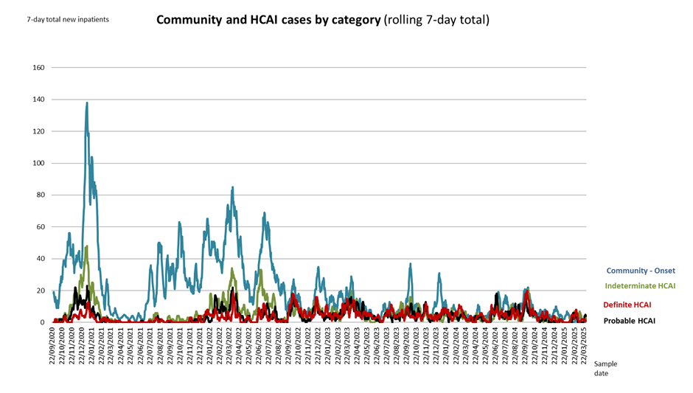

Outbreaks of COVID-19 Infection
Despite our efforts, in line with many other trusts, we were unable to fully contain this highly transmissible virus and reported fifty-eight ward outbreaks during 2024/25. Each outbreak was reported and managed in line with national requirements.

Review and Learning
There are quarterly COVID outbreak meetings and there is a review of all outbreaks for the quarter. The Divisional Governance teams present cases and the learning that has happened at Divisional level to enable wider dissemination of learning.

Measures Taken to Protect Patients from Hospital-Acquired RESPIRATORY virus.
Throughout the year there have been steps put in place to ensure that the appropriate risk assessment and safe patient placement occurs. The Trusts EPR system has enabled staff to have access to a respiratory risk assessment tool. Where patients with a confirmed or suspected respiratory virus are placed is regularly reviewed, by both the ward and IPC team to ensure patients are separated as far as possible from those who do not have a respiratory virus.

- Hand hygiene messages are reinforced regularly to encourage staff and patients to clean their hands more often than normal.

- Alcohol hand gel is readily available in all areas.

- There is a risk assessment in place to determine when there is a requirement for universal mask wearing. This is based on number of cases, staff sickness and community prevalence.

- Access to masks for patients/visitors is available.

- The Trust continues to clean with disinfectant products that are effective against respiratory viruses.

- Special air scrubbers were installed in key areas to help to reduce the risk of airborne transmission of COVID-19.

- We swab patients in line with guidance to identify anyone who presents with respiratory and wider symptoms.

- The Infection Prevention and Control Nurses visit our wards regularly to support staff and check standards.

- The Trust takes take rapid action if an outbreak is identified to stop further spread of infection. This includes deep cleaning the ward and swabbing patients in the affected area.

Carbapenemase-Producing Enterobacterales (CPE)

CPE has been an endemic problem at the Worcester site for approx.4 years where CPE was identified following an outbreak in the Laurels wards and zonal kitchen.

There is a continued surveillance program that requires patients to have an admission and then then weekly screens. This checks for any ongoing acquisition of the organism that results in colonisation that may lead to an infection.

During 2024/25 there were 2 outbreaks of CPE. Aconbury 4 outbreak a total of 2 patients were found to be colonised, clinical, estates and facilities interventions halted the outbreak promptly. Avon 4 outbreak a total of thirty-six colonisations cases was identified through routine screening. An extensive investigation was completed by the trust; assistance from UK HSA, NHSE and ICB was sort as despite multiple interventions (estates works, HPV cleans and strict IPC precautions) and extensive MDT effort (Clinical Team, IPC, Microbiology, Facilities and Estates) we were unable to identify the source of the CPE. The zonal kitchen was not implicated in this outbreak. The source of the outbreak was suspected to be from hand wash basins and oral care. There have been no new cases since September 2024.

Measles
There has been a resurgence of measles in the region, particularly in Birmingham where there has been a high number of cases.

In preparation for potential cases, clinical pathways were devised. A screening tool is used to enable early identification of cases and therefore earlier isolation. Staff were encouraged to seek Occupational Health advice regarding vaccination status.

Measles Immunoglobulin pathways developed and shared with ICB.

The Trust has seen very few cases, and the appropriate care and treatment was received by the patients. Contact tracing was completed for patients and staff and actions taken as per the National guidance. There were no transmission events in the Trust to report.

In 2024-25 we achieved the 3 out of the 5 (MRSA, E. Coli, and Pseudomonas) national infection reduction targets. We were close to achieving our Klebsiella objective being over by 1 case. We did not achieve our internal target for MSSA bacteraemia reduction. Nationally there has been an increase of HCAI. We are unsure of the reasoning behind the increase, and this is currently being reviewed by UK HSA and NHS England. The Trust achieved zero MRSA bacteraemia which was a reduction from 7 reported in 2023/2024.
HCAI National Targets 2024/25 | Outcome Against Target
Clostridioides difficile infection= 142 Vs 129 | 
MSSA = 46 Vs 40 (internally set)
MRSA= 0 infections | 
E coli BSI = 105 vs 112

Klebsiella species= 36 vs 35
Pseudomonas aeruginosa BSI = 12 vs 15

Clostridioides difficile Infection (CDI)  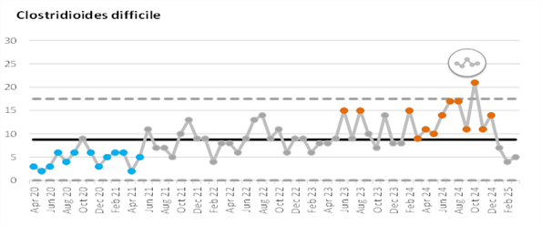 | How Are We Doing?  We did not meet our improvement target this year.  We reported 142 vs 129 full-year target, although most recent months show a reducing number.
To Reduce These Infections, We Have….
- Aligned case reviews with the PSIRF model which has allowed us to focus on the themes and trends obtained through the MDT case reviews.
- As a result, C. diff related documents are now embedded into the EPR system, cleaning standards and Star ratings are reviewed more frequently, and isolation facilities are easily identified with the implementation of a new daily side room report.
- Antimicrobial prescribing and stewardship (AMS) is well-recognised as a significant factor in the development of CDI. Throughout the year we have had a major focus on AMS, including monthly audits to monitor our compliance with the national Start Smart Then Focus principles. We have achieved significant improvements in AMS this year. 2024-25 saw the e re-implementation of an MDT approach to C.diff reviews with the Trusts newly appointed AMS pharmacist.
- Improved communication and awareness of C.diff between the Trust, positive patients, and GP colleagues by providing C.diff information following discharge in an attempt to prevent relapse and associated complications.
- “Gloves Off” campaign focused on staff use of PPE.
- Equipment trials are in progress to replace bed pan washer disinfectors on the WRH site with macerator systems, to reduce the risks of cross contamination caused by multi patient use items. There are 3 bed pan macerators (3 different suppliers) installed at the WRH site, all received favourably by the clinical teams and so far, no reported issues with drainage-blockages or leaks.
- Patient advice leaflet “Preventing Infections.”
- Held drop-in sessions for Hand Hygiene and commode cleaning training and competence.
- Red, amber, Green (RAG) poster was updated and awareness promotion undertaken.
- Bed cleaning video is now part of mandatory training.

Clostridioides difficile 30-day all-cause mortality
It is recommended in national guidance that 30-day all-cause mortality be monitored in CDI patients. The following graphs therefore show this: the number of patients who have died of any cause in the 30-days after having a positive test for CDI. This data includes patients from all settings.
The mortality rate based on rolling 12-month totals has remained close to 14% throughout the year and remains below the 20% trigger point.

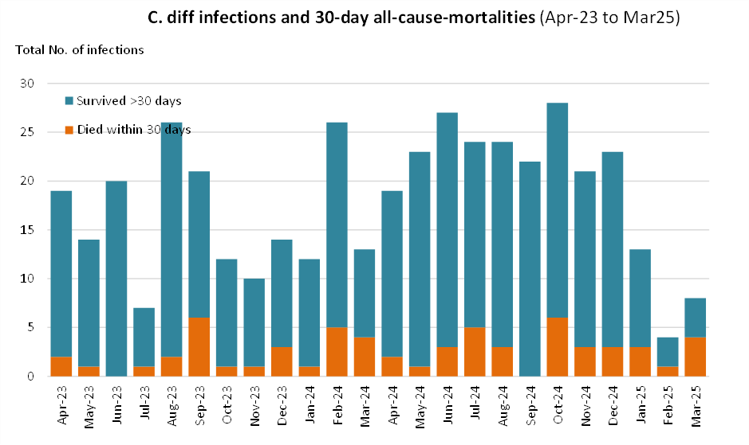

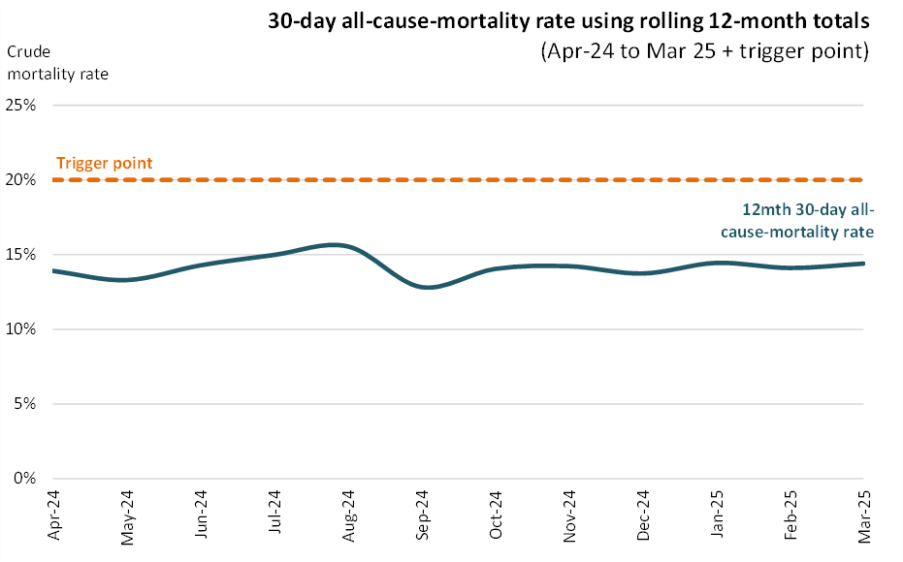

Meticillin-Sensitive Staphylococcus aureus (MSSA) Bacteraemia | How Are We Doing?
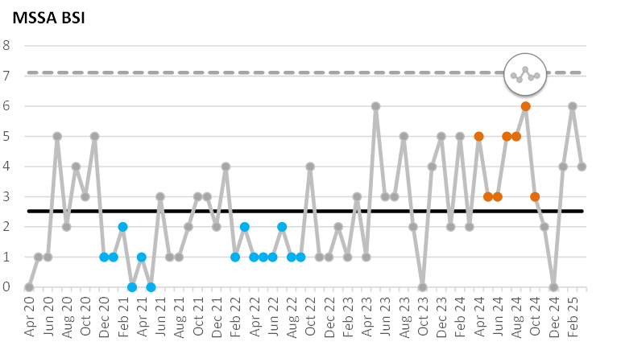 | Though no national target was set in 2024-25, we continued our focus on reducing MSSA bacteraemia and set an internal reduction target of no more than 17 cases, which was amended in Q3 to be 40.  We did not meet our improvement target this year.  46-year end cases against our local target of 40.
To Reduce These Infections, We Have….

- Initiated the Peripheral Venous Device (PVD) task and finish group.
- Continued the PVD Pack quality improvement project which has involved promotion of the PVD insertion packs across the Trust.
- Audit of use of packs by procurement, with link made of use and reduction in BSI risk/non-use and BSI risk.
- Attended Divisional Governance meetings to present/promote PVD projects.
- “Scrub the hub” poster which was rolled out across the Trust.
- In collaboration with the Professional Development Team and BBraun, launched the role of a PVD Champion at WRH site on 24th January 2024, Alexandra hospital launch planned for Q1 2025/26
- ANTT training materials on source page: videos and posters
- ANTT training must be completed before staff can complete cannulation training.
- Launched a teaching video on the use of the PVD forms on EPR.
- Promoted the “Gloves Off” campaign focused on staff use of PPE, through spot checks to clinical areas.
- Hand hygiene products change over to new supplier.
- RAG cleaning poster promoted.
- Quality improvement project to improve bed cleaning across the trust, updated bedspace check list and produced and launched a bed cleaning video for mandatory training, which is now available on ESR.

MRSA | How Are We Doing?
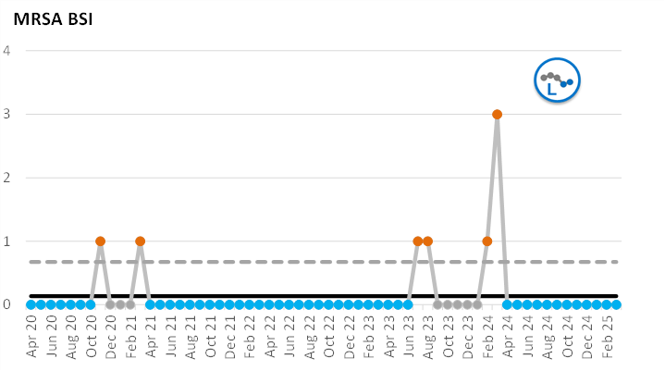 | Zero Tolerance  Zero cases reported.  The trust reported below threshold infections.
To Reduce These Infections, We Have….
- Link practitioner day -Focus on MRSA
- Ran the Peripheral Venous Device (PVD) task and finish group.
- Continued the PVD Pack quality improvement project which has involved promotion of the PVD insertion packs across the Trust.
- Audit of use of packs by procurement, with link made of use and reduction in BSI risk/non-use and BSI risk.
- Attended Divisional Governance meetings to present/promote PVD projects.
- “Scrub the hub” poster which was rolled out across the Trust.
- In collaboration with the Professional Development Team and BBraun, launched the role of a PVD Champion at WRH site, on 24th January 2024, Alexandra Hospital launch planned for Q1 2025/26
- ANTT training materials on source page: videos and posters
- ANTT training must be completed before staff can complete cannulation training.
- Launched a teaching video on the use of the PVD forms on EPR.
- Promoted the “Gloves Off” campaign focused on staff use of PPE, through spot checks in clinical areas.
- Hand hygiene products change over to new supplier.
- RAG cleaning poster promoted.
- Quality improvement project to improve bed cleaning across the trust, updated bedspace check list and produced and launched a bed cleaning video for mandatory training, which is now available on ESR.

Ecoli | How Are We Doing?
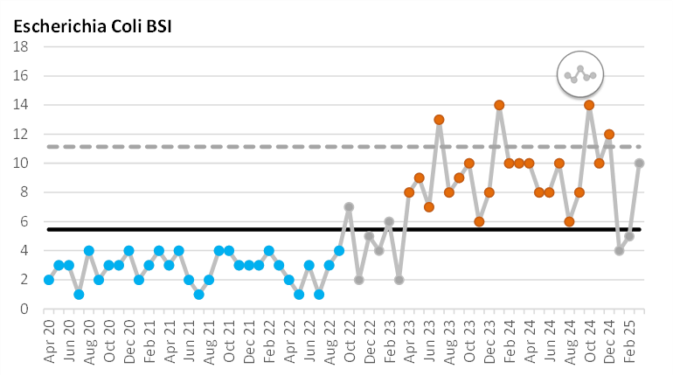 | 105/112  The trust reported below threshold infections
To Reduce These Infections, We Have….

- Initiated the Peripheral Venous Device (PVD) task and finish group.
- Continued the PVD Pack quality improvement project which has involved promotion of the PVD insertion packs across the Trust.
- Audit of use of packs by procurement, with link made of use and reduction in BSI risk/non-use and BSI risk.
- Attended Divisional Governance meetings to present/promote PVD projects.
- “Scrub the hub” poster which was rolled out across the Trust.
- In collaboration with the Professional Development Team and BBraun, launched the role of a PVD Champion at WRH site on 24th January 2024, Alexandra Hospital launch planned for Q1 2025/26
- ANTT training materials on source page: videos and posters
- ANTT training must be completed before staff can complete cannulation training.
- Launched a teaching video on the use of the PVD forms on EPR.
- Promoted the “Gloves Off” campaign focused on staff use of PPE, through spot checks in clinical areas.
- Hand hygiene products change over to new supplier.
- RAG cleaning poster promoted.
- Quality improvement project to improve bed cleaning across the trust, updated bedspace check list and produced and launched a bed cleaning video for mandatory training, which is now available on ESR.

Klebsiella species BSI | How Are We Doing?
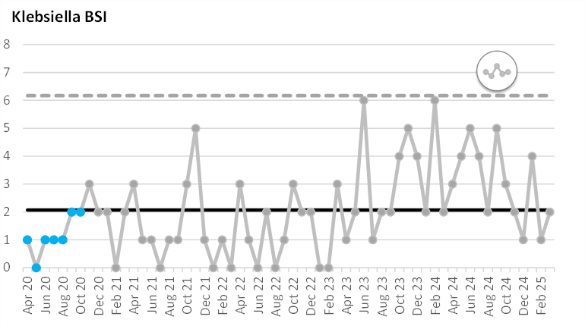 | We reported 13 vs 12 full year target.  We did not meet our improvement target this year.
To Reduce These Infections, We Have….
Focus on water management at link practitioner session.

- Initiated the Peripheral Venous Device (PVD) task and finish group.
- Continued the PVD Pack quality improvement project which has involved promotion of the PVD insertion packs across the Trust.
- Audit of use of packs by procurement, with link made of use and reduction in BSI risk/non-use and BSI risk.
- Attended Divisional Governance meetings to present/promote PVD projects.
- “Scrub the hub” poster which was rolled out across the Trust.
- In collaboration with the Professional Development Team and BBraun, launched the role of a PVD Champion at WRH site on 24th January 2024, Alexandra Hospital launch planned for Q1 2025/26
- ANTT training materials on source page: videos and posters
- ANTT training must be completed before staff can complete cannulation training.
- Launched a teaching video on the use of the PVD forms on EPR.
- Promoted the “Gloves Off” campaign focused on staff use of PPE, through spot checks in clinical areas.
- Hand hygiene products change over to new supplier.
- RAG cleaning poster promoted.
- Quality improvement project to improve bed cleaning across the trust, updated bedspace check list and produced and launched a bed cleaning video for mandatory training, which is now available on ESR.

Pseudomonas aeruginosa BSI | How Are We Doing?
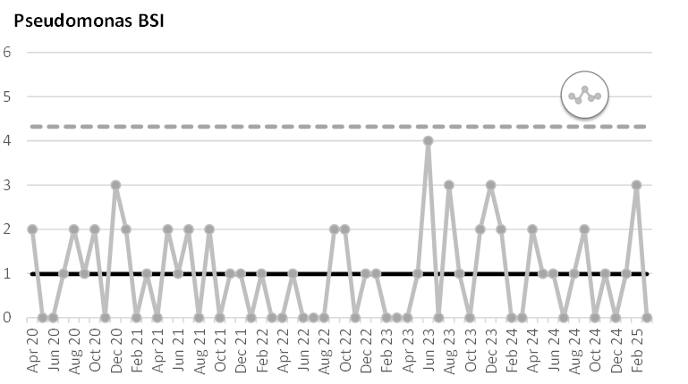 | .  We reported 12 vs 15 full-year target.  The trust reported below threshold infections.
To Reduce These Infections, We Have….

- Focus on water management at link practitioner session.
- Ran the Peripheral Venous Device (PVD) task and finish group.
- Continued the PVD Pack quality improvement project which has involved promotion of the PVD insertion packs across the Trust.
- Audit of use of packs by procurement, with link made of use and reduction in BSI risk/non-use and BSI risk.
- Attended Divisional Governance meetings to present/promote PVD projects.
- “Scrub the hub” poster which was rolled out across the Trust.
- In collaboration with the Professional Development Team and BBraun, launched the role of a PVD Champion at WRH site on 24th January 2024, Alexandra hospital launch planned for Q1 2025/26
- ANTT training materials on source page: videos and posters
- ANTT training must be completed before staff can complete cannulation training.
- Launched a teaching video on the use of the PVD forms on EPR.
- Promoted the “Gloves Off” campaign focused on staff use of PPE, through spot checks to clinical areas.
- Hand hygiene products change over to new supplier.
- RAG cleaning poster promoted.
- Quality improvement project to improve bed cleaning across the trust, updated bedspace check list and produced and launched a bed cleaning video for mandatory training, which is now available on ESR.

Surgical Site Infection Surveillance Survey

SSIs can range from a relatively a relatively trivial wound discharge with no other complications to a life- threatening condition” National Institute for Health and Clinical excellence (NICE) (2008).
Infections of the surgical site account for approximately 16% of all hospital acquired infections (HCAI), are estimated to double the length of post-operative stay in hospital and significantly increase the cost of care.

In April 2004 surveillance of Surgical Site Infections (SSIs) in Orthopaedic surgery became mandatory in all English NHS Trusts, specifying that each trust should conduct surveillance for at least 1 orthopaedic category for 1 period in the financial year. This surveillance helps hospitals, in England, to review or change practice, as necessary. WAHT conduct surveillance in all four quarters for three of the four categories.
- Hip replacement.
- Knee replacement
- Repair of neck of femur
 | April-June  2024 | July/Sept  2024 | Oct-Dec  2024 | Total
Hip Replacement | 130 | 123 | 130 | 383
No. inpatient/readmission | 1 | 0 | 1 | 2
% Infected | 0.8% | 0.0% | 0.8% | 0.52%
No. post-discharge confirmed | 0 | 1 | 0 | 2
% Infected | 0.0% | 0.8% | 0.05 | 0.52%
No. patient reported | 0 | 0 | 0 | 0
% Infected | 0.0% | 0.0% | 0.0% | 0.0%
All SSI | 1 | 1 | 1 | 4
% Infected | 0.8% | 0.8% | 0.8% | 1.04%
Knee Replacement | 141 | 156 | 137 | 434
No. inpatient/readmission | 0 | 1 | 0 | 1
% Infected | 0.0% | 0.6% | 0.0% | 0.23%
No. post-discharge confirmed | 0 | 1 | 0 | 2
% Infected | 0.0% | 0.6% | 0.0% | 0.46%
No. patient reported | 0 | 0 | 0 | 0
% Infected | 0.0% | 0.0% | 0.0% | 0.0%
All SSI | 0 | 2 | 0 | 3
% Infected | 0.0% | 1.3% | 0.0% | 0.69%
Neck of Femur | 185 | 169 | 205 | 559
No. inpatient/readmission | 0 | 1 | 2 | 3
% Infected | 0.0% | 0.6% | 1.0% | 0.54%
No. post-discharge confirmed | 0 | 0 | 0 | 1
% Infected | 0.0% | 0.0% | 0.0% | 0.18%
No. patient reported | 0 | 0 | 0 | 0
% Infected | 0.0% | 0.0% | 0.0% | 0.0%
All SSI | 0 | 1 | 2 | 4
% Infected | 0.0% | 0.6% | 1.0% | 0.71%
- Reduction of long bone fracture

**Quarter four data is awaiting validation & release from SSISS

The Trust has initiated a review of the process of the SSISS and has identified a number of improvements to further strengthen the assurance in how we review the learning from SSI to ensure better outcomes for our patients as part of this review we are looking at:

Reports to the Surgical Site Infections Surveillance Service.

- The monitoring of reporting from the Surgical Site Infections Surveillance Service regarding Trust performance.
- The end-to-end process for Surgical Site Infections including security and learning from incidents of infection post-surgery. This will include engagement of:
  - Pre-Operative assessments to raise awareness regarding related infections.
  - Intraoperatively Theatre Journey to support both patient and environment preparedness.
  - Outpatients follow up appointment to monitor for signs of infection.
  - General Practitioners in proactively sharing post operative complications.
- Reviewing patient information in support of SSISS process and ensure changes to documentation goes through the governance process.
- How input and output of the Bone and Joint Infection MDT is shared for action and learning.

Implementation is currently in progress with inclusion and input from all stakeholders within the Trust.

Criterion 2 Provide and maintain a clean and appropriate environment in managed premises that facilitates the prevention and control of infections.
Written by Emma King Interim director for Estates and Facilities

Cleanliness

Our focus on cleanliness has continued throughout 2024-2025 continuing to work in accordance with the National Standards for Healthcare Cleanliness 2021, including the new reporting methodology and from March 2025 we have aligned ourselves with the update National Standards of Cleanliness 2025

The audit scores for each functional area are represented in two ways: a percentage score and a star rating score. The percentage score is for internal verification and scrutiny that a safe standard has been achieved, whereas the star rating score is for external verification of this.

Cleanliness by Site

During April 2025, the average star ratings were as follows:

    - Trust – 4.6
    - Alex – 4.8
    - KTC – 4.8
    - WRH – 4.7

The trend over the last 12 months has seen cleanliness audit scores overall continuing to increase across the organisation We have continued to build on the improved working relationships and collaborative approach between the Estates and Facilities Teams with clinical teams. Regular scrutiny and review sessions are held to maintain focus on the importance of cleanliness to ensure safe environments.

Regular meetings are held with all stakeholder groups to review issues from areas that only attain a 3-star rating. These are led by IPCT, however the number required are reducing due to the continuing improvements based on the scoring methodology.

We have contributed to feedback in relation to the new scoring methodology via various network groups, that potentially the scoring methodology does not provide the necessary accountability for issues raised and is not always reflective of the standards.

Despite capacity levels we have continued with enhanced levels of cleaning including proactive routine Hydrogen Peroxide Vapour (HPV) and Ultraviolet-c (UV-c) decontamination of high-risk areas (at WRH and Alex) This includes dirty utility areas and communal bathrooms. Going forward we will be scrutinising the numbers being requested.

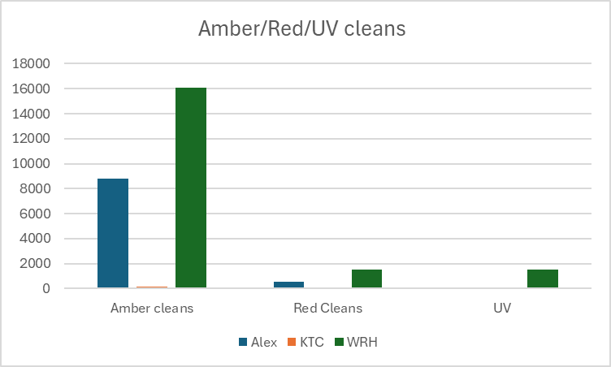

 | Amber cleans | Red Cleans | UV
Alex | 8820 | 559 | 107
KTC | 182 | 93 | Not used
WRH | 16076 | 1506 | 1506

The Trust Monitoring Team continue to report directly into the Deputy Director of Estates and Facilities (Soft FM) which has enabled the team to remain independent of both cleaning services ensuring monitoring reports are objective and as accurate as possible utilising modern audit software aligned to the National Standards of Cleanliness

Previously we have reported concerns in relation to the performance of our PFI partners, however we have seen a significant sustained improvement, however we will continue to manage closely.

Safe Ventilation Systems
The Critical Ventilation Safety Group continues to meet regularly and is principally concerned with ensuring that Trust ventilation systems are inspected, tested, maintained, and operated safely across all 3 sites. The group also has a remit of ensuring that clinical staff are aware of any risks these systems may pose to clinical activity. There has been a review and update for the terms of reference for this Group.

In line with national guidance, an external Authorising Engineer (AE) Ventilation is in place to audit the management of the Trust’s ventilation systems and appoint Authorised Persons (APs). APs are in place at all WAHT hospitals to manage the ventilation systems.

All critical ventilation systems are verified in accordance with HTM03-01, and systems are broadly compliant. Where there is a lack of compliance there are additional controls in place which are actively reviewed and managed via the Estates Team or our PFI partners.

Our specialist units such as theatres, endoscopy and your intensive care units have additional ventilation in line with guidance. However, one of our continuing challenges during the pandemic is that much of our hospital estate was built to have natural ventilation only. This means we cannot guarantee that the amount of fresh air entering those areas will fully dilute or remove all COVID-19/influenza virus which may be present. Therefore, the trust has heavily invested in HEPA air filters called Rediairs. The installation of Rediairs air filters was completed across the Worcester Royal and Alexandra hospital in-patient settings during November-December 2024 Ward based training was given and standard operating procedure for maintenance was produced.

Water Safety
Our Water Safety Group is now chaired by the DIPC. The committee continues to meet on a quarterly basis, overseeing a system which is providing good assurance on water quality and governance. Our electronic system for recording water outlet flushing has been in place for over five years, with a system of escalation to management teams for any areas which do not complete their flushing and reporting.
The Water Safety Plan (WSP) was reviewed, updated, and commissioned in 2023/24 from our Specialist Water Management has been implemented which satisfied the latest guidance requirements in addition to HTM 04-01.
A programme of sampling is in place to detect any Legionella and Pseudomonas aeruginosa in the water system. Sampling results have been generally good across all sites, however there were several counts of Pseudomonas aeruginosa isolated via 6 monthly routine sampling. The adverse samples were dealt with promptly in accordance with the water safety plan to ensure patient and staff safety. The issue identified was poor condition of taps and cleaning deficits. There have been no linked infections to this incident.
Safe water management was a focus for our link practitioner’s sessions held in April 2024 and 2 senior IPC nurses completed water management ILM training. The IPC Nurse manager and DIPC also hold ILM qualifications.

Criterion 3: Ensure appropriate antimicrobial use to optimise patient outcomes and to reduce the risk of adverse events and antimicrobial resistance.
Written by Sadiya Hussain – Clinical Antimicrobial Pharmacist.

The Trust Antimicrobial Stewardship Group have continued to provide leadership and oversight for antimicrobial stewardship (AMS) activities, further building on positive progress made in 2023-24.
Key progress made during 2024-25 includes:
- Commenced antimicrobial ward rounds across both sites:
AMS Snapshot data from ward rounds: Conclusions:
No patients came to harm/became bacteraemic due to advice.
Re-reinforced benefit of AMS ward rounds.
Advice appreciated by clinical ward teams.
No Datixes have been raised and no verbal/email complaints received.
- Commenced AMS education sessions across both sites.
- Appointment of antimicrobial Pharmacist in post April 2024.
- The overall level of assurance was assessed at level 5. The levels of assurance for the Divisions range from level 6 (OPAT Services) to level 4 (Surgery and SCSD). The Divisions have had representatives available to present their written AMS reports or if not, a verbal update has been provided including an update on their action plans.
- There has been a fluctuation in the overall numbers of Start Smart Then Focus audits completed by ward staff by junior doctors in January- March.
- The Quarterly Point Prevalence Survey results (where all charts are audited against antimicrobial prescribing standards on one day by the pharmacists) was undertaken during Q4. Results show that improvement is required for antibiotics to be prescribed in line with guidance and 72-hour reviews.
- All divisions have confirmed that AMS is embedded in their Quality and Governance agendas and have action plans signed off by their Divisional Boards.

CQUIN and NHS Standard Contract
CQUIN IVOS (Intravenous to oral switch) antibiotics
For 2024/2025, the Trust participated and submitted data for the following CQUIN: Timely switch of Antibiotics from IV to Oral. Although this was not incentivised, we were able to perform considerably better than the national criteria. The aim of this audit was to assess what % of patients are on IV antibiotics who could have been switched to oral treatment.
Target is achieving 15% or fewer still receiving IV antibiotics past the point at which they meet switching criteria. Minimum < 25% and maximum 15% (lower % indicates better performance) Inclusion criteria: Adults (>16 years of age) and paediatric (<16 years of age) inpatients with active prescriptions for IV antibiotics at the point of the audit.
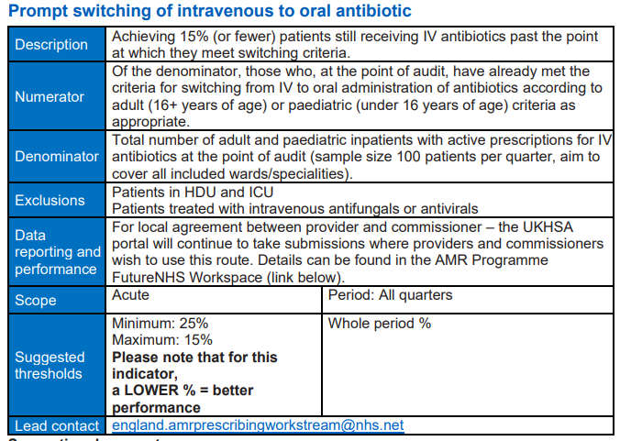
Results:
Q1: 12.03%
Q2: 7.62%
Q3: 16.19%
Q4: 10.24%
The audit undertaken by the pharmacists in all quarters met the national target. This data is yet to be published on the national database.
This non-mandatory CQUIN will not be continuing nationally but will be continued as an internal Trust audit for the 2025/26.
A poster created showing the benefits of IV to oral antibiotic switches and the impact this has on the nursing workforce and the green agenda was shared in the Nurse Midwifery and AHP board meeting.
Audit Results
Antimicrobial Point Prevalence Survey (PPS)
This audit was completed during Q4. Overall, the compliance of antimicrobials in line with guidance has not achieved the target – 85.02%. Wards in particular that require improvement as they achieved less than 80% are Specialty Medicine at ALEX W2 and W5, Surgical wards at ALEX and majority of the surgical wards at WRH, ALEX Urgent Care AMU and WRH MSSU.
The 72-hour reviews have not improved (from 75.71% to 71.65%) and have still not achieve the target. At the time of writing this report, this data has not yet been presented to ASG for discussion and development of any actions.

Carbapenem prescribing.
Carbapenem usage
Further to all the work undertaken by our antimicrobial stewardship leads and revision of prescribing policies, a downward trend in usage of carbapenems has been seen up until August 2024. There has been a slight increase since but this may have been due to new junior doctors commencing and due to high acuity of patients. The ward level data has been and continues to be scrutinised by ASG to identify clinical areas to target. It is noted that the Consultant Microbiologist AMS lead and AMS lead pharmacist have commenced ward rounds and provide a ward based presence.
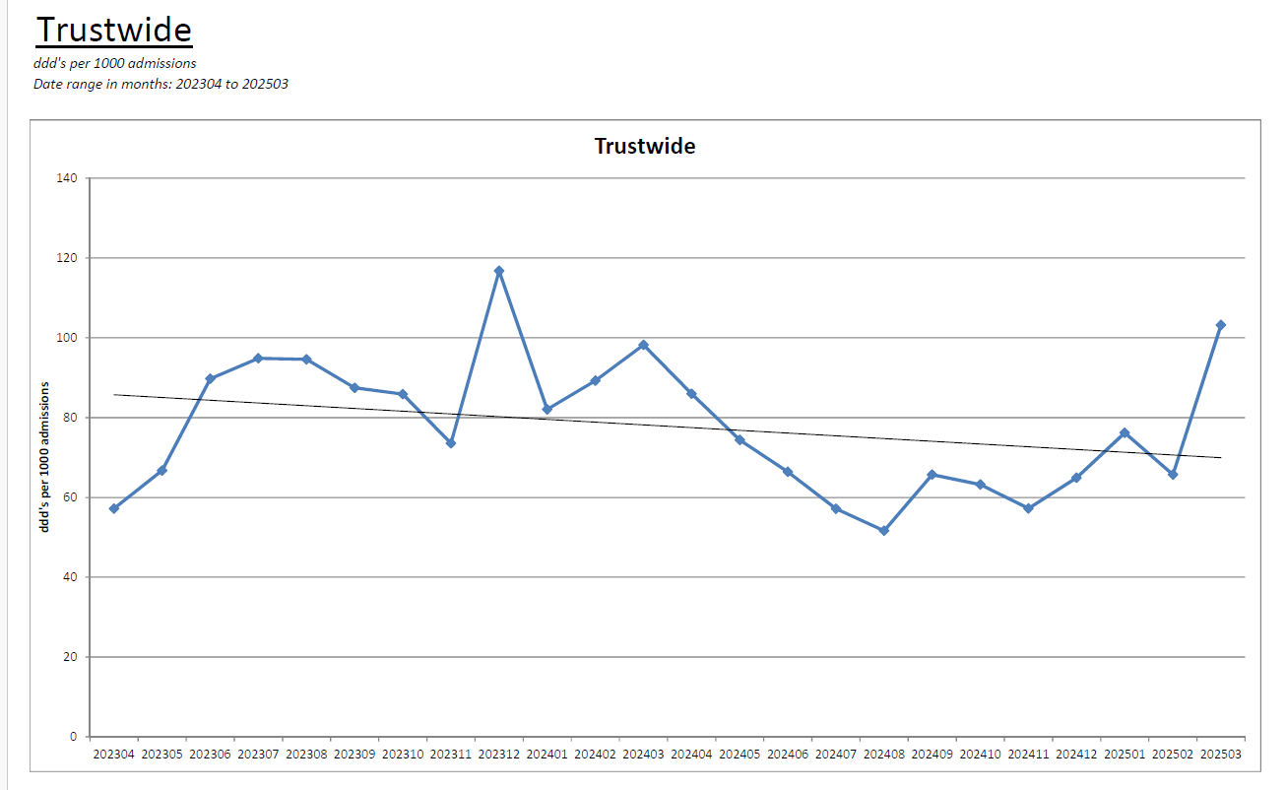
Since the increased usage, the ward level data has been and continues to be scrutinised by ASG to identify clinical areas to target. The lead AMS pharmacist commenced in April 2024, and this is an additional resource to support changes in practice. It should also be noted that due to significant pharmacist vacancies, many of the medication charts are not being reviewed after admission until discharge. There will therefore be fewer antimicrobial interventions. It is also hoped that ePMA will also facilitate the appropriate prescribing of carbapenems.
An audit carried out by one of the trainee Pharmacists in 2023-24 found that:
- Meropenem was prescribed in accordance with the trusts antimicrobial guidelines and were prescribed correctly regarding the dose and frequency.
- If treatment had been at least 72 hours there was lower compliance with putting review/stop dates of the antibiotic.
- General surgery and acute medicine had the most amount of Meropenem prescribed.
- There was room for improvement when it comes to Meropenem prescribing as prescribing was not done 100% correctly all the time.
- Compared to a previous audit there was an improvement when it came to prescriptions being in line with the antimicrobial guidelines or deviating with a valid reason
A re-audit into carbapenem prescribing is going to undertake by one of the Pharmacists over a three-month period in the financial year 2025-2026 to overcome the following limitations:
- Above audit conducted over a 2-week period so potentially was not fully representative of Meropenem prescribing in the trust
- Given the small sample size received from the Alexandra hospital (4 prescriptions) the overall findings may not be a true representation of the trust as a whole.

NHS Standard Contract – data from FutureNHS relevant for Q2 2024/54:
DDD update
Across the NHS, an initiative was set to reduce consumption of Watch & Reserve antibiotics by ~10%, by 2024/25 whilst using 2017 data as a baseline.

The target in Q2 has not yet been achieved +16%.

It is expected that Q3 results will be available in June 25.
There are four Trusts (previously three) achieving the target in the West Midlands and the AMS lead Pharmacist has contacted colleagues to ask what they have done to achieve this.
Other ASG activities (some on-going):
- Extensive antimicrobial treatment guideline review has been undertaken focusing on rationalising broad-spectrum recommendations and improving proportion of Access list antibiotics and reducing proportion of Watch and Reserve list antibiotics. Divisions to focus on guideline promotion and education to improve compliance.
- Microguide (antimicrobial guide) successfully transitioned to EOLAS and currently reviewing new guidelines and drug monographs to be added.
- Paediatric antimicrobial guide approved and will be added to EOLAS.
- Engaging with the EMPA team to ensure the system can support antimicrobial stewardship including documentation of allergies, length of course and compliance with guidance.
- AMS representation at ICS/ICB groups to develop strategic priorities and identify actions. Five key prescribing priorities include: optimise therapy, reduce demand, reduce exposure, shorten courses, and narrow spectrum. We have completed a gap analysis against the ICS action plan which will be reviewed along with other providers in the system.
- Collaborating with Wye Valley regarding guidelines and adding antimicrobials on to the Hereford and Worcestershire formulary.
- The ASG terms of reference have been reviewed and identified that the group would benefit from ward-based nurses especially as they may be able to support and promote IV to oral switches, and challenge length of antibiotics courses. ASG members now include ward-based nurses and non-medical prescribers who are encouraged to attend the bi-monthly meetings.
- The Antimicrobial Stewardship Policy was reviewed in June and updated.

Criterion 4: Provide suitable accurate information on infections to service users, their visitors and person concerned with providing further support or nursing/medical care in a timely fashion.

Our continued approach during 2024-25 has been to ensure open and clear communication with our patients, their carers, family and the wider public. Information is available on the internet Trust website and signposts patients/carers to National guidance. The IPC team have produced a patient information leaflet outlining IPC practices and how to stay safe in hospital by carrying out such things as good hand hygiene and wearing the correct PPE as directed by the ward teams.
Social media has been used to promote key messages about preventing infection, especially during the pandemic. Our public website contains a range of information to help inform the public, including on MRSA, Clostridioides difficile, influenza and Norovirus.
Information on COVID-19 and other organisms is available on a dedicated section of the intranet which can be accessed by all staff. Key messages are distributed by the communication team using a variety of media that is available across the Trust.
Criterion 5: Ensure prompt identification of people who have or are at risk of developing an infection so that they receive timely and appropriate treatment to reduce the risk of transmitting infection to other people.

We have several assessment tools available to reduce the risk of transmitting infection, and our admission process includes assessment of patients for signs of infection. This has been strengthened further and moved to a Respiratory symptom checker.
Our Infection Prevention Team works closely on a daily basis with wards, our site management teams and our cleaning teams to ensure patients with infection are rapidly identified, isolated correctly, and additional cleaning is in place as required.
During 2024-25 we identified and effectively dealt with a number of infection outbreaks and incidents relating to a range of infections.
With the introduction of the EPR system there has been a diarrhoea risk assessment tool introduced.
The policy for Outbreaks and Isolation of patients has been updated and an updated RAG poster issued to help decision making re cleans.
Criterion 6: Ensure prompt identification of people who have or are at risk of developing an infection so that they receive timely and appropriate treatment to reduce the risk of transmitting infection to other people.

Strong and visible leadership by all senior clinical leaders continued throughout the year 2024/25, including leadership by the CNO and the DIPC.
Throughout 2024-25 we continued to require all staff to complete the electronic mandatory training rather than face-to-face sessions. We have introduced a face-to-face session for induction for HCAs. This includes donning and doffing, hand hygiene competencies and clear instruction on where to find policies.

Our compliance target in 2024-25 was 90%. At the end of 2024-25 the achievement was 90% for clinical staff, and 96% for non-clinical staff.

Ward-based training and electronic resources have remained in place to support staff during the year.

The IPC team have successfully delivered link practitioner training covering a variety of subjects.

Hand hygiene competencies are delivered at Ward level and there is a requirement for annual update.

Fit Testing
FFP3 mask fit-testing is stipulated by the Health and Safety Executive and any mask that is fit to the face must be fit tested.

This continued over 2024/25 with the withdrawal of government support in April 2023. The provision of the service was supported by NHS Professional staff however, the Trust successfully recruited two permanent staff to oversee fit mask testing. The fusion system was updated to enable direct booking and recording of fit tests.

Fit tests are provided for all Trust staff as well as our PFI partners.

Criterion 7: Provide or secure adequate isolation facilities.

In general, isolation for infection prevention reasons means caring for someone in a single room, preferably with ensuite toilet and washing facilities. Of our bed-base we had 175 single rooms across the Trust, which is 18% of our hospital beds. Of these 134 are ensuite, which is 13% of our beds. These beds are routinely used for isolation. When the number of patients with possible infection rises, patients with the same infection/suspected infection are nursed together in cohorts.
Cohort isolation continued to be used throughout 2024- 25 for influenza, COVID-19 and norovirus cases.
The Trust introduced a more standard model of isolation, with patients being isolated in single rooms and bays within the ward most appropriate for their clinical care based upon their reason for admission (our ‘presenting condition model’). The national guidelines were adapted to ensure that the Trust was maintaining patient safety. Within the Frailty areas we continue to isolate patients who are classified as COVID contacts. This is supported by a risk assessment agreed at TIPCC.
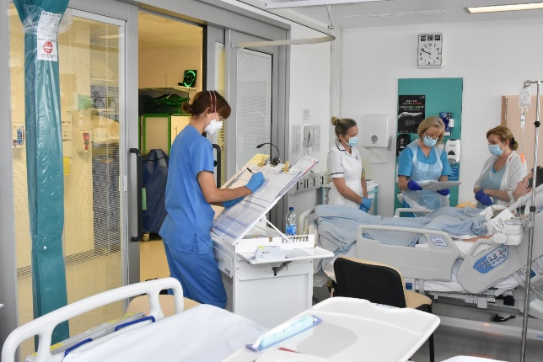
We have infection assessment tools for patients on admission. If someone develops common symptoms of infection such as diarrhoea or respiratory symptoms during admission, these tools are used by staff to identify the need for isolation.
ED at Worcester has access to single cubicles, however, there remains significant attendees in the department that add to the overcrowding there. Increased cleaning has been implemented in both EDs, but this remains a challenging environment.
Due to the pressures on side rooms and often the demand outweighing the supply, IPC works with capacity and site to review side room provision and the ‘live’ side room” tool developed with Informatics’ helps to support the clinical decision-making process.
Criterion 8: Secure adequate access to laboratory support.

We have our own trust-wide on-site microbiology laboratory, based at Worcestershire Royal Hospital. This provides a full range of microbiology services, linking with the national reference laboratory network for specialised testing which cannot be performed locally. The laboratory is UKAS accredited, confirming it operates an effective and quality-controlled system.
Throughout 2024/25 the laboratory has maintained sufficient increased capacity to provide all the required testing for COVID-19 for the health system across Worcestershire, via a range of rapid and standard tests. In 2025/26 the laboratory will continue with work to further extend the range and number of rapid testing platforms available for other infections. This includes molecular based testing for enteric pathogens including a wider range of viruses to assist in the control of infection.
The department has been challenged at times due to the lack of staff but there have been no incidents reported relating to performance due to staffing levels.
Criterion 9: Have and adhere to policies, designed for the individual’s care and provider organisations that will help to prevent and control infections

We monitor adherence to a number of our Fundamentals of Infection Prevention and Control with a programme of monthly auditing via our electronic system with reporting in real-time. The national High Impact Intervention audit tools issued by NHS Improvement have been used as the basis for the monitoring tools. The compliance information is included routinely within divisional reports to TIPCC, supporting detailed review of good practice.

Hand hygiene is audited monthly, and all clinical areas are expected to participate. There has been a high level of compliance, achieving over 99%. However, there has been a variable compliance with completion.

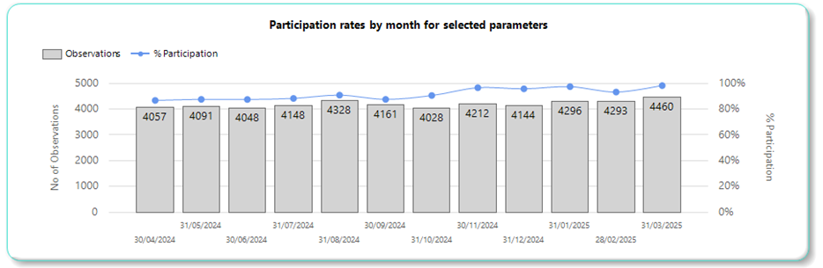

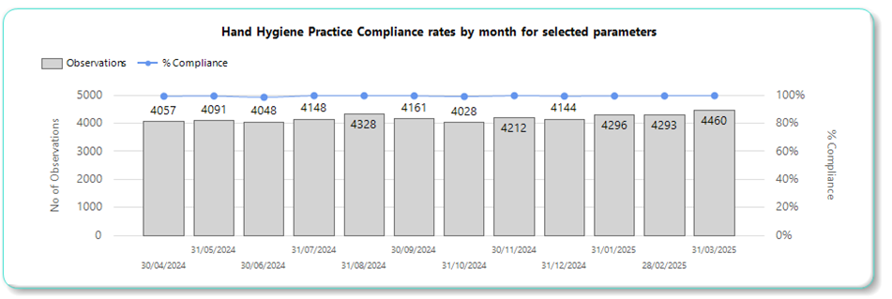

During the past year, the audit program and response to alert organisms have shifted and a cleanliness and standard infection control interventions are measured. Work is in progress to move the IPC audits to GAP to ensure that all clinical areas can audit at any time and contribute to the ward accreditation process.

Criterion 10: Providers have a system in place to manage the occupational health needs and obligations of staff in relation to infection.
Written by Julie Noble, Head of Health & Safety and Fire Safety

The Health and Safety Team are responsible for ensuring there are systems and processes in place to enable legal compliance against secondary legislation, which if complied with effectively, protects staff from exposure to infectious diseases. An example is compliance against The Health and Safety (Sharp Instruments in Healthcare) Regulations 2013. To comply with this regulation the Trust has an Inoculation Policy and a Safer sharps group (that includes Occupational Health leads) that meets bi-monthly to analysis inoculation injuries with the aim to identify areas of concern/improvement and implement corrective and preventative measures.
Inoculation injuries were the highest cause of injuries reported under the H&S category during 2024/25 via Datix. There had previously been some disparity between records held by Occupational Health and via Datix therefore during the year reporting was promoted. Positively, the number of inoculation incidents reported is low compared to the number of interventions with sharps and equipment conducted by staff on a daily basis; however, staff must avoid injuries where possible – but reliably report all inoculation incidents if one occurs.
The number reported this year was 144, which is a significant increase compared to 86 (23/24) and 69 (22/23) with an increasing trend as demonstrated below:

- The type of device used, resulting in the most injuries was a hollow-bore needle.
- The main cause of injuries was inattentiveness. This being staff were not being focused on preventing harm to themselves.
- The second cause was not following the correct process for disposal of sharps.
- The top three activities being conducted when the injuries occurred was: Taking blood, disposal, and surgical procedures.
- The highest affected group was nursing/HCA staff.
- Reporting divisions were: Corporate - 2, SCDC – 48, Spec Medicine – 15, Surgery – 28, Woman`s and Children`s – 23, Urgent Care – 27.
- ED and Theatres at WRH were the highest reporting areas (12 incidents each); Collectively the number of incidents by theatres across all sites is a concern (total 21).
- During the year there were 7 inoculation incidents reported to the HSE to comply with the Reporting of Injuries, Diseases and Dangerous Occurrences Regulations 2013, this was a significant increase compared to zero the previous year. These were reported due to staff being exposed to a Blood borne disease (e.g. HIV, Hep C) (Listed as a Dangerous Occurrence under RIDDOR).
- Staff affected by the RIDDOR injuries were Doctor x 2, PA 1, Nurse x 3, 1 Radiographer.
- The Injuries were sustained when staff were: Taking Bloods (4) Inserting a CV line (1), Splash (1), Giving IV medication (1).
- The first reported incident led to the HSE assessing the investigation and then subsequently visiting WRH / ED to assess the Department / Trusts processes for the management of sharps. Unfortunately, they did not consider this was robust and two Improvement Notices were issued October 2024. The Trust was then required to implement improvements and provide evidence to the HSE. Example improvements were:
  - The Inoculation Policy was amended and highlighted to all staff, via screen savers, divisional governance leads, briefings.
  - Training on venepuncture / cannulation for new starters was changed requiring Trust training to be conducted / signed off before staff are permitted to practice.
  - A new Safer Sharps Awareness training package was launched for all staff.
  - The workplace risk assessment template was amended to ensure staff are risk assessing the use of safer and non-safer sharps and implementing mitigation for their risks.
  - The Procurement team introduced new safer sharps devices (e.g. safer hypodermic needles) and continue to evaluate products as part of an on-going improvement plan.
  - The safer sharps group was refreshed with the DIPC chairing meetings and membership widened to include representatives from professional development, procurement, and wider divisional clinical representation. The purpose of the group was revised to ensure outputs from data analysis can be addressed (e.g. more training, change of devices etc).
  - A new Investigation questionnaire was rolled out for use post inoculation injury to aid assessment of compliance against the Health and Safety (Sharp Instruments in Healthcare) Regulations 2013 / Inoculation Policy, and to ensure lessons learnt were addressed.
  - New Investigation training package was rolled out to ED senior staff; and ED staff attended H&S training for managers to ensure they were competent with risk assessing.
  - A new Scrutiny and Learning group was formed (February 2025) to critically assess selected inoculation incidents and to share with a wide representation of clinical staff the findings to aid wider sharing / learning and prevention.
  - This is on-going work. NB at year end the final sign off of evidence to the HSE was still under review.
- Biological Incidents (11):
  - The number reported is a significant increase compared to last year where only 3 incidents were reported.
  - All were splashes. 6 incidents were reported by differing theatres across the Trust reporting fluid/bodily fluid splashed in the eye whilst conducting their task. These locations should risk assess their tasks and wear eye protection where a reasonably foreseeable risk is noted.
  - The remaining 4 incidents occurred when a surgical task was conducted, or blood splash occurred. All staff must follow the inoculation policy for these types of incidents if fluids have got into the eyes.
The health and safety team work with clinical teams to prevent all types of injuries; especially any that may lead in an exposure risk. Clinical teams therefore need to comply robustly with Trust H&S and Infection Contril policies.
Occupational Health Services
All healthcare workers can access Occupational Health services. Our Occupational Health Service has a programme of staff health assessment to ensure healthcare workers are both protected from infectious disease by vaccination and are screened as required on employment to ensure they do not pose an infection risk to patients. The OH service supports the health and wellbeing of our healthcare workers across the Trust, as well as supporting our PFI contractors’ staff. All healthcare workers are health screened on employment, vaccination status is checked at this stage and any outstanding vaccinations are offered on commencement of employment and all healthcare workers are offered BBV testing at pre placement. Decisions on offering immunisation is made in line with OH Policy and local risk assessment as described in ‘Immunisation against infectious disease’ (the ‘Green Book’) and other guidance from UKHSA. Records are kept on Cority, as part of confidential staff occupational health records, including where vaccination has been offered and refused.
If healthcare workers are to work in areas where they will be undertaking Exposure Prone Procedures (such as maternity, theatres, A&E) then validated EPP bloods are taken (prior to medical clearance being given) for Hepatitis B Surface Antigen, Hepatitis C Antibody and HIV Antibody/Antigen.
Vaccines are offered based on risk assessment and are free of charge to all healthcare workers. Vaccine clinics are held at Worcester, Kidderminster, and Redditch Hospitals for accessibility.
If any healthcare workers are coming from Countries identifeid as having a high prevelance for Tuberculosis (TB) by the GOV.UK website for incidence of TB TB profile then they will have an IGRA blood test which identifies if they have latent TB. Positive cases are referred to the Acute Trusts TB Specialist Team for appropriate advice and/or treatment. A positive IGRA test does not prevent healthcare workers from starting work providing they are symptom free.
Our staff winter vaccination programme was promoted for 24/25 and involved co-administration of flu and Covid boosters, delivered in partnership with the Health and Care Trust. The programme was delivered by Crest pharmacy across the region.
Improving uptake continues to be a challenge but this was comparable nationally across other Trusts. The flu vaccination was subsequently offered until March 2025.

Vaccine | Population | Doses | Percentage
Flu | 5,828 | 1,999 | 34.3%
Employee Staff Group |  | Uptake
Nursing and Midwifery |  | 33%
Additional Clinical Services |  | 29%
Medical and Dental |  | 35%
Allied Health |  | 42%
Estates and Ancillary |  | 34%
Admin and Clerical |  | 40%
Healthcare Scientists |  | 44%
Add Prof Scientific and Technical |  | 46%
Students |  | 25%

Vaccine | Population | Doses | Percentage
COVID | 5,828 | 1,386 | 23.8%
Employee Staff Group |  | Uptake
Nursing and Midwifery |  | 20%
Additional Clinical Services |  | 19%
Medical and Dental |  | 29%
Allied Health |  | 29%
Estates and Ancillary |  | 23%
Admin and Clerical |  | 28%
Healthcare Scientists |  | 37%
Add Prof and Technical |  | 38%
Students |  | 0%

The Occupational Health Service also provides timely risk assessments and appropriate referral after accidental occupational exposure to blood and body fluids. Information provided on Datix is cross checked daily against information held by Occupational Health to ensure that incidents are not missed. Occupational Health also have a direct line for reporting of incidents during the Departments working hours, Monday to Friday 8.30-16.30, outside of these hours staff report incidents via ED. Awareness continues to be raised to all healthcare workers around best practice regarding prevention and advice following inoculation injuries and the Trust has recently launched an updated inoculation injury policy.
Occupational Health also provide advice and support in the event of infectious disease outbreaks and once notified of staff contacts will check the employee vaccination status and will follow up with the healthcare worker as required.

SECTION FIVE - Our Plan for 2025-26

In the coming year we will continue to strive for clean safe care for our patients. We will continue to focus on protecting patients and staff from all infections, reacting and risk assessing the Trusts requirements against the national guidance to ensure we follow recommended good practice.
Our overall aim remains to achieve excellent infection prevention standards and very low rates of infection. Although we have not met all of the Trajectories, we have worked to increase the engagement with teams and increase their understanding of IPC and improve standards.
We will continue our focus on hand hygiene, cleanliness, antimicrobial prescribing, and the care of invasive devices.
With the introduction of Patient Safety Incident Response Framework (PSIRF) the IPC team have worked with the clinical and governance teams to align the reviews to the new way of working. There is a strong focus on actions and learning from infection incidents. There is work underway to have the DATIX form as the assessment tool for the incident to enable an auditable process and to track completion of actions. There will be shared learning disseminated across the Trust.
Top three priorities will be:
- Optimisation of Cdiff management – focus on AMS, cleaning, and patient assessment.
- Promotion of the fundamentals of infection prevention and control, to include cleaning both environmentally and equipment. This will cover all responsible groups.
- Education and training to ensure that we have a skilled workforce that have good knowledge of IPC to deliver safe clean care. In line with the Infection Prevention and control education framework.
To deliver these improvements and continue responding to the Quality Priorities we are implementing a comprehensive annual infection prevention improvement plan for 2025/26. This continues our focus on our ‘Fundamentals of Infection Prevention and Control’ along with the other core actions we must take to achieve our aim.

References
- The Health & Social Care Act 2008: Code of Practice on the prevention and control of infections and related guidance (2015). (Updated 2022)
https://www.gov.uk/government/publications/the-health-and-social-care-act-2008-code-of-practice-on-the-prevention-and-control-of-infections-and-related-guidance/health-and-social-care-act-2008-code-of-practice-on-the-prevention-and-control-of-infections-and-related-guidance

- Start Smart Then Focus: antimicrobial stewardship toolkit for English hospitals (2015). https://www.gov.uk/government/publications/antimicrobial-stewardship-start-smart-then-focus

- Infection prevention and control education framework 2023. https://www.england.nhs.uk/long-read/infection-prevention-and-control-education-framework/

- UK 5-year action plan for antimicrobial resistance 2024 to 2029 https://www.gov.uk/government/publications/uk-5-year-action-plan-for-antimicrobial-resistance-2024-to-2029

Appendix 1: Outbreaks and Incidents
During 2024-25 we identified the following infection outbreaks and incidents which were not related to COVID-19:

Organism | Summary-ward outbreaks | Learning and Key Actions
CDiff | 2 X outbreaks  ARU – 2 cases  Beech B – x 2cases | Robust cleaning is in place as per policy. Improvement required in D&V risk assessment and stool chart completion.
CPE | 2 x outbreaks  Aconbury 4  2 Cases  Avon 4  36 Cases | Estates works, Rolling HPV clean and surveillance screening implemented in both areas, drain treatment and screening remains in place
Influenza | 15 | Ward closure and cleaning in larger outbreaks and rolling HPV completed. Less outbreaks for this year compared to 2023/24,
Norovirus | 7 | Ward closure, isolation of patients and deep cleans completed.
MRSA | 2 outbreaks  NNU x 4 cases  Aconbury 3  3 cases | Robust cleaning is in place as per policy.  Increased MRSA screening undertaken. MRSA screening introduced o Transitional care

Appendix 2: WAHT Infection Prevention and Control Improvement Plan 2025-26

WAHT Statement of Intent

The Trust is committed to achieving excellent infection prevention practices,
and we aim to be one of the best organizations in the UK for our rates of infection.

The prevention of infection remains as a key priority for Worcestershire Acute Hospitals NHS Trust in 2025-26. This will be achieved through continuing and determined focus on improving clinical practices, antimicrobial stewardship, and the environment of care, and by continually improving the knowledge of our staff so that they can achieve excellent standards of infection prevention practice.

This improvement plan supports delivery of the WAHT Quality Improvement Strategy and 4ward Improvement System. It sets out the objectives and actions that will be taken across WAHT to achieve our ambition to be one of the best organizations in the UK for our rates of infection, and to ensure compliance with Care Quality Commission Standards and ‘the Hygiene Code’ (2022), and our Infection Prevention & Control Board Assurance Framework.

Key Issues and Elements for Focus
Drivers:
Guidance, Standards, Reports

- Priorities and Operational Planning Guidance (NHSE)
- National Infection Prevention & Control Manual

- Patient feedback
- Learning from incidents and outbreaks
- CQC Standards, and the Hygiene Code (2022)

- National infection Prevention and Control Board Assurance Framework
- National guidance including on MRSA & CPE prevention, TB, Influenza
- National guidance on infection prevention practices: epic3

- NICE Quality Standard 113 (2016), Quality Standard 49 (2013) and Quality Standard 61 (2014)

- UK Five-Year Antimicrobial Resistance Action Plan

- National Standards for Cleaning (2025)

- Safer Sharps legislation, H&SaW Act

- 4ward Improvement System
- Care Excellence Awards

Priority Elements of Improvement Programme

- Fundamentals of IPC – embed standards.
- Hand hygiene and bare below the elbows
- Environmental Cleanliness
- Management of the environment to minimise aerosol and droplet transmission, including improvements in ventilation
- Prescribing of antimicrobial agents and proton pump inhibitors
- Decontamination of medical devices
- Aseptic non-touch technique (ANTT)
- Policy development, staff training and competence to support implementation.
- Audit and monitoring of policies, facilities, and key practices
- Sharps safety & waste management
- MRSA, CPE and other MDRO screening and MRSA decolonisation, respiratory swabbing
- Update and Implementation of care bundles; specific focus on invasive devices, wounds
- Isolation facilities, including negative pressure facilities and practices.
- Refurbishment of facilities; fabric of the estate
- Emergency preparedness for annual threats, and novel/emerging infections (HCID)
- Public involvement and information provision for patients, visitors, and the public
- Collaborative working across secondary, primary and community care.
- Research & development opportunities to improve local practices and knowledge.

Focus: Infections
- Clostridioides difficile infection

- Staphylococcus aureus bacteraemia, including MRSA.

- E coli and other gram-negative bacteraemia

- Respiratory Viruses

- Multi-Drug-Resistant Organisms, including Vancomycin Resistant Enterococci and Carbapenemase Producing Enterobacteriaceae

- Urinary Tract infections, including those related to urinary catheters.

- Pseudomonas aeruginosa in augmented care

- Preparedness for Ebola, MERS, Plague and other novel or emerging infections

- Norovirus

WAHT Infection Prevention Aims 2021-22
Key Objectives

 | Objective | Reporting
 | Clostridioides difficile infection  - The number of new cases of Trust-attributable Clostridioides difficile infection will meet the national target of no more than the contractual set trajectories. | Via TIPCC and monthly performance reporting
 | Staphylococcus aureus bacteraemia  - There will be no Trust-attributable cases of MRSA bacteraemia. (zero tolerance)  - The number of new cases of Trust-attributable MSSA bacteraemia will meet the national target once this is announced: locally agreed target no more than cases per annum | Via TIPCC and monthly performance reporting
 | E coli bacteraemia  - The number of E coli bacteraemia will reduce to no more than the contractual set trajectories | Via TIPCC and monthly performance reporting
 | Klebsiella species bacteraemia  - The number of Klebsiella spp bacteraemia will reduce to no more than the contractual set trajectories | Via TIPCC and monthly performance reporting
 | Pseudomonas aeruginosa bacteraemia  - The number of Pseudomonas aeruginosa bacteraemia will reduce to no more than the contractual set trajectories | Via TIPCC and monthly performance reporting
 | Respiratory Viruses  - Patients, staff, and visitors will be protected from nosocomial respiratory infection.  - The number of HCAI infections will be minimised, aiming to benchmark at or better than the Midlands rate. | Via TIPCC
 | Carbapenemase-Producing Enterobacteriaceae (CPE) and other multi-drug-resistant organisms.  - There will be no detected Trust transmission of CPE or other MDRO during the year.  - Screening programmes will be in place in key departments with at least 95% compliance with the screening programme | Via TIPCC
 | Antimicrobial prescribing  - More than 90% of antibiotic prescriptions are in line with prescribing guidance or specialist advice.  - More than 90% of antibiotic prescriptions are reviewed within 72 hours of initiation.  - Reduce consumption of ‘Watch’ and ‘Reserve’ category antibiotics by 4.5% compared to 2018 baseline.  - Minimum 90% participation and 90% compliance with Start Smart Then Focus monthly audits | Via ASG and  Medicines Safety Committee; also reporting to TIPCC.  Report to ICB AMS group
 | Norovirus & Influenza Preparedness  - The Trust will be appropriately prepared for infection emergencies, including large outbreaks in hospitals, and new or emerging infections with significant public health implications.  - Preparedness for high-consequence infections will be reviewed. | Via TIPCC, with link into Emergency Planning & Resilience Response Meeting
 | Fundamentals of IPC  - Fundamentals to be promoted and embed.  - This includes hand hygiene performed consistently by staff in accordance with the World Health Organisation ‘5 moments for hand hygiene’ at least 98% of the time | Via TIPCC and Divisional governance meetings
 | Cleanliness & Care Environments  - All areas across WAHT will consistently meet or be above the national minimum standards for cleanliness, as set out in the Fundamentals of IPC.  - Environments will support effective infection prevention, by complying and being maintained in compliance with relevant Health Building Notes, and Health Technical Memoranda.  - Water safety and the safety of critical ventilation systems will be maintained.  - Improvements will be made in ventilation in clinical areas to reduce risk of spread of airborne infections. | Via TIPCC, PEOG and Divisional governance meetings
 | Decontamination of Medical Devices  - Medical devices will not pose a risk of infection to patients; they will be single-use or decontaminated effectively in compliance with HTM 01-01 and 01-06. | Via TIPCC and Divisional governance meetings
 | Staff Training and Competence  - All staff will possess the knowledge, skills and competence needed to practice safely and minimize risk of infection, and this will be reflected in key standards audits; in particular, all relevant staff will be trained and competent in ANTT, and statutory and mandatory training: 95% minimum.  - All staff will complete donning/doffing training, and relevant staff will be FFP3 mask fit tested. | Via TIPCC and Divisional Governance Groups
 | Patient & Public Involvement  - Patients, visitors, and the public will be informed about and involved in infection prevention. Information on the internet will be developed and improved.  - Involvement in the development of information  - Engagement with cleanliness reviews | Annual review by TIPCC
 | Research & Development  - New and novel programmes of work will be identified and progressed in support of the ambition of the Trust, to achieve very low rates of infection, and excellent standards of infection prevention practice. | Annual review by TIPCC

Governance & Management

This corporate plan underpins, integrates, and influences improvement plans in the Divisions and the corporate Infection Prevention Team. Lead responsibility and accountability for local plans rests with Divisional Management Teams. A detailed delivery plan has been developed to achieve the aims and objectives set out in this summary plan.

Progress with this programme will be monitored via the Trust Infection Prevention and Control Committee (TIPCC), chaired by the Chief Nursing Officer/DIPC, and supported by the DIPC. Updates will be provided to the Trust Management Executive Meeting, the Quality Governance Committee, and to the Board as part of regular reporting in place.

Progress with local plans and escalated issues will be monitored and managed via Divisional Governance Meetings, and updates will also be provided to the Infection Prevention and Control HCAI Scrutiny meeting.

Approval: TIPCC Date:

