

User Instructions

These instructions are to help you tailor your KnowledgeShare experience.
We will outline how to log in, your profile, and how to amend your details and preferences.

Things to know before hand – KnowledgeShare uses your OpenAthens account to verify who you are. (If you don’t have an account already, please sign up for a free account here.)

Logging in to my profile

- Search for KnowledgeShare on your web browser or use the link below:
www.knowledgeshare.nhs.uk

- You will then see a log in screen, click Log in.
If you are on site, you may be picked up automatically, but if not simply put our Institution name: Worcestershire Acute Hospitals NHS Trust

- You then use your OpenAthens log in details to sign in.

You should now see a welcome screen, that looks a bit like this, with your profile set up (we’ve used one of our librarian’s here for an example):
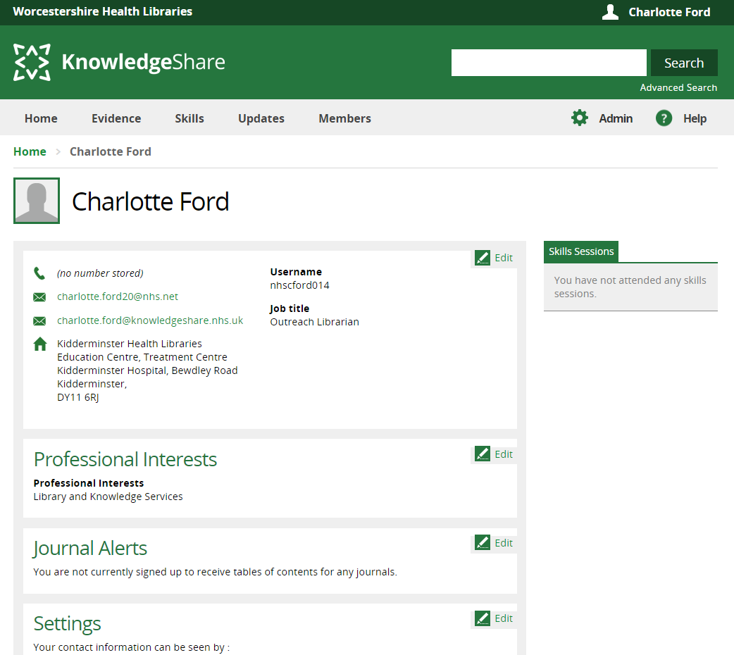

As you can see, there are several boxes and categories of information.
You can edit them by clicking on the Edit icons.

How to edit my Professional Interests
In our example below, you can see our user has got “Library and Knowledge Services” selected as a Professional Interest.

To edit this, we first need to click the Edit icon

After clicking the Edit icon, you can see all the options below:
Take some time to check all the options and preferences from the drop-down menus the top part of the screen covers your personal preferences, for example, how often you’d like to be e-mailed updates, who can see your interests and how did you hear about the service.
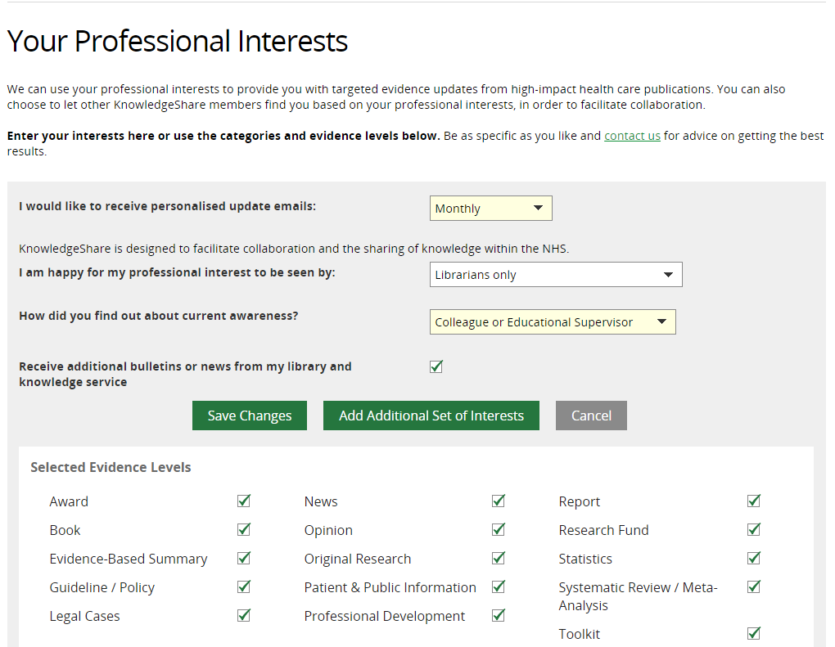

The bottom half of this screen covers your individual areas of interest:
This covers the specific categories of information you’d like to receive.
The user in this example is only interested in one professional interest ‘Library and Knowledge Services’.
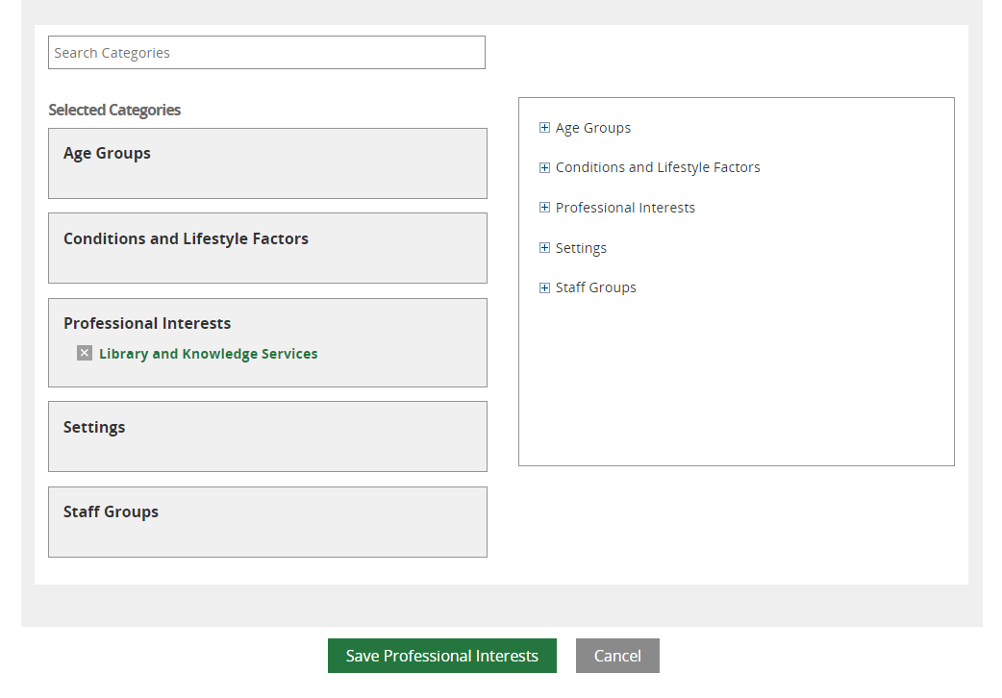
We can edit this section by clicking into each category box on the left side and selecting from the options on the right.
Let’s change what this person is interested in, we’re going to add a new category for this person and say they’re interested in receiving the latest information about ‘Anxiety’.

We first click the category ‘Conditions and Lifestyle Factors’ to reveal all the fields in that category.
You can now see that under ‘Long Term Conditions’, ‘Anxiety Disorders’ has appeared as one of the options and you can click on it to add it, if you are struggling to find an option, you can type in the Search Categories box to help you:
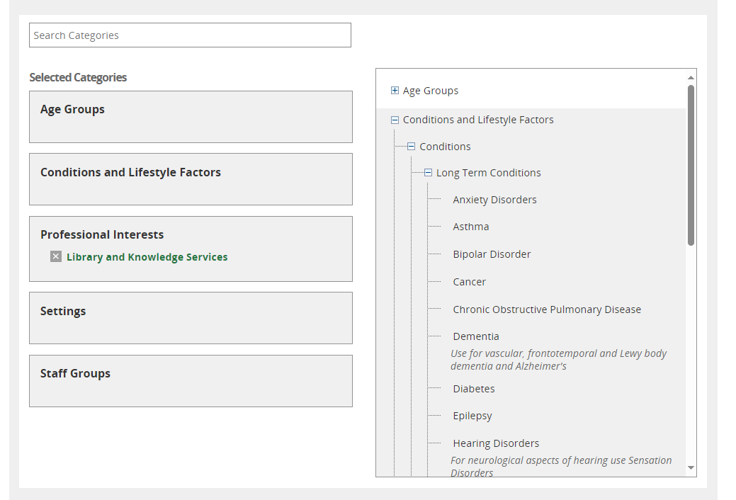

Now it’s been clicked, you can see below, ‘Anxiety Disorders’ has now been selected and appears in this person’s selected categories.
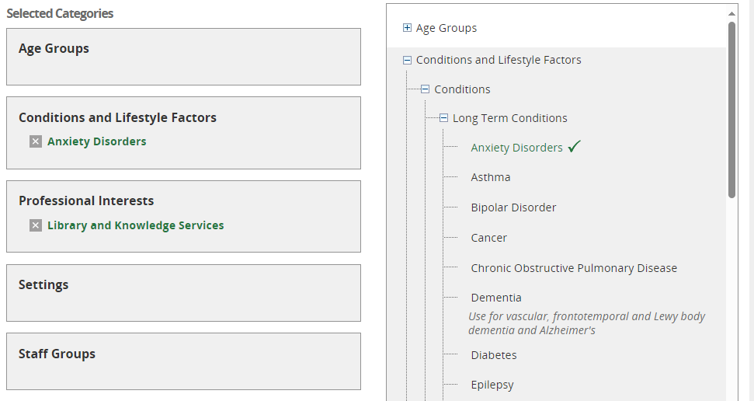
You can work your way through the various categories selecting the topics/options that are relevant to you and your work.
Once you are satisfied with your selections, you can save your changes by clicking ‘Save Professional Interests’.
As a bonus – under this button, you will see a sample of some of the resources that match with your category selection – this is a good indicator to check you’re on the right lines!
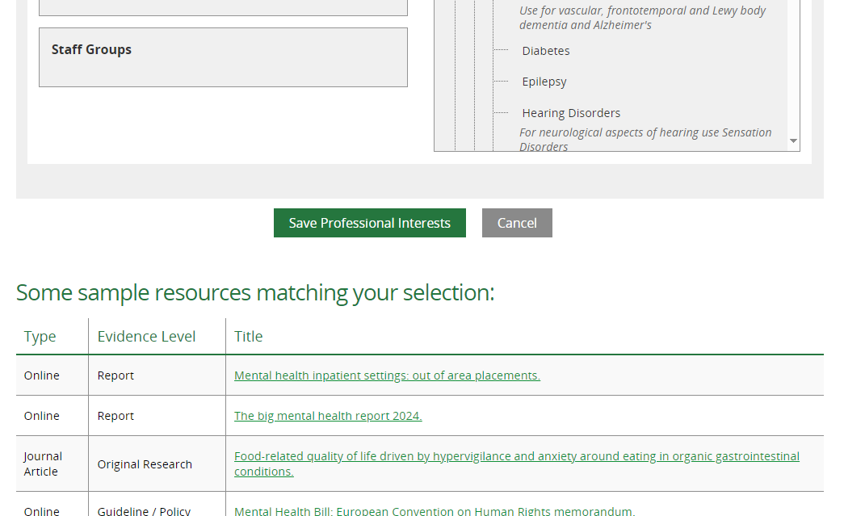

Need help?
If you are struggling at any point, please get in touch with the Knowledge Management Team (Library Services)
Our webpages: https://www.worcsacute.nhs.uk/worcestershire-health-libraries/knowledgeshare/
You can see our website guides, contact information and use our Live Chat for assistance.

