Organisation name | Worcestershire Acute Hospitals NHS Trust | Directorate | People and Culture
Library name | Knowledge & Library Service – Worcestershire Health Libraries | Completed by | David Chamberlain  KLS Manager
Email address | David.Chamberlain2@nhs.net | Date completed | 29th April 2024
Board member signature |  | Date signed

Worcestershire Acute Hospitals NHS Trust

Knowledge & Library Services Strategy

2024-2027

Strategy on a Page

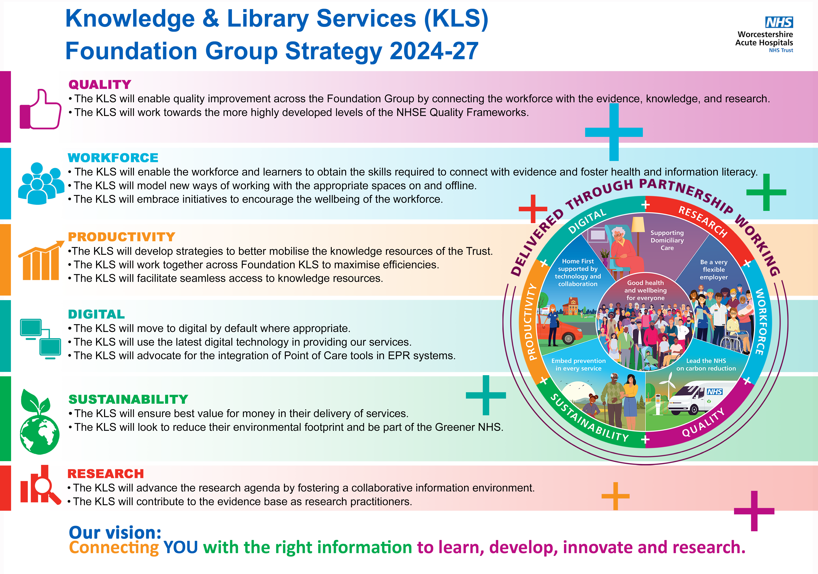

Purpose

The purpose of the Knowledge and Library Services (KLS) Strategy 2024-2027 is to define the service’s vision and ambitions, as well as to align the service to the organisation’s aims and objectives within the Worcestershire health economy. In addition, these will include regional and national strategic initiatives and link to the Foundation Group.

Once defined the KLS aims and ambitions will be outlined in a clear improvement plan with specific, measurable targets.

Trust background
Facts
In 2022/23, the Trust provided care to more than 250,000 different patients – that’s 40% of the Worcestershire population that received care at one of the hospitals.

The Trust employs over 7,000 people and over 130 volunteers. There is an annual turnover of nearly £600 million.

Our catchment population extends beyond Worcestershire itself, as patients are also attracted from neighbouring areas including South Birmingham, Warwickshire, Shropshire, Herefordshire, Gloucestershire and South Staffordshire. This results in a catchment population which varies between 420,000 and 800,000 depending on the service.

Foundation Group
In 2017, a ‘Foundation Group’ was created in partnership with South Warwickshire University NHS Foundation Trust (SWFT) and Wye Valley NHS Trust (WVT). In 2018, George Eliot Hospital NHS Trust (GEH) joined the Group.

The model has proven benefits for all the partner organisations and has been highlighted as best practice within national NHS guidance. In light of its success, the Group recognised the potential to extend their learning, and opportunities for sharing best practice between other organisations facing similar challenges. To support this, the Foundation Group created an Associate Membership option and in 2021 Worcestershire Acute Hospitals NHS Trust (WAHT) joined as an Associate Member. WAHT then became a full member in 2023.

Knowledge and Library Services Background

Current context
The Knowledge and Library Service is hosted by the Worcestershire Acute Hospitals NHS Trust within the People and Culture directorate. The KLS also provides full library services to the Herefordshire and Worcestershire Health and Care NHS Trust as well as to Worcestershire Commissioning Group. The KLS also runs a full Registration Authority service for the Acute Trust and runs Kidderminster Education Centre.

National and regional context
The NHS Knowledge & Library Services in England Policy was approved by the Health Education England Executive on the 29th November 2016. The policy sets out key objectives of enabling access to knowledge and evidence for healthcare decision makers.

https://library.nhs.uk/employer-leaders/nhs-library-and-knowledge-services-policy/accessible-nhs-knowledge-and-library-services-policy/

- Enabling all NHS workforce members to freely access knowledge and library services so that they can use the right knowledge and evidence to achieve excellent healthcare and health improvement.

- Developing NHS librarians and knowledge specialists to use their expertise to mobilise evidence obtained from research and organisational knowledge to underpin decision-making in the National Health Service in England

- Developing NHS knowledge and library services into a coherent national service that is proactive and focussed on the knowledge needs of the NHS and its workforce

Knowledge for Healthcare – A development framework outlines that healthcare knowledge and library services underpin all aspects of the NHS – supplying the evidence base to the service to make decisions on treatment options, patient care and safety, commissioning and policy, and to support lifelong learning, undertake research and to drive innovation.

https://www.hee.nhs.uk/our-work/knowledge-for-healthcare

Topol Review - Preparing the healthcare workforce to deliver the digital future. This is an independent report on behalf of the Secretary of State for Health and Social Care. As a result of the evolving health workforce it recommends health service leadership to integrate and adopt new technologies. Library & Knowledge Service is ideally placed to lead this innovational change and fully supports the recommendations.

https://topol.hee.nhs.uk/wp-content/uploads/HEE-Topol-Review-2019.pdf

Our Vision for Knowledge and Library Services

The Knowledge and Library Services’ vision is to provide evidence-based information at the point of need so clinical and non-clinical staff can improve patient care to the highest quality. We aim that the right information will be available to the right people in the right format at the right time. We believe that the effective management of knowledge and information is essential for the provision of the best patient care.

In addition, we aspire to support evidence-based decision making within the organisations we serve and aim to work with them to ensure effective and efficient patient care.

Our Key Objectives

Working with the KLS Foundation Group and incorporating the Foundation six objectives agreed by all the Foundation organisations the KLS has identified key aims within these objectives and linked the NHS England essential outcomes to these.

Quality

The KLS will enable quality improvement across the Foundation Group by connecting workforce with evidence, knowledge and research.
The KLS will work towards the more highly developed levels of the NHSE Quality Framework.
This dimension looks at the higher end of quality service for library users such as bespoke services direct to workplace and looks at the means to deliver this.

Outcome/ Indicator | Essential Indicators | Details of Developments, Good Practice or Innovation, and any challenges | Year
2.4 | Knowledge and library specialists provide evidence summaries for healthcare staff. | Quality and Improvement and sustainability bulletins to be sent monthly and other bulletins developed when staff in post | 1-3
2.5 | Knowledge and library specialists provide evidence summaries for healthcare staff. | This is not something we offer as part of a KLS and will have to train to do this – bulletins to resume once vacant posts filled | 2-3
3.2 | The knowledge and library services team use knowledge and evidence needs analysis and feedback from users to consider changes to services and/or resources. | There is a KLS bi-annual survey, training and LS impact, customer service feedback forms in library. Impact stories to be collected and regionally advertised. | 2-3
4.1 | The organisation ensures that the knowledge and library service is led and managed by a qualified and experienced knowledge specialist, librarian or knowledge manager. | Manager has Post graduate qualification and FCLIP certification with 23 years’ experience of working in health libraries. Further development to be identified in PDRs | 1-3
4.3 | Plans for service development and improvement incorporate a review of the capacity, strengths and skill gaps within the team. | Informal discussion at team meetings and pdrs. Discuss organisational structure and capacity with Director. | 1-3
Workforce

The KLS will enable the workforce and learners to obtain the skills required to connect with evidence and foster health and information literacy.
The KLS will model new ways of working with the appropriate working spaces on and offline.
The KLS will embrace initiatives to encourage the wellbeing of the workforce.

Outcome/ Indicator | Essential Indicators | Details of Developments, Good Practice or Innovation, and any challenges | Year
2.2 | Knowledge and library specialists provide evidence and literature search services for clinical staff. | Appoint to post Clinical and Outreach Librarian to develop from an ad hoc service | 1
2.3 | Knowledge and library specialists provide evidence and literature search services to non-clinical staff. | As above | 1
2.9 | Knowledge and library staff promote and deliver personalised alerting services from a range of sources. | Current “virtual book boxes” presented as web pages. Service to be promoted via Nursing, Midwifery and AHP Board. Specific subject alerts to be set up by new staff | 1-2
3.1 | The knowledge and library service is promoted to all staff and learners. | The KLS has an online present at inductions, communications is used to advertise resource of the month and other services. Routine presence on FY1 and FY2 inductions needs setting up | 1-3
3.5 | The knowledge and library services team work with the organisation to take a targeted and planned approach to marketing the service. | Regular KLS promotions sent to communication. Marketing policy to be written and research needed to identify further approaches | 2-3
4.3 | Plans for service development and improvement incorporate a review of the capacity, strengths and skill gaps within the team. | KLS Manager to discuss with new Director of P&C funding, staffing levels and capacity | 1

Productivity

The KLS will develop strategies to better mobilise the Knowledge resources of the Trust.
The KLS will work together across Foundation KLS to maximise the efficiencies.
The KLS will facilitate seamless access to knowledge resources.

Outcome/ Indicator | Essential Indicators | Details of Developments, Good Practice or Innovation, and any challenges | Year
1.1 | The organisation has identified a member of the Board or the Executive to engage with the knowledge and library services team to ensure that the needs of the organisation are met. | This needs to be re-established following the resignation of the previous Director of People and Culture. Previously bi-monthly and bi-annual slides were sent to Senior briefs for LKS Manager to present and to TME for Director to report | 1
1.3 | The organisation has an approved and documented strategy for the knowledge and library service that is aligned to the Knowledge for Healthcare strategy. | A new strategy has been developed with the Foundation Group for 2024-27 | 1
1.5 | The organisation ensures that there is an established identifiable budget to fund knowledge and library services staffing, services and resources for users. It is managed by the knowledge and library services manager. | There is an established pay and non-pay budget that the KL manager has access to and oversees | 1-3
1.6 | Delivery of the knowledge and library service Improvement Plan is regularly reviewed by the line manager and other senior staff with the knowledge and library service manager. | The improvement plan has been regularly discussed at team meetings and annual reviews. The plan needs to be discussed at board level | 1-3

Digital
The KLS will move to digital by default when appropriate.
The KLS will utilizing the latest digital technology in providing our services.
The KLS will advocate integration of PoC tools in EPR systems.

Outcome/ Indicator | Essential Indicators | Details of Developments, Good Practice or Innovation, and any challenges | Year
2.1 | The organisation and the knowledge and library services team advocate the use of clinical decision support tools. | Point of Care resources are purchased that supports clinical decision makings. Trust clinical policies and procedures are sent to the KLS Manager to review for the latest evidence. KLS training modules are aligned to Research core competences, | 1-3
 |  | Work with Near misses to be re-established once staff in post | 1-2
 |  | IT to embed POC into Sunrise EPR – need to evidence benefit for the project to be prioritized. | 1-2

Sustainability
The KLS will ensure best value for money in their delivery of services.
The KLS will look to reduce their environmental footprint and be part of the Greener NHS

Outcome/ Indicator | Essential Indicators | Details of Developments, Good Practice or Innovation, and any challenges | Year
Please note there is no reference to sustainability in the Improvement plan standards |  | All products to be reviewed for cost effectiveness using British Library loans as a base for cost | 1-3
 |  | Purchases are digital by default | 1-3
 |  | KLS signed up to Greener NHS | 1-3
 |  | KLS Manager active member of Sustainability in NHS Knowledge and Library Services | 1-3
 |  | KLS promotes its sustainability through Green Infographs | 1-3
Research

The KLS will advance the research strategy by fostering a collaborative information environment developing new knowledge.
The KLS will contribute to the evidence base as research practitioners.
.
Outcome/ Indicator | Essential Indicators | Details of Developments, Good Practice or Innovation, and any challenges | Year
5.4 | Developments and improvements of the knowledge and library service are informed by the evidence base. | Based on user survey and user feedback pods and self-service machines have been purchased as well as stock selection. Resources purchased on the evidence of usage. Training is delivered on the evidence-based principles and depends on the needs of the user. | 1-3
6.3 | The knowledge and library services team promote the service using evidence of impact that is analysed and reported. | Data collected but not actively advertised due to vacancies. Customer care team to front desk impact stories. | 1-3

Realising the Vision

There are three key components needed to realise the vision:
- Investment in KLS resources and the infrastructure to enable their management to the level indicated by NHS England.
- Successful restructuring of the KLS to refocus on key objectives.
- Effective leadership of the KLS.

Key Enablers

- Board support and endorsement.
- Clear Service Level Agreements and appropriate funding and staffing.
- IT support.
- Knowledge and Library Services expertise.
Roles and Responsibilities

The Trust Board will oversee the implementation of the strategy and be accountable for its delivery.

The Knowledge and Library Services manager will:
- Produce an annual improvement plan and annual report.
- Work to develop SLAs and KLS funding.
- Seek collaborative purchasing agreements and ensure value for money when selecting resources.
- Enhance external relationships with the public and academic sector.

The Library & Knowledge Service Team will:
- Focus on getting information into clinical teams and areas.
- Ensure staff have access to the knowledge base that provides right information at the right time.
- Work collaboratively with higher education and the public sector.
- Provide training to staff to utilise and maximise access to information at the point of care.

Governance

NHS England – annual statistics and bi-annual assessments including a current strategy, annual reports, and an improvement plan.
Monitoring and Compliance

- Annual report presented to People and Culture steering board.
- Comply with NHS England assessment.
- Comply with NHS England use and staff annual statistics.
- Performance Indicators set for literature searches.
- Impact surveys conducted quarterly.
- User surveys conduct bi-annually.
- Statistics collected from resources.

Summary

The Knowledge and Library Service plays a vital part in the delivery of evidence-based care for patients in Worcestershire and is committed to using the latest technology and resources to support clinicians and non-clinicians in decision making.

