
Worcestershire Royal Hospital
Charles Hastings Way
Newtown Road
Worcester
WR5 1DD
Tel No: 01905 760653 or 01527 512118

Department of Clinical Biochemistry

21.02.2024
Dear colleague,

Changes to requesting of protein electrophoresis/myeloma screen or monitoring

The new way to order Myeloma testing (including protein electrophoresis) is through Myeloma / MGUS Monitoring and Myeloma Screen test collections on ICE – available on GP Panel tab and profiles page:
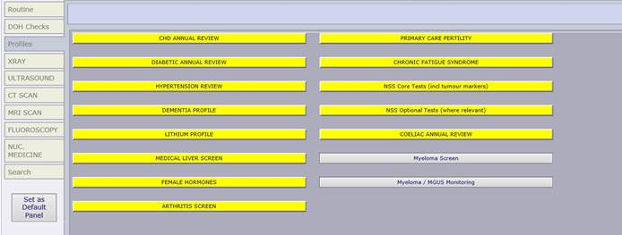

If you need to search for these profiles, please ensure that ‘Test Collections’ is selected on ICE:
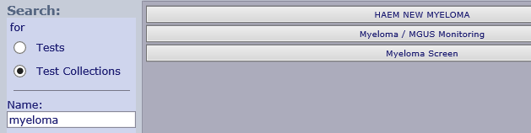
These test collections now contain: protein electrophoresis (PE), serum free light chains (SFLC), immunoglobulins (IGS), electrolytes and creatinine, bone profile, CRP and FBC. There is no need to order these tests separately.
If you hover over either of these collections the yellow ‘help text’ will indicate what they contain:
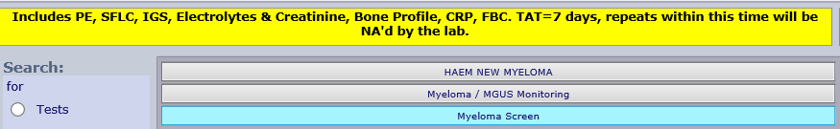

As stated in the yellow help box, the turnaround time for these tests are 7 days. If you request Myeloma / MGUS Monitoring within this time period, a box will pop-up informing you of the most recent results.
Please do not request again within 7 days unless the previous request had a sample issue preventing a result being obtained. Requests within 7 days where a previous result is available will be reported as a duplicate request.

Changes to Protein Electrophoresis and Serum Free Light Chain requesting

- ‘Protein Electrophoresis’ can no longer be requested on its own in primary care.
If you search for and select Protein Electrophoresis on ICE, you will be redirected to Myeloma / MGUS Monitoring and Myeloma Screen

- Serum Free Light Chains should not be requested on its own. If you select this, a pop-up will direct you towards the Myeloma / MGUS Monitoring and Myeloma Screen Test Collections:
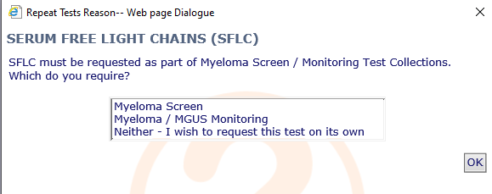

You will notice that it is still possible to request SFLC on its own – this is for use by Haematology only and should not be used in General Practice. Serum free light chain comments are being updated to reflect this.

Changes to reflex testing

Previously, protein electrophoresis may have been reflexed if immunoglobulins were requested. This will no longer be done. If PE is required, please select Myeloma Screen / Monitoring test collections on ICE.
Protein electrophoresis may still be reflexed if calculated globulin results are raised and the patient has not had a protein electrophoresis within the last year.

If you have any questions, please email wah-tr.duty-biochemist@nhs.net

Kind regards,


Louise Hawke

Consultant Clinical Scientist
Biochemistry, Pathology
Worcestershire Acute Hospitals NHS Trust

