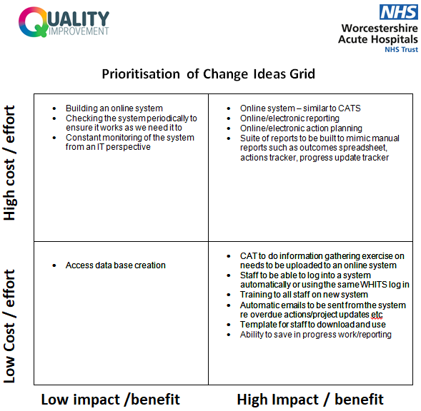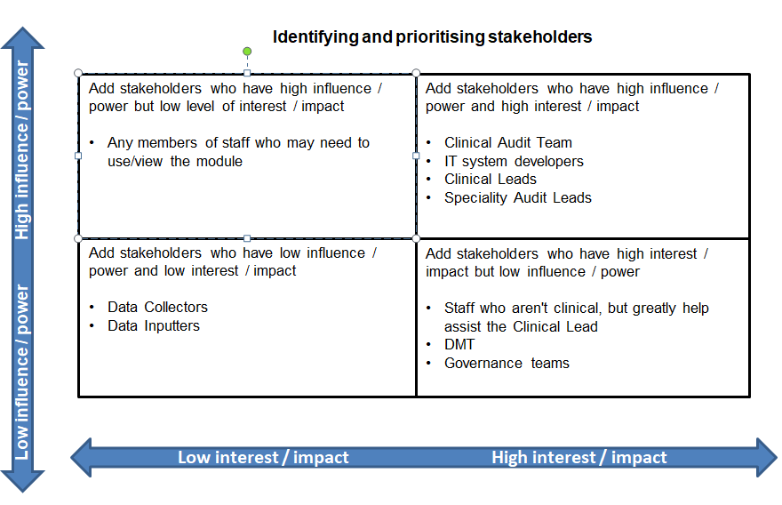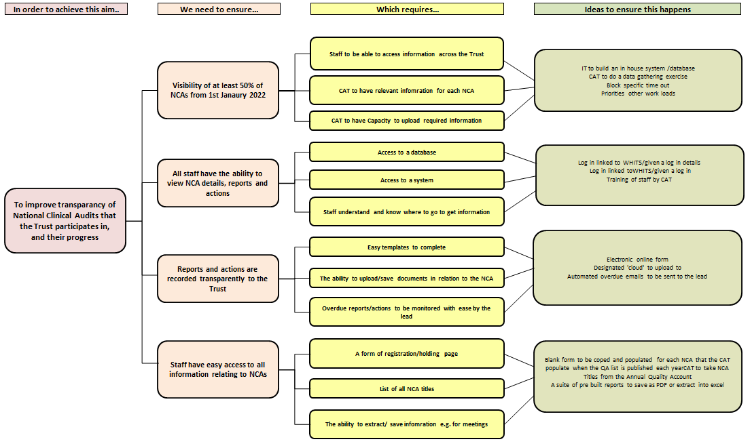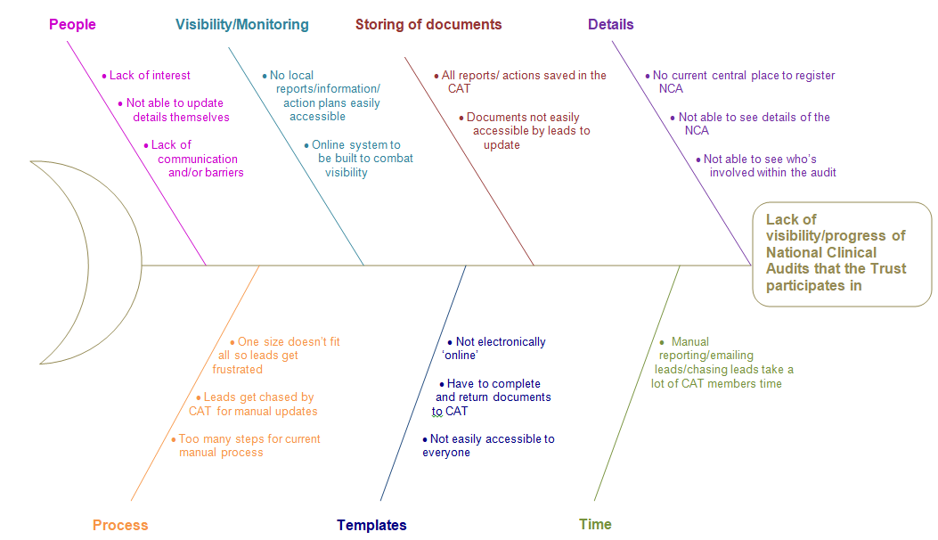 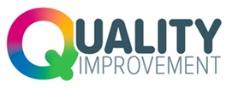

**Visibility of National Clinical Audits QIP**

**Jo Howden, Clinical Audit Manager, August 2021**

**Progress to date**

The route the project took was deemed to be a development of an online module that would sit alongside, and run in a similar way, to the current CATS module. To date, I have sought feedback from National Clinical Leads regarding their thoughts and ideas for the module and we are currently in our second round of PDSA cycle where we are reviewing what’s been amended from the 1st PDSA cycle and making any necessary changes to mimic our current manual process.

**Root Cause Analysis - Fishbone Diagram**

**QIP SMART Aim:**

Ensure that from the 1st January 2022 details of at least 50% of the national audits that WAHT is participating in, and associated action plans are recorded in such a way to greater improve transparency and easier access to information relating to national audits.