Stakeholders

Think about who needs to be involved in your improvement project and keep checking to ensure you are involving the right people. Identify groups of individuals (for example: ward nurses, IT department, procurement, finance, HR, Consultants, Ward clerks, Physios, Directorate Manager, Comms team, Matron) and where, appropriate name key individuals.

Ask yourself whether they have power / influence? Senior staff usually have influence.

Ask yourself whether they have interest in your project. Are they impacted? Will they benefit from it? Will they have to change what they do or how they do it?

Put the stakeholders in one of the boxes below.

Identifying and prioritising stakeholders
Low power / influence High power / influence
Fully engage with these stakeholders
Keep these stakeholders informed and satisfied with what you are doing

Keep these stakeholder informed
These stakeholders can be ignored if time is stretched

Low impact High impact

Developing Your Aims Statement

When you write your aims statement with your stakeholders, you should consider the following:
Specific | Don’t just say, “ We will improve patient safety”. Be specific about what element of your service you are going to improve. Site, ward, department.
Measurable | Include a numerical goal where possible.
Achievable | Is this something that is within the stakeholders control to achieve?
Relevant | Is it aligned to Trust strategic objectives?
Timescales | When do you expect to achieve the aim? A date is needed

Use the table below to prepare your full aims statement
What are you improving?

For whom?
By when?
By how much?
Full statement for approval by stakeholders. Try to get your aim into one sentence

The Problem / issue
is…………………….
Use the fishbones to identify the cause

Improvement Project overall aim:

Improvement measure description:
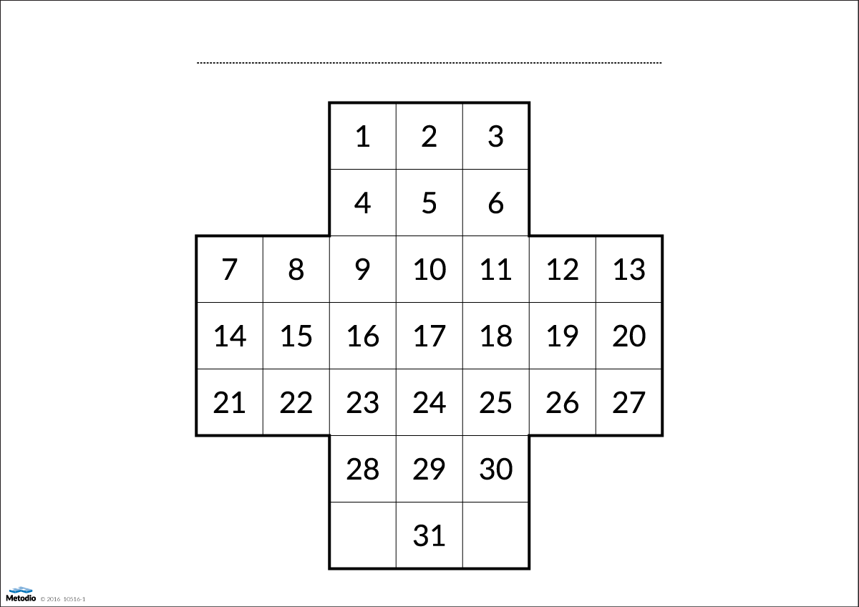

X | ………
X | ………
Please complete daily. Place one cross in each box for each day of the month.

Green cross if ……………………

Red cross if …………...

Prioritising Change Ideas Grid

Low Cost / effort High cost / effort

Low impact on aim High Impact on aim

Are you thinking creatively? Use thinking creatively tools help to generate ideas for change:
Brainstorming – remember; no criticism, go for quantity, encourage wild ideas, build of ideas of others, one conversation at a time. Have you helped people think out of the box by using the “inheriting tyres” activity?
Fresh eyes – think like another person, invite someone from outside your team to generate ideas, see how industry / others are solving the problem. What about the patient’s voice?
Breaking the rules – identify underlying rules (even if unwritten) and then deliberately think around them to create new ideas. What if there were no rules?
Random word, picture, object – a random word etc. will activate thoughts that we do not usually associate with the problem and therefore gives possibility of new ideas. What random words did you use with the team?
That’s Impossible – what was previously impossible may be possible now or some of the time? What’s possible?

Driver Diagram - a one page summary of your change plan. Do all ideas link back to your aim?
Aim | Primary Drivers | Secondary Drivers | Change Ideas

Multidisciplinary Team

PDSA Cycle Template Source: Adapted with permission from the Institute for Healthcare Improvement (www.IHI.org).
Plan  - What is the objective of the test?  - What do you predict will happen and why?  - What change will you make?  - Who will it involve (e.g. one unit, one floor, one department)?  - How long will the change take to implement?  - What resources will they need?  - What data need to be collected? | List your action steps along with person(s) responsible and time line
Do  - Implement the change. Try out the test on a small scale.  - Carry out the test.  - Document problems and unexpected observations.  - Begin analysis of the data. | Describe what actually happened when you ran the test
Study  Set aside time to analyze the data and study the results and determine if the change resulted in the expected outcome.  - Complete the analysis of the data.  - Compare the data to your predictions.  - Summarize and reflect on what was learned. Look for: unintended consequences, surprises, successes, failures. | Describe the measured results and how they compared to the predictions
Act  If the results were not what you wanted you try something else Refine the change, based on what was learned from the test.  - Adapt – modify the changes and repeat PDSA cycle  - Adopt – consider expanding the changes in your organization to additional residents, staff, units  - Abandon – change your approach and repeat PDSA cycle | Describe what modifications to the plan will be made for the next cycle from what you learned

