QWaht…Chat…
Spring Ed. No.1 April 2019
Join the QI Movement @qualitywaht

Spring Edition No. 1 April 2019

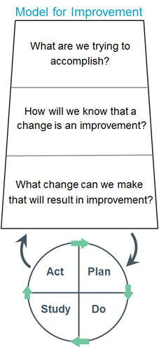
QI PROJECTS OF THE MONTH: PATH2PLATINUM: LOOK OUT FOR YOUR SILVER TRAINING DATES
We were delighted to have launched your new QI faculty this month,
along with tier one of your QI program of education and training: Bronze introduction to QI. The first 2 weeks of April saw over 100 staff: of various roles and responsibilities being introduced to or taking the benefit of being refreshed in the use of QI tools when embarking on a QI project. The Improvement team received helpful feedback that each attendee took away new skills and knowledge; and left feeling better informed of how to apply the Model for Improvement. The next set of training dates are on the intranet site …don’t miss out…on Dotmocracy …

Go and visit the Faculty on the Trust Intranet:https://www.worcsacute.nhs.uk/quality-improvement and let us know what you would like to see: wah-tr.qiteam@nhs.net
Over time all YOUR QI Projects will be presented as a Poster showcased on the site for shared learning: the 1st to go live is Emma Davies (Alcohol Liaison Nurse) and her CQUIN QI Project that saw an improvement in inpatient alcohol screening as a result of using QI PDSA cycles.
We look forward to seeing you, hearing from you, supporting you and facilitating
you through your changes for Improvement: join the conversation on twitter @qualitywaht:
make us the best we can be with the patient at the heart of everything that we do #betterneverstops.

.
TAKE A PEEK AND SPRING #4WARD INTO YOUR 1ST qi pROJECT

"I begin with an idea and then it becomes something else" Pablo Picasso... everything begins with an idea.
The transformation of Healthcare is described with just two words: Quality Improvement. There are many definitions of Quality Improvement, but ultimately it is about making healthcare safe, effective, patient-centered, timely, efficient and equitable. Through the combined and unceasing efforts of everyone we can make changes that will lead to better care and better patient experiences for the people of Worcestershire.
" One's mind, once stretched by a new idea, never regains its original dimensions." Oliver Wendell Holmes

