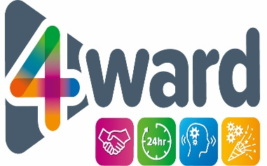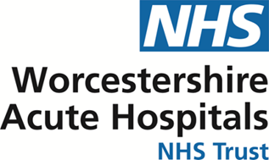

INFECTION PREVENTION & CONTROL: ANNUAL REPORT 2020-2021

SUMMARY

We are pleased to present our annual infection prevention and control report for 2020-21. The continuing pandemic has emphasised the importance of good infection prevention practices as part of everything we do across the NHS.
The year has been dominated by the COVID-19 pandemic, and our annual report reflects this. Our focus on hand hygiene, cleanliness and other hygiene measures has continued during the year to ensure that people are receiving safe and effective care from us. Some of our programmes of work had to be paused in order to ensure we focussed all the resources needed to respond to the second wave of the pandemic, especially between October 2020 and February 2021. Since March 2021 we have re-focussed upon our wider infection prevention work programme.
We remain committed to ensuring that we achieve very high standards of infection prevention practice. The Trust Board views this as a priority for our patients as part of our commitment to Putting Patients First. The Quality Governance Committee continued to scrutinise our infection prevention progress at each meeting on behalf of the Board throughout 2020-21.
This annual report follows the format of the Code of Practice (known as the Hygiene Code 2015), as required by the Health & Social Care Act (2008), and demonstrates our compliance with the requirements of the Hygiene Code.
During 2020-21 a COVID-19 Board Assurance Framework was issued by NHS England/Improvement. This is set out using the Hygiene Code framework, and this annual report also provides assurance of compliance with this framework.
Many of the control measures required to prevent the spread of COVID-19 build upon existing infection prevention practices. Therefore the measures we have taken during 2020-21 to prevent spread of COVID-19 have also been improvements which will help us to prevent the spread of other infections as we move forward next year.
Finally, the report sets out our priorities and plans to achieve further improvement and reductions in infection during 2021-22 as we continue to manage and move beyond the challenge of the COVID-19 pandemic.

