Introducing the
NHS Knowledge and Library Hub
Your URL:
https://search.ebscohost.com/login.aspx?authtype=guest&custid=ns199947&groupid=main&profile=hee_eds
Search journal articles, e- books, guidelines and clinical decision tools, all in one place.
Go directly to full text, as an immediate download or on request from an NHS library.
Avoid the less-reliable sources you might find in a general web search.

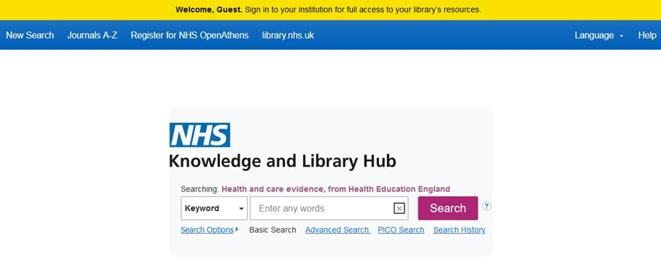
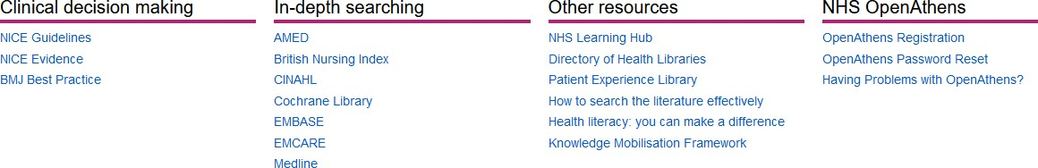
Click the text on the yellow bar to log in with your NHS OpenAthens account.
This lets you see the full text of all the resources NHS libraries buy for you.

Type your search words in the box and click Search. You can search for a topic, a journal article or a book or journal title.

You will see results which contain all your search words.
The search options let you choose alternative ways to search.

Go directly to other resources when you know what you need.
Do a detailed search or explore a specific resource from the links below the search box.

Change your search
- Add or remove search words in the search box.
- See your Search History
to combine results of 3
different searches.
- Alter the search options under Current Search.
- Add limits to narrow your 4
results by date, type or other options.

10 12
1
Manage your results 10 Sign In to save your
results and searches.
- Add a result to the Folder by clicking the folder icon
- Open the Folder to see saved items, print or export results, and share folders with other searchers.
- Create Alert will let you know when new articles match your search.
- Share lets you quickly add results to the folder or create alerts.
13
2

5 6 14

7 11

8

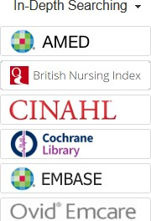
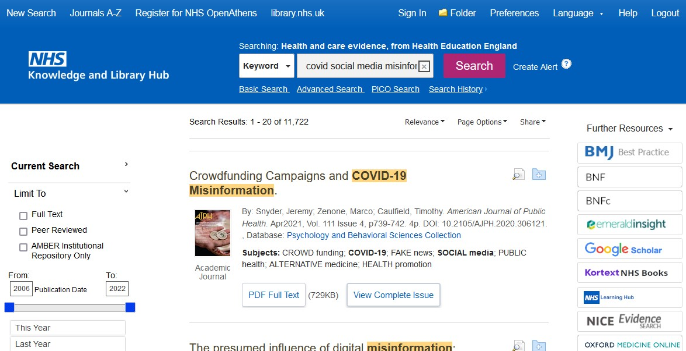
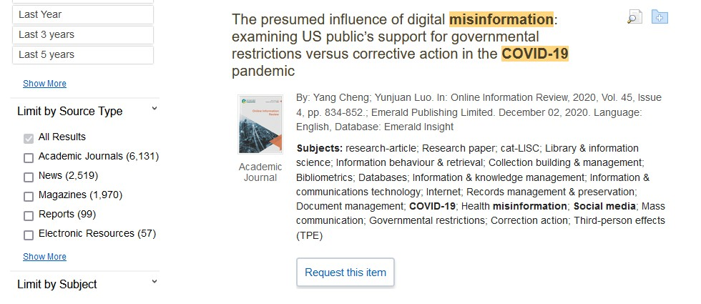
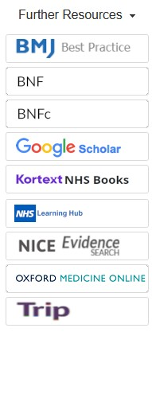

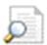
15
View your results
- Click Relevance to sort your results by date.
- Page Options lets you change the layout and increase the number of results displayed.
7 The detail icon
on
each result shows you more information.

9
Continue your search 15 Choose any of the
buttons in the righthand column to open a new search in another database or search tool.

Get the full text
  - Clicking Get PDF, PDF Full Text or Access Online
will take you to an online copy you can download.
  - Clicking Request this item will open a request form to send to your library.

Questions? Contact [your library details]

