

**Introducing the**

**NHS Knowledge and Library Hub**

**Your URL: https://search.ebscohost.com/login.aspx?authtype=guest&custid=ns237210&groupid=main&profile=hee_eds**

****

Search journal articles, e-books, guidelines and clinical decision tools, **all in one place**.

**Go directly to full text**, as an immediate download or on request from an NHS library.

**Avoid the less-reliable sources** you might find in a general web search.

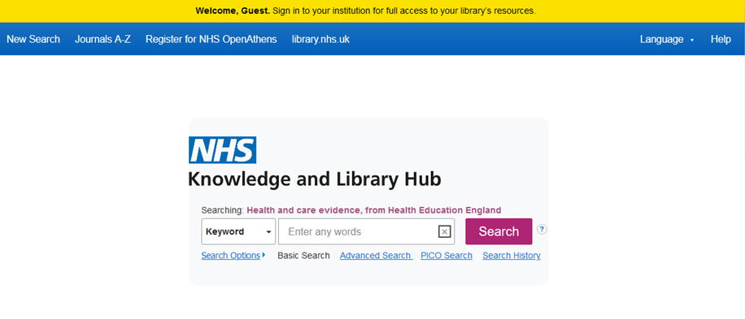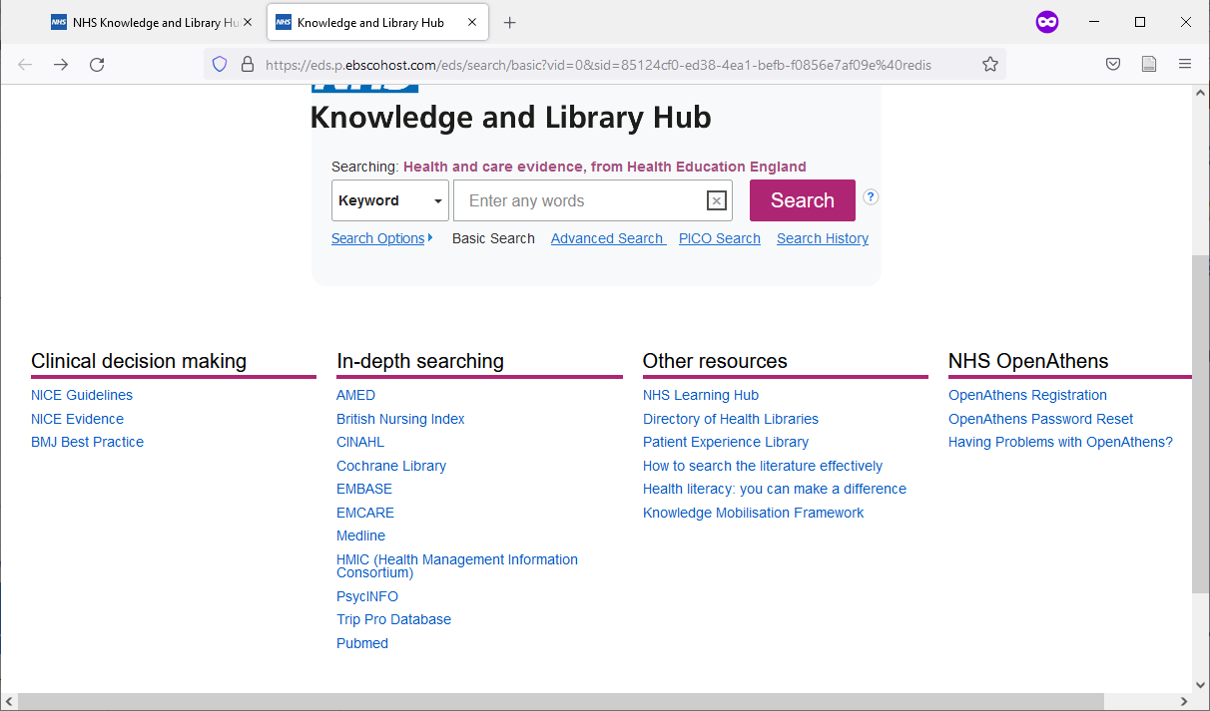

**You will see results which contain all your   
search words.**   
The search options let you choose alternative ways   
to search.

**Click the text on the yellow bar to log in   
with your NHS OpenAthens account.**  
This lets you see the full text of all the resources NHS libraries buy for you.

**Type your search words in the box and click Search.**You can search for a topic, a journal article or a book or journal title.

**Go directly to other resources when you   
know what you need.**   
Do a detailed search or explore a specific resource from the links below the search box.

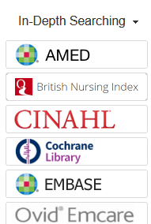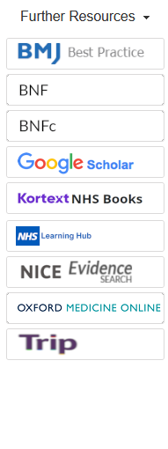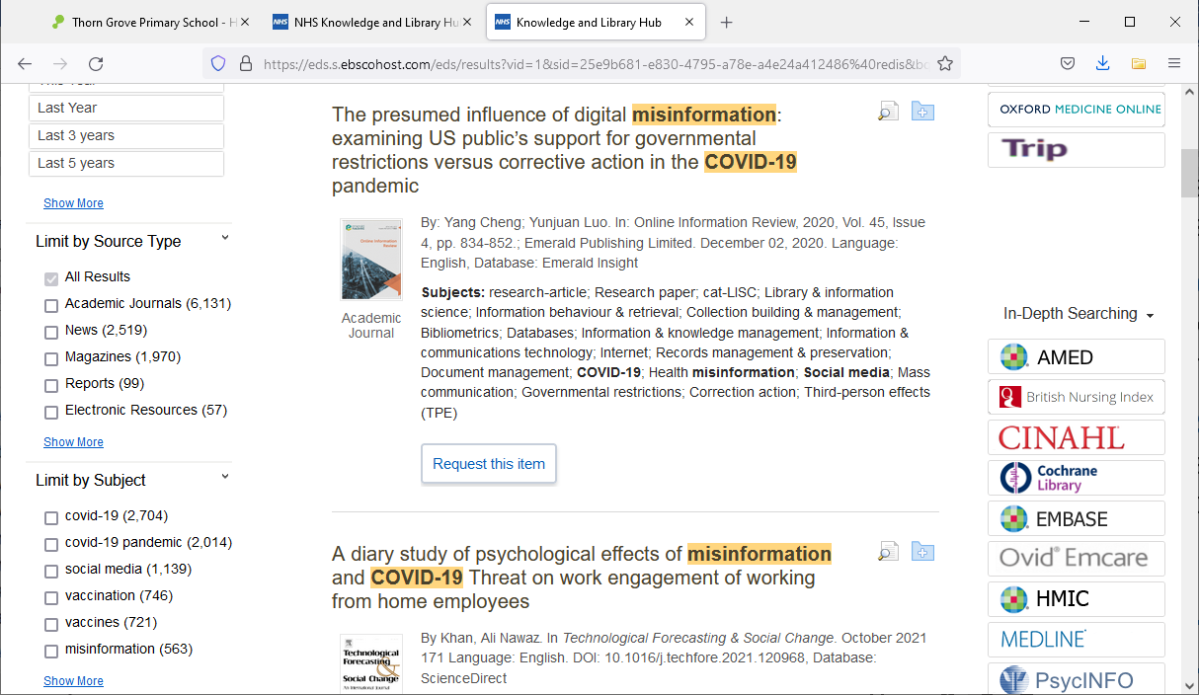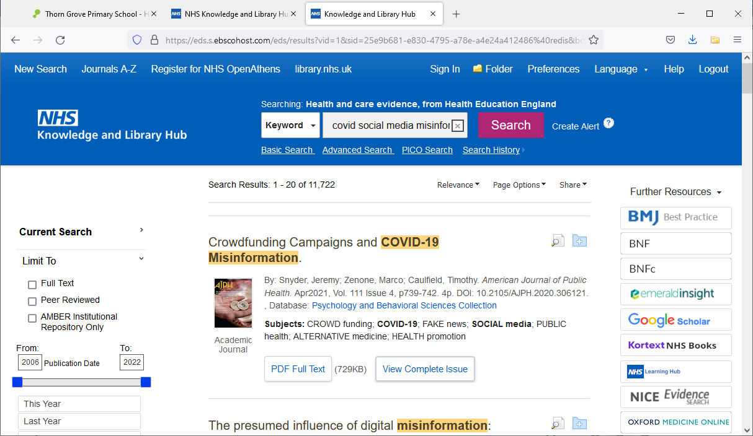

**15**

**9**

**8**

**Get the full text**

**8** Clicking **Get PDF**, **PDF Full Text** or **Access Online** will take you to an online copy you can download.

**9** Clicking **Request this item** will open a request form to send to your library.

Questions? Contact [your library details]

**View your results**

**5** Click **Relevance** to sort your results by date.

**6 Page Options** lets you change the layout and increase the number of results displayed.

**7** The **detail** icon  on each result shows you more information.

**Change your search**

**1** Add or remove search words in the **search box**.

**2** See your **Search History** to combine results of different searches.

**3** Alter the search options under **Current Search**.

**4** Add **limits** to narrow your results by date, type or other options.

**Manage your results**

**10 Sign In** to save your results and searches.

**11 Add a result** to the Folder by clicking the folder icon

**12** Open the **Folder** to see saved items, print or export results, and share folders with other searchers.

**13 Create Alert** will let you know when new articles match your search.

**14 Share** lets you quickly add results to the folder or create alerts.



**Continue your search**

**15** Choose any of the buttons in the righthand column to open a new search in another database or search tool.

**7**

**1**

**2**

**4**

**3**

**11**

**10**

**13**

**14**

**12**

**5**

**6**