Academic Writing

What Is Academic Writing?

A particular writing style used in assessed work (University of Cumbria, 2019):
  - Logical structure.
  - Formal language.
  - Statements supported by evidence.

Structure

Based on a ‘rule of three’ (Peck & Coyle, 2012):
  - Introduction:
    - Gives a brief outline of the subject.
  - Discussion:
    - Develops points and arguments.
  - Conclusion:
    - Draws conclusions from the discussion.

Benefits of a logical structure (Peck & Coyle, 2012):
  - Allows the reader to follow the written work.
  - Helps you to follow logical steps in forming your ideas.

Structure: Real-world example

Title:
The importance of hygiene

Introduction:
The risk of infection needs to be kept at a minimum in healthcare settings – as infection can lead to negative health outcomes. One way of avoiding this is through the use of sound hygiene practices.

Discussion:
These practices can reduce the risk of infection by eliminating the presence and transfer of microbes – but only when based on appropriate evidence, and followed consistently by all relevant staff .

Conclusion:
Hygiene practices that are properly implemented can contribute towards reducing the risk of infection.

Language

Language refers to the tone and vocabulary used (Peck & Coyle, 2012):
  - Informal language can trivialise your point.
  - Write objectively and not subjectively.

What to avoid (Walden University, 2019):
  - Broad generalisations (e.g. ‘always’ and ‘never’).
  - Adverbs (e.g. ‘clearly’ and ‘really’).
  - Emotional language (e.g. “it is heart breaking that so many are starving”).
  - Slang (e.g. “their research was so cool”).

Language: Real-world example

Informal (Walden University, 2019):
  - When I got my students to think that science was wicked cool, their test scores went through the roof!

Formal (Walden University, 2019):
  - When I was able to engage with my students and get them interested in science, their test scores improved significantly.

Library Support and Resources

Relevant library resources accessible via www.wkp.nhs.net:
  - Includes access to an academic writing reading list:
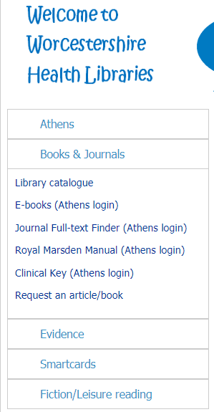
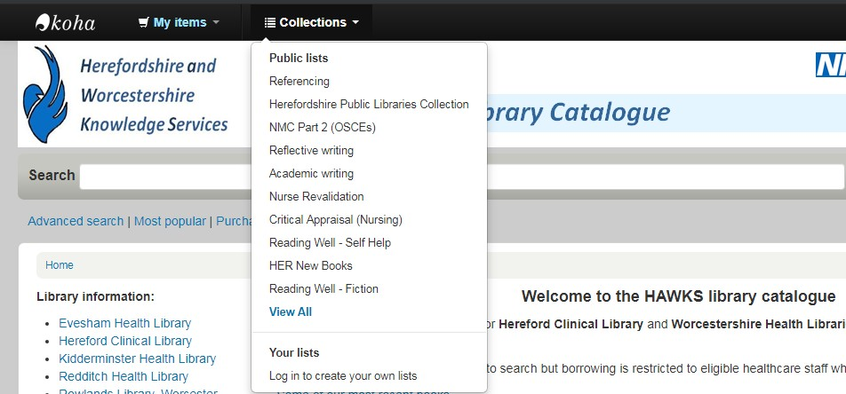

External Resources

University of Cumbria (2019):
  - Structure.
  - Developing a coherent flow.
  - Tips on editing and proof-reading.

University of Worcester (2019):
  - Step-by-step guide.
  - Academic language.
  - Additional external resources.

*Web-links available at the end of this presentation

Contact Us

- Visit us (09:00 – 16:00):
  - Kidderminster Health Library.
  - Rowlands Health Library (Worcester).
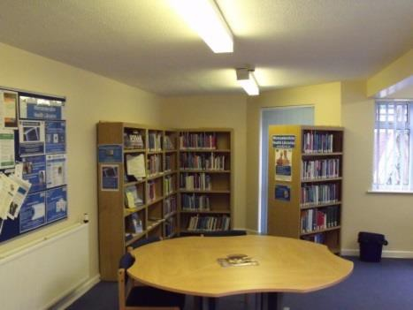
  - Redditch Health Library.

- Online:
  - www.wkp.nhs.uk

- Twitter:
  - @worcshealthlib

Conclusions

Academic writing:
  - Employing a three-part structure.
  - Writing formally.

Support from the library team and service:
  - Topic-specific reading lists.
  - Further 1-to-1 training.

References

- University of Cumbria. (2019). Writing at University. Retrieved from https://my.cumbria.ac.uk/Student-Life/Learning/Skills-Cumbria/Academic-Writing/

- Peck, J., & Coyle, M. (2012). The student's guide to writing. Basingstoke: Palgrave
Macmillan.

- University of Worcester. (2019). Academic Writing. Retrieved from: https://www2.worc.ac.uk/studyskills/727.htm

- Walden University. (2019). Scholarly voice: Tone. Retrieved from:
https://academicguides.waldenu.edu/writingcenter/scholarlyvoice/tone

