Reading Together
A poetry reading group

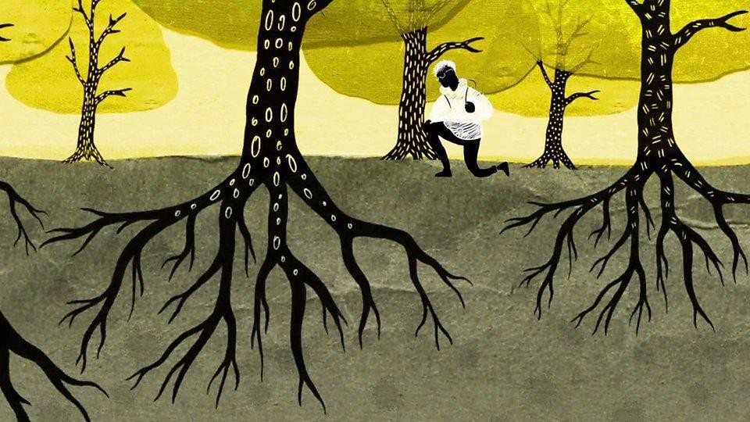

Designed by David Chamberlain October 2019

Contents

Introduction

Halloween/ Ghosts 31/10

- I felt a funeral
- The ghost
- The ghosts are walking again
- The listeners
- All Hallows Eve
- The hour and the ghost
- Alone War poems 7/11
- In Flanders fields
- Not to keep
- We lived happily during the war
- The evacuee
- Now to be still and rest
- Joining the colours Autumn 14/11
- A slash of blue
- To autumn
- Your dresses
- Autumn
- To Autumn
- Fall leaves fall
- Autumn fires Time 21/11
- A time to talk
- Things men have made
- Time
- Everything changes
- I had no time to hate
- The road not taken
- Time: real and imaginary

Childhood 28/11

- My heart leaps up
- I remember, I remember
- It was long ago
- Walking away
- Second childhood
- I remember I remember (Larkin) Love 5/12
- Love and friendship
- Twilight night
- Meeting at night
- Let me not – Sonnet 116
- How Do I Love Thee?
- Touched by an angel
- Habitation Water 12/12
- Maggie and Milly and Molly and May
- Sea fever
- The lake Isle of Innisfree
- Dover beach
- Going for water
- All day I hear the noise of waters
- With ships the sea was sprinkled Christmas 19/12
- Christmas bells
- Ring out, wild bells
- The oxen
- Mistletoe
- Good will to man – now give us your money
- Twas the night before Christmas
- Before the ice is in the pools

New beginnings 9/1

- To The origins of birds
- Up hill
- Caged bird
- Blossom
- Do not go gently into that good night
- Sonnet 29
- I am Winter 16/1
- Stopping by the woods
- Those winter Sundays
- The cold earth slept below
- The Darkling Thrush
- Horses
- Winter song
- A winter night

Introduction

Bibliotherapy is the beneficial act of reading together in a group. There are many archetypes and themes we all share as we experience life. Reading together has been shown to have a therapeutic effect.
In the light of this Nursing and Library staff have worked together to set up a reading group for an in-patient ward.
There will be 10 x 1 hour sessions based on 10 themes.

There will be two staff members (including a Librarian) at each meeting. Attendees are encouraged to stay for the session but an open group policy is adopted.
Time is flexible – but the session will last an hour at its longest.

Initially staff will read a poem and open the group to discuss using the following structure:
- what is happening in the text (in terms of themes, descriptions, language)
– “What was the poem about?”

- what may be happening within themselves as individuals (in terms of reflection about personal experiences, feelings and thoughts) –
- “Did you like it?”

Reading aloud and open ended discussion is encouraged.

Support is available after the meeting if anyone would wish to discuss any issues the session raises.

Halloween and Ghosts
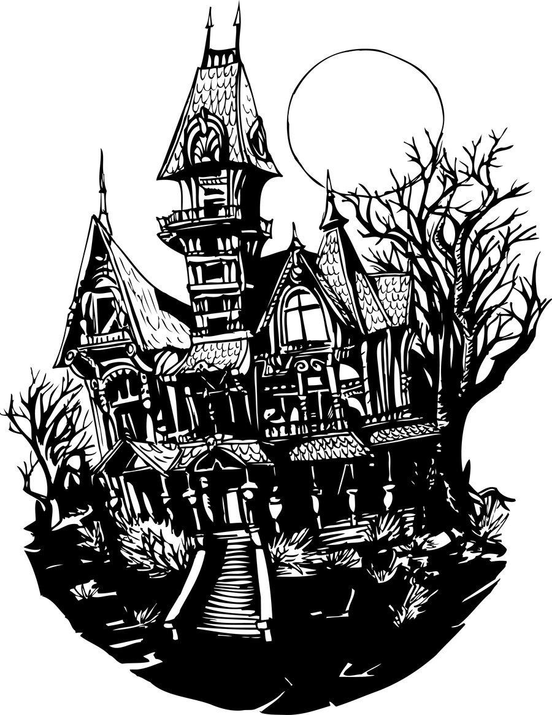

I felt a Funeral, in my Brain by Emily Dickinson

I felt a Funeral, in my Brain, And Mourners to and fro
Kept treading - treading - till it seemed That Sense was breaking through -

And when they all were seated, A Service, like a Drum -
Kept beating - beating - till I thought My mind was going numb -

And then I heard them lift a Box And creak across my Soul
With those same Boots of Lead, again, Then Space - began to toll,

As all the Heavens were a Bell, And Being, but an Ear,
And I, and Silence, some strange Race, Wrecked, solitary, here -

And then a Plank in Reason, broke, And I dropped down, and down - And hit a World, at every plunge, And Finished knowing - then -

The Ghost by Sara Teasdale

I went back to the clanging city,

I went back where my old loves stayed,

But my heart was full of my new love's glory, My eyes were laughing and unafraid.

I met one who had loved me madly And told his love for all to hear --
But we talked of a thousand things together, The past was buried too deep to fear.

I met the other, whose love was given With never a kiss and scarcely a word -- Oh, it was then the terror took me
Of words unuttered that breathed and stirred.

Oh, love that lives its life with laughter Or love that lives its life with tears
Can die -- but love that is never spoken

Goes like a ghost through the winding years.

I went back to the clanging city,

I went back where my old loves stayed, My heart was full of my new love's glory, -- But my eyes were suddenly afraid.

The ghosts are walking again by Susan Williams

the ghosts are walking again

walking and talking in the night again sorrow is eating my bones again

the fog is creeping again

creeping and seeping through the cracks again fear is fracturing my bones again

the shadows are whispering again whispering and weeping by my bed again despair is sundering my bones again

the ghosts are walking again the fog is creeping again
the shadows are whispering again

..............and I?

..............I'm feeling like dust again

..............the unknown is leaching the marrow out of my bones again

The Listeners by Walter De La Mare

‘Is there anybody there?’ said the Traveller, Knocking on the moonlit door;
And his horse in the silence champed the grasses Of the forest’s ferny floor:
And a bird flew up out of the turret, Above the Traveller’s head:
And he smote upon the door again a second time; ‘Is there anybody there?’ he said.
But no one descended to the Traveller; No head from the leaf-fringed sill
Leaned over and looked into his grey eyes, Where he stood perplexed and still.
But only a host of phantom listeners That dwelt in the lone house then
Stood listening in the quiet of the moonlight To that voice from the world of men:
Stood thronging the faint moonbeams on the dark stair, That goes down to the empty hall,
Hearkening in an air stirred and shaken By the lonely Traveller’s call.
And he felt in his heart their strangeness,

Their stillness answering his cry,

While his horse moved, cropping the dark turf, ’Neath the starred and leafy sky;
For he suddenly smote on the door, even Louder, and lifted his head:—
‘Tell them I came, and no one answered, That I kept my word,’ he said.
Never the least stir made the listeners, Though every word he spake
Fell echoing through the shadowiness of the still house From the one man left awake:
Ay, they heard his foot upon the stirrup, And the sound of iron on stone,
And how the silence surged softly backward, When the plunging hoofs were gone.

All Hallows Eve by Michael R. Burch

In the ruins

of the dreams and the schemes of men;

when the moon begets the tide and the wide sea sighs;

when a star appears in heaven and the raven cries;

we will dance and we will revel in the devil’s
fen ...

if nevermore again.

The Hour and the Ghost by Christina Rossetti - 1830-1894

O love, love, hold me fast,

He draws me away from thee; I cannot stem the blast,
Nor the cold strong sea:

Far away a light shines Beyond the hills and pines; It is lit for me.

Bridegroom

I have thee close, my dear, No terror can come near;
Only far off the northern light shines clear.

Ghost

Come with me, fair and false, To our home, come home.
It is my voice that calls:

Once thou wast not afraid When I woo’d, and said,
‘Come, our nest is newly made’— Now cross the tossing foam.

Bride

Hold me one moment longer! He taunts me with the past, His clutch is waxing stronger;

Hold me fast, hold me fast. He draws me from thy heart, And I cannot withhold:
He bids my spirit depart With him into the cold:— Oh bitter vows of old!

Bridegroom

Lean on me, hide thine eyes: Only ourselves, earth and skies, Are present here: be wise.

Ghost

Lean on me, come away, I will guide and steady:
Come, for I will not stay:

Come, for house and bed are ready. Ah sure bed and house,
For better and worse, for life and death, Goal won with shortened breath!
Come, crown our vows.

Bride

One moment, one more word, While my heart beats still, While my breath is stirred
By my fainting will.

O friend, forsake me not, Forget not as I forgot:
But keep thy heart for me, Keep thy faith true and bright;
Through the lone cold winter night Perhaps I may come to thee.

Bridegroom

Nay peace, my darling, peace:

Let these dreams and terrors cease:

Who spoke of death or change or aught but ease?

Ghost O fair frail sin,
O poor harvest gathered in! Thou shalt visit him again
To watch his heart grow cold: To know the gnawing pain
I knew of old;

To see one much more fair Fill up the vacant chair,
Fill his heart, his children bear; While thou and I together,
In the outcast weather, Toss and howl and spin.

Alone by Edgar Alan Poe

From childhood's hour I have not been As others were; I have not seen
As others saw; I could not bring

My passions from a common spring. From the same source I have not taken My sorrow; I could not awaken
My heart to joy at the same tone; And all I loved, I loved alone.
Then—in my childhood, in the dawn Of a most stormy life—was drawn From every depth of good and ill The mystery which binds me still: From the torrent, or the fountain, From the red cliff of the mountain, From the sun that round me rolled In its autumn tint of gold,
From the lightning in the sky As it passed me flying by,
From the thunder and the storm, And the cloud that took the form (When the rest of Heaven was blue) Of a demon in my view.

War

In Flanders Fields by John McCrae

In Flanders fields the poppies blow Between the crosses, row on row, That mark our place; and in the sky The larks, still bravely singing, fly Scarce heard amid the guns below.

We are the Dead. Short days ago

We lived, felt dawn, saw sunset glow, Loved and were loved, and now we lie In Flanders fields.

Take up our quarrel with the foe: To you from failing hands we throw The torch; be yours to hold it high. If ye break faith with us who die
We shall not sleep, though poppies grow In Flanders fields.

Not to Keep by Robert Frost

They sent him back to her. The letter came Saying... And she could have him. And before She could be sure there was no hidden ill Under the formal writing, he was in her sight, Living. They gave him back to her alive—
How else? They are not known to send the dead— And not disfigured visibly. His face?
His hands? She had to look, and ask, “What was it, dear?” And she had given all
And still she had all—they had—they the lucky! Wasn’t she glad now? Everything seemed won, And all the rest for them permissible ease.
She had to ask, “What was it, dear?”

“Enough,

Yet not enough. A bullet through and through, High in the breast. Nothing but what good care And medicine and rest, and you a week,
Can cure me of to go again.” The same Grim giving to do over for them both.
She dared no more than ask him with her eyes How was it with him for a second trial.
And with his eyes he asked her not to ask.

They had given him back to her, but not to keep.

We Lived Happily During the War by Ilya Kaminsky

And when they bombed other people’s houses, we protested
but not enough, we opposed them but not

enough. I was

in my bed, around my bed America

was falling: invisible house by invisible house by invisible house.

I took a chair outside and watched the sun.

In the sixth month

of a disastrous reign in the house of money

in the street of money in the city of money in the country of money, our great country of money, we (forgive us)

lived happily during the war.

The Evacuee by Arthur E. King

Can I come home now? Can I come home now?
Can I come home now mum? Can I come home now?
I went to the school house
A change of clothes in a sack. We then walked to the station But we didn't come back.
We got on to a train It headed due south. We got off the train
At a little town called Louth. The war it won't last long You'll soon be back home.
But it seems like for ever
I must be brave and not moan. You can't come back home yet The planes they still fly,
The bombs they still fall, and the danger's still nigh. You'll have to be patient. One day you'll come home. When the war it is over And we're all free to roam. They say I am safer here Than where I've left behind
And the people looking after me Are warm, good and kind.
But home is where the heart is, and home is with you.
Is it time for me to come back now And be back home with you?
I used to play with my brother, We had such good fun,
But he went to Ilkley and I'm here all alone.
Last night we had an air-raid. I was frightend and alone.
When will it all end mum? When can I come home? Yes you can come home, Yes you can come home.
You can come home now son. You can come home now.

Now to be Still and Rest by PHB Lyon

Now to be still and rest, while the heart remembers All that is learned and loved in the days of long past, To stoop and warm our hands at the fallen embers, Glad to have come to the long way's end at last.

Now to awake, and feel no regret at waking, Knowing the shadowy days are white again,
To draw our curtains and watch the slow dawn breaking Silver and grey on English field and lane.

Now to fulfil our dreams, in woods and meadows Treading the well-loved paths - to pause and cry 'So, even so I remember it' - seeing the shadows Weave on the distant hills their tapestry.

Now to rejoice in children and join their laughter, Tuning our hearts once more to the fairy strain, To hear our names on voices we love, and after Turn with a smile to sleep and our dream again.

Then - with a new-born strength, the sweet rest over, Gladly to follow the great white road once more,
To work with a song on our lips and the heart of a lover, Building a city of peace on the wastes of war.

Joining the Colours by Katharine Tynan

There they go marching all in step so gay!

Smooth-cheeked and golden, food for shells and guns. Blithely they go as to a wedding day,
The mothers' sons.

The drab street stares to see them row on row On the high tram-tops, singing like the lark.
Too careless-gay for courage, singing they go Into the dark.

With tin whistles, mouth-organs, any noise, They pipe the way to glory and the grave; Foolish and young, the gay and golden boys Love cannot save.

High heart! High courage! The poor girls they kissed Run with them : they shall kiss no more, alas!
Out of the mist they stepped-into the mist Singing they pass.

Autumn
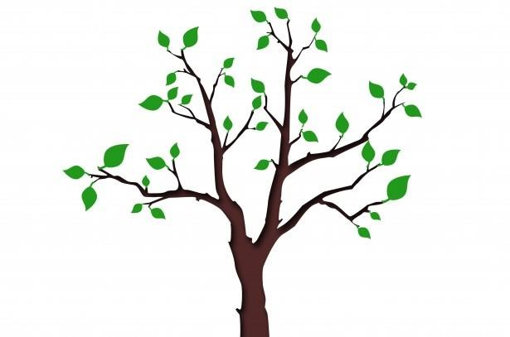

A slash of blue by Emily Dickinson

A slash of Blue— A sweep of Gray—
Some scarlet patches on the way, Compose an Evening Sky—
A little purple—slipped between— Some Ruby Trousers hurried on— A Wave of Gold—
A Bank of Day—

This just makes out the Morning Sky

To Autumn by William Blake

O Autumn, laden with fruit, and stain'd

With the blood of the grape, pass not, but sit Beneath my shady roof; there thou may'st rest, And tune thy jolly voice to my fresh pipe,
And all the daughters of the year shall dance! Sing now the lusty song of fruits and flowers.

'The narrow bud opens her beauties to

The sun, and love runs in her thrilling veins; Blossoms hang round the brows of Morning, and Flourish down the bright cheek of modest Eve, Till clust'ring Summer breaks forth into singing,
And feather'd clouds strew flowers round her head.

'The spirits of the air live in the smells

Of fruit; and Joy, with pinions light, roves round The gardens, or sits singing in the trees.'
Thus sang the jolly Autumn as he sat,

Then rose, girded himself, and o'er the bleak Hills fled from our sight; but left his golden load.

Your Dresses by Carol Ann Duffy

I like your rain dress, its strange, sad colour,
its small buttons like tears. I like your fog dress,
how it swirls around you when you dance on the lawn. Your snow dress I like,
its million snowflakes

sewn together with a needle of ice. But I love your thunderstorm dress, its huge, dark petticoats,
its silver stitches flashing as you run away.

The Autumn by Elizabeth Barrett Browning (1833)

Go, sit upon the lofty hill, And turn your eyes around,
Where waving woods and waters wild Do hymn an autumn sound.
The summer sun is faint on them — The summer flowers depart —
Sit still — as all transform’d to stone, Except your musing heart.

How there you sat in summer-time, May yet be in your mind;
And how you heard the green woods sing Beneath the freshening wind.
Though the same wind now blows around, You would its blast recall;
For every breath that stirs the trees, Doth cause a leaf to fall.

Oh! like that wind, is all the mirth That flesh and dust impart:
We cannot bear its visitings,

When change is on the heart.

Gay words and jests may make us smile, When Sorrow is asleep;
But other things must make us smile, When Sorrow bids us weep!

The dearest hands that clasp our hands, — Their presence may be o’er;
The dearest voice that meets our ear, That tone may come no more!
Youth fades; and then, the joys of youth, Which once refresh’d our mind,
Shall come — as, on those sighing woods, The chilling autumn wind.

Hear not the wind — view not the woods; Look out o’er vale and hill —
In spring, the sky encircled them — The sky is round them still.
Come autumn’s scathe — come winter’s cold — Come change — and human fate!
Whatever prospect Heaven doth bound, Can ne’er be desolate.

TO AUTUMN by John Keats

SEASON of mists and mellow fruitfulness, Close bosom-friend of the maturing sun;
Conspiring with him how to load and bless

With fruit the vines that round the thatch-eves run; To bend with apples the moss’d cottage-trees,
And fill all fruit with ripeness to the core;

To swell the gourd, and plump the hazel shells With a sweet kernel; to set budding more,
And still more, later flowers for the bees, Until they think warm days will never cease,
For Summer has o’er-brimm’d their clammy cells.

Who hath not seen thee oft amid thy store?

Sometimes whoever seeks abroad may find Thee sitting careless on a granary floor,
Thy hair soft-lifted by the winnowing wind; Or on a half-reap’d furrow sound asleep,
Drows’d with the fume of poppies, while thy hook Spares the next swath and all its twined flowers:
And sometimes like a gleaner thou dost keep

Steady thy laden head across a brook; Or by a cyder-press, with patient look,
Thou watchest the last oozings hours by hours.

Where are the songs of Spring? Ay, where are they?

Think not of them, thou hast thy music too,— While barred clouds bloom the soft-dying day,
And touch the stubble plains with rosy hue; Then in a wailful choir the small gnats mourn
Among the river sallows, borne aloft

Or sinking as the light wind lives or dies;

And full-grown lambs loud bleat from hilly bourn; Hedge-crickets sing; and now with treble soft The red-breast whistles from a garden-croft;
And gathering swallows twitter in the skies.

Fall, Leaves, Fall by Emily Bronte

Fall, leaves, fall; die, flowers, away; Lengthen night and shorten day; Every leaf speaks bliss to me, Fluttering from the autumn tree.
I shall smile when wreaths of snow Blossom where the rose should grow; I shall sing when night's decay
Ushers in a drearier day

Autumn Fires by Robert Louis Stevenson

In the other gardens And all up the vale,
From the autumn bonfires See the smoke trail!
Pleasant summer over

And all the summer flowers, The red fire blazes,
The grey smoke towers. Sing a song of seasons! Something bright in all! Flowers in the summer, Fires in the fall!

Time

A Time to Talk By Robert Frost

When a friend calls to me from the road And slows his horse to a meaning walk, I don’t stand still and look around
On all the hills I haven’t hoed,

And shout from where I am, What is it? No, not as there is a time to talk.
I thrust my hoe in the mellow ground, Blade-end up and five feet tall,
And plod: I go up to the stone wall For a friendly visit.

Things Men Have Made by D.H. Lawrence

Things men have made with wakened hands, and put soft life into are awake through years with transferred touch, and go on glowing for long years.
And for this reason, some old things are lovely

warm still with the life of forgotten men who made them.

Time by Percy Shelley

Unfathomable Sea! whose waves are years, Ocean of Time, whose waters of deep woe Are brackish with the salt of human tears!
Thou shoreless flood, which in thy ebb and flow Claspest the limits of mortality,
And sick of prey, yet howling on for more, Vomitest thy wrecks on its inhospitable shore; Treacherous in calm, and terrible in storm, Who shall put forth on thee,
Unfathomable Sea?

Everything Changes by Bertolt Brecht

Everything changes. You can make A fresh start with your final breath.
But what has happened has happened. And the water You once poured into the wine cannot be
Drained off again.

What has happened has happened. The water You once poured into the wine cannot be Drained off again, but
Everything changes. You can make A fresh start with your final breath.

I Had no time to hate by Emily Dickinson

I had no time to hate, because The grave would hinder me, And life was not so ample I Could finish enmity.

Nor had I time to love; but since Some industry must be,
The little toil of love, I thought, Was large enough for me.

The Road Not Taken by Robert Frost

Two roads diverged in a yellow wood, And sorry I could not travel both
And be one traveler, long I stood

And looked down one as far as I could To where it bent in the undergrowth;

Then took the other, as just as fair, And having perhaps the better claim
Because it was grassy and wanted wear, Though as for that the passing there Had worn them really about the same,

And both that morning equally lay In leaves no step had trodden black. Oh, I kept the first for another day!
Yet knowing how way leads on to way I doubted if I should ever come back.

I shall be telling this with a sigh Somewhere ages and ages hence: Two roads diverged in a wood, and I, I took the one less traveled by,
And that has made all the difference.

On Time - by John Milton

Fly, envious Time, till thou run out thy race, Call on the lazy leaden-stepping hours,
Whose speed is but the heavy plummet's pace; And glut thyself with what thy womb devours, Which is no more than what is false and vain, And merely mortal dross;
So little is our loss, So little is thy gain.
For when as each thing bad thou hast intombed, And last of all thy greedy self consumed,
Then long Eternity shall greet our bliss With an individual kiss,
And Joy shall overtake us as a flood; When every thing that is sincerely good And perfectly divine,
With truth, and peace, and love, shall ever shine About the supreme throne
Of Him, t' whose happy-making sight alone When once our heav'nly-guided soul shall climb, Then, all this earthly grossness quit,
Attired with stars, we shall for ever sit,

Triumphing over Death, and Chance, and thee, O Time.

Childhood
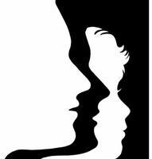

My heart leaps up by William Wordsworth

My heart leaps up when I behold A rainbow in the sky:
So was it when my life began; So is it now I am a man;
So be it when I shall grow old, Or let me die!
The Child is father of the Man; And I could wish my days to be
Bound each to each by natural piety.

I Remember, I Remember by Thomas Hood

I remember, I remember The house where I was born,
The little window where the sun Came peeping in at morn;
He never came a wink too soon Nor brought too long a day; But now, I often wish the night Had borne my breath away.

I remember, I remember The roses red and white,
The violets and the lily cups-- Those flowers made of light! The lilacs where the robin built, And where my brother set
The laburnum on his birthday,-- The tree is living yet!

I remember, I remember Where I was used to swing,
And thought the air must rush as fresh

To swallows on the wing;

My spirit flew in feathers then That is so heavy now,
The summer pools could hardly cool The fever on my brow.

I remember, I remember The fir-trees dark and high;
I used to think their slender tops Were close against the sky:
It was a childish ignorance, But now 'tis little joy
To know I'm farther off from Heaven Than when I was a boy.

It Was Long Ago by Eleanor Farjeon

I'll tell you, shall I, something I remember? Something that still means a great deal to me. It was long ago.

A dusty road in summer I remember,

A mountain, and an old house, and a tree That stood, you know,

Behind the house. An old woman I remember In a red shawl with a grey cat on her knee Humming under a tree.

She seemed the oldest thing I can remember. But then perhaps I was not more than three. It was long ago.

I dragged on the dusty road, and I remember How the old woman looked over the fence at me And seemed to know

How it felt to be three, and called out, I remember "Do you like bilberries and cream for tea?"
I went under the tree.

And while she hummed, and the cat purred, I remember How she filled a saucer with berries and cream for me So long ago.

Such berries and such cream as I remember I never had seen before, and never see Today, you know.

And that is almost all I can remember,

The house, the mountain, the gray cat on her knee, Her red shawl, and the tree,

And the taste of the berries, the feel of the sun I remember, And the smell of everything that used to be
So long ago,

Till the heat on the road outside again I remember And how the long dusty road seemed to have for me No end, you know.

That is the farthest thing I can remember. It won't mean much to you. It does to me. Then I grew up, you see.

Walking away – Cecil Day-Lewis

It is eighteen years ago, almost to the day – A sunny day with leaves just turning,
The touch-lines new-ruled – since I watched you play Your first game of football, then, like a satellite Wrenched from its orbit, go drifting away

Behind a scatter of boys. I can see

You walking away from me towards the school With the pathos of a half-fledged thing set free Into a wilderness, the gait of one
Who finds no path where the path should be.

That hesitant figure, eddying away

Like a winged seed loosened from its parent stem, Has something I never quite grasp to convey
About nature’s give-and-take – the small, the scorching Ordeals which fire one’s irresolute clay.

I have had worse partings, but none that so Gnaws at my mind still. Perhaps it is roughly Saying what God alone could perfectly show – How selfhood begins with a walking away, And love is proved in the letting go.

Second Childhood by Robert William Service

Some deem I'm gentle, some I'm kind: It may be so,--I cannot say.
I know I have a simple mind And see things in a simple way; And like a child I love to play.

I love to toy with pretty words And syllable them into rhyme;
To make them sing like sunny birds In happy droves with silver chime, In dulcet groves in summer time.

I pray, with hair more white than grey, And second childhood coming on, That yet with wonderment I may
See life as in its lucent dawn, And be by beauty so beguiled I'll sing as sings a child.

I remember I remember by Philip Larkin

Coming up England by a different line For once, early in the cold new year,
We stopped, and, watching men with number plates Sprint down the platform to familiar gates,
'Why, Coventry!' I exclaimed. 'I was born here.’

I leant far out, and squinnied for a sign

That this was still the town that had been 'mine' So long, but found I wasn't even clear
Which side was which.

From where those cycle-crates

Were standing, had we annually departed

For all those family hols? .

A whistle went:

Things moved.

I sat back, staring at my boots.

'Was that,' my friend smiled, 'where you "have your roots"?'

No, only where my childhood was unspent, I wanted to retort, just where I started:

By now I've got the whole place clearly charted.

Our garden, first: where I did not invent Blinding theologies of flowers and fruits, And wasn't spoken to by an old hat.

And here we have that splendid family

I never ran to when I got depressed,

The boys all biceps and the girls all chest, Their comic Ford, their farm where I could be 'Really myself'.
I'll show you, come to that,

The bracken where I never trembling sat,

Determined to go through with it; where she Lay back, and 'all became a burning mist'.

And, in those offices, my doggerel

Was not set up in blunt ten-point, nor read

By a distinguished cousin of the mayor,

Who didn't call and tell my father There Before us, had we the gift to see ahead -
'You look as though you wished the place in Hell,' My friend said, 'judging from your face.’
'Oh well,

I suppose it's not the place's fault,' I said.

'Nothing, like something, happens anywhere.’

Love

Love and Friendship by Emily Bronte

Love is like the wild rose-briar, Friendship like the holly-tree—
The holly is dark when the rose-briar blooms But which will bloom most constantly?

The wild rose-briar is sweet in spring, Its summer blossoms scent the air; Yet wait till winter comes again
And who will call the wild-briar fair?

Then scorn the silly rose-wreath now And deck thee with the holly’s sheen, That when December blights thy brow He still may leave thy garland green.

Twilight Night by Christina Rossetti

I.

We met, hand to hand,

We clasped hands close and fast, As close as oak and ivy stand;
But it is past:

Come day, come night, day comes at last.

We loosed hand from hand, We parted face from face;
Each went his way to his own land At his own pace:
Each went to fill his separate place.

If we should meet one day,

If both should not forget.

We shall clasp hands the accustomed way, As when we met
So long ago, as I remember yet.

II.

Where my heart is (wherever that may be) Might I but follow!
If you fly thither over heath and lea, O honey-seeking bee,

O careless swallow!

Bid some for whom I watch keep watch for me

Alas! that we must dwell, my heart and I, So far asunder.
Hours wax to days, and days and days creep by; I watch with wistful eye,
I wait and wonder:

When will that day draw nigh--that hour draw nigh?

Not yesterday, and not I think to-day; Perhaps to-morrow.
Day after day "to-morrow," thus I say: I watched so yesterday
In hope and sorrow,

Again to-day I watch the accustomed way.

Meeting at Night by Robert Browning

The grey sea and the long black land; And the yellow half-moon large and low; And the startled little waves that leap
In fiery ringlets from their sleep,

As I gain the cove with pushing prow, And quench its speed i' the slushy sand.

Then a mile of warm sea-scented beach; Three fields to cross till a farm appears;
A tap at the pane, the quick sharp scratch And blue spurt of a lighted match,
And a voice less loud, thro' its joys and fears, Than the two hearts beating each to each.

Let me not Sonnet 116 by William Shakespeare

Let me not to the marriage of true minds Admit impediments. Love is not love Which alters when it alteration finds,
Or bends with the remover to remove: O, no! it is an ever-fixed mark,
That looks on tempests and is never shaken; It is the star to every wandering bark,
Whose worth's unknown, although his height be taken. Love's not Time's fool, though rosy lips and cheeks Within his bending sickle's compass come;
Love alters not with his brief hours and weeks, But bears it out even to the edge of doom.
If this be error and upon me proved, I never writ, nor no man ever loved.

How Do I Love Thee? By Elizabeth Barrett Browning

How do I love thee? Let me count the ways.

I love thee to the depth and breadth and height My soul can reach, when feeling out of sight For the ends of Being and ideal Grace.
I love thee to the level of every day's Most quiet need, by sun and candlelight. I love thee freely, as men strive for Right;
I love thee purely, as they turn from Praise. I love with a passion put to use
In my old griefs, and with my childhood's faith. I love thee with a love I seemed to lose
With my lost saints, I love thee with the breath, Smiles, tears, of all my life! and, if God choose, I shall but love thee better after death.

Touched by an Angel by Maya Angelou

We, unaccustomed to courage exiles from delight
live coiled in shells of loneliness until love leaves its high holy temple and comes into our sight
to liberate us into life.

Love arrives

and in its train come ecstasies old memories of pleasure ancient histories of pain.
Yet if we are bold,

love strikes away the chains of fear from our souls.
We are weaned from our timidity In the flush of love’s light
we dare be brave And suddenly we see
that love costs all we are and will ever be.
Yet it is only love which sets us free.

Habitation by Margaret Atwood

Marriage is not

a house, or even a tent

it is before that, and colder:

the edge of the forest, the edge of the desert
the unpainted stairs

at the back, where we squat outdoors, eating popcorn

where painfully and with wonder

at having survived this far

we are learning to make fire

Seaside and water
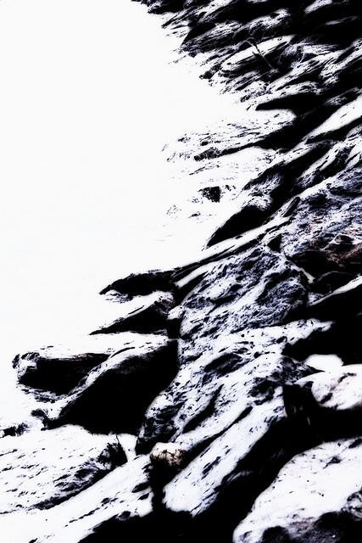

maggie and milly and molly and may by E. E. Cummings

maggie and milly and molly and may went down to the beach(to play one day)

and maggie discovered a shell that sang

so sweetly she couldn’t remember her troubles,and

milly befriended a stranded star whose rays five languid fingers were;

and molly was chased by a horrible thing

which raced sideways while blowing bubbles:and

may came home with a smooth round stone as small as a world and as large as alone.

For whatever we lose(like a you or a me) it’s always ourselves we find in the sea

Sea Fever by John Masefield

I must go down to the seas again, to the lonely sea and the sky, And all I ask is a tall ship and a star to steer her by,
And the wheel's kick and the wind's song and the white sail's shaking, And a grey mist on the sea's face, and a grey dawn breaking.

I must go down to the seas again, for the call of the running tide Is a wild call and a clear call that may not be denied;
And all I ask is a windy day with the white clouds flying,
And the flung spray and the blown spume, and the sea-gulls crying.

I must go down to the seas again, to the vagrant gypsy life,
To the gull's way and the whale's way, where the wind's like a whetted knife; And all I ask is a merry yarn from a laughing fellow-rover,
And quiet sleep and a sweet dream when the long trick's over.

The Lake Isle of Innisfree by W. B. Yeats

I will arise and go now, and go to Innisfree,

And a small cabin build there, of clay and wattles made: Nine bean-rows will I have there, a hive for the honey-bee; And live alone in the bee-loud glade.

And I shall have some peace there, for peace comes dropping slow, Dropping from the veils of the morning to where the cricket sings; There midnight’s all a glimmer, and noon a purple glow,
And evening full of the linnet’s wings.

I will arise and go now, for always night and day

I hear lake water lapping with low sounds by the shore; While I stand on the roadway, or on the pavements grey, I hear it in the deep heart’s core.

Dover Beach by Matthew Arnold

The sea is calm to-night,

The tide is full, the moon lies fair

Upon the straits; -- on the French coast the light Gleams and is gone; the cliffs of England stand, Glimmering and vast, out in the tranquil bay.
Come to the window, sweet is the night-air! Only, from the long line of spray
Where the sea meets the moon-blanch'd land, Listen! you hear the grating roar
Of pebbles which the waves draw back, and fling, At their return, up the high strand,
Begin, and cease, and then again begin, With tremulous cadence slow, and bring The eternal note of sadness in.

Sophocles long ago

Heard it on the Aegean, and it brought Into his mind the turbid ebb and flow Of human misery; we
Find also in the sound a thought, Hearing it by this distant northern sea.

The sea of faith

Was once, too, at the full, and round earth's shore Lay like the folds of a bright girdle furl'd.
But now I only hear

Its melancholy, long, withdrawing roar, Retreating, to the breath
Of the night-wind, down the vast edges drear And naked shingles of the world.

Ah, love, let us be true

To one another! for the world which seems To lie before us like a land of dreams,
So various, so beautiful, so new,

Hath really neither joy, nor love, nor light, Nor certitude, nor peace, nor help for pain; And we are here as on a darkling plain
Swept with confused alarms of struggle and flight, Where ignorant armies clash by night.

Going for Water by Robert Frost

The well was dry beside the door, And so we went with pail and can Across the fields behind the house To seek the brook if still it ran;

Not loth to have excuse to go,

Because the autumn eve was fair

(Though chill), because the fields were ours, And by the brook our woods were there.

We ran as if to meet the moon

That slowly dawned behind the trees, The barren boughs without the leaves, Without the birds, without the breeze.

But once within the wood, we paused Like gnomes that hid us from the moon, Ready to run to hiding new
With laughter when she found us soon.

Each laid on other a staying hand

To listen ere we dared to look, And in the hush we joined to make
We heard, we knew we heard the brook.

A note as from a single place,

A slender tinkling fall that made Now drops that floated on the pool Like pearls, and now a silver blade.

All Day I Hear the Noise of Waters by James Joyce

All day I hear the noise of waters Making moan,
Sad as the sea-bird is when, going Forth alone,
He hears the winds cry to the water's Monotone.

The grey winds, the cold winds are blowing Where I go.
I hear the noise of many waters Far below.
All day, all night, I hear them flowing To and fro.

With ships the sea was sprinkled by William Wordsworth

With ships the sea was sprinkled far and nigh, Like stars in heaven, and joyously it showed; Some lying fast at anchor in the road,
Some veering up and down, one knew not why. A goodly vessel did I then espy
Come like a giant from a haven broad; And lustily along the bay she strode, Her tackling rich, and of apparel high. The ship was nought to me, nor I to her, Yet I pursued her with a lover's look; This ship to all the rest did I prefer:
When will she turn, and whither? She will brook No tarrying; where she comes the winds must stir: On went she, and due north her journey took.

Christmas

Christmas Bells by Henry Wadsworth Longfellow

I heard the bells on Christmas Day Their old, familiar carols play,
And wild and sweet The words repeat
Of peace on earth, good-will to men!

And thought how, as the day had come, The belfries of all Christendom
Had rolled along The unbroken song
Of peace on earth, good-will to men!

Till ringing, singing on its way,

The world revolved from night to day, A voice, a chime,
A chant sublime

Of peace on earth, good-will to men!

Then from each black, accursed mouth The cannon thundered in the South, And with the sound

The carols drowned

Of peace on earth, good-will to men!

It was as if an earthquake rent The hearth-stones of a continent, And made forlorn
The households born

Of peace on earth, good-will to men!

And in despair I bowed my head; "There is no peace on earth," I said; For hate is strong,
And mocks the song

Of peace on earth, good-will to men!"

Then pealed the bells more loud and deep: "God is not dead, nor doth He sleep;
The Wrong shall fail, The Right prevail,
With peace on earth, good-will to men.

Ring Out, Wild Bells by Alfred, Lord Tennyson

Ring out, wild bells, to the wild sky, The flying cloud, the frosty light: The year is dying in the night;
Ring out, wild bells, and let him die…

Ring out false pride in place and blood, The civic slander and the spite;
Ring in the love of truth and right, Ring in the common love of good.

Ring out old shapes of foul disease; Ring out the narrowing lust of gold; Ring out the thousand wars of old, Ring in the thousand years of peace.

Ring in the valiant man and free, The larger heart, the kindlier hand; Ring out the darkness of the land, Ring in the Christ that is to be

The Oxen by Thomas hardy

Christmas Eve, and twelve of the clock. “Now they are all on their knees,”
An elder said as we sat in a flock By the embers in hearthside ease.

We pictured the meek mild creatures where They dwelt in their strawy pen,
Nor did it occur to one of us there To doubt they were kneeling then.

So fair a fancy few would weave In these years! Yet, I feel,
If someone said on Christmas Eve, “Come; see the oxen kneel,

“In the lonely barton by yonder coomb Our childhood used to know,”
I should go with him in the gloom, Hoping it might be so.

Mistletoe by Walter De La Mare

Sitting under the mistletoe (Pale-green, fairy mistletoe), One last candle burning low, All the sleepy dancers gone, Just one candle burning on, Shadows lurking everywhere:
Some one came, and kissed me there.

Tired I was; my head would go Nodding under the mistletoe (Pale-green, fairy mistletoe),
No footsteps came, no voice, but only, Just as I sat there, sleepy, lonely, Stooped in the still and shadowy air Lips unseen—and kissed me there.

Goodwill To Men - Give Us Your Money by Pam Ayres

It was Christmas Eve on a Friday The shops was full of cheer, With tinsel in the windows,
And presents twice as dear.

A thousand Father Christmases, Sat in their little huts,
And folk was buying crackers And folk was buying nuts.

All up and down the country, Before the light was snuffed, Turkeys they get murdered, And cockerels they got stuffed,
Christmas cakes got marzipanned, And puddin's they got steamed Mothers they got desperate
And tired kiddies screamed.

Hundredweight's of Christmas cards, Went flying through the post,
With first class postage stamps on those,

You had to flatter most. Within a million kitchens, Mince pies was being made, On everyone's radio,
"White Christmas", it was played.

Out in the frozen countryside Men crept round on their own, Hacking off the holly,
What other folks had grown, Mistletoe on willow trees, Was by a man wrenched clear,
So he could kiss his neighbour's wife, He'd fancied all the year.

And out upon the hillside,

Where the Christmas trees had stood, All was completely barren,
But for little stumps of wood, The little trees that flourished All the year were there no more, But in a million houses,
Dropped their needles on the floor.

And out of every cranny, cupboard, Hiding place and nook,
Little bikes and kiddies' trikes, Were secretively took,
Yards of wrapping paper, Was rustled round about,
And bikes were wheeled to bedrooms, With the pedals sticking out.

Rolled up in Christmas paper The Action Men were tensed, All ready for the morning,
When their fighting life commenced, With tommy guns and daggers,
All clustered round about,

"Peace on Earth - Goodwill to Men" The figures seemed to shout.

The church was standing empty, The pub was standing packed, There came a yell, "Noel, Noel!" And glasses they got cracked.

From up above the fireplace, Christmas cards began to fall, And trodden on the floor, said: "Merry Christmas, to you all."

'Twas the Night Before Christmas by Clement Clarke Moore

'Twas the night before Christmas, when all through the house Not a creature was stirring, not even a mouse;
The stockings were hung by the chimney with care, In hopes that St. Nicholas soon would be there; The children were nestled all snug in their beds; While visions of sugar-plums danced in their heads; And mamma in her 'kerchief, and I in my cap,
Had just settled our brains for a long winter's nap, When out on the lawn there arose such a clatter, I sprang from my bed to see what was the matter. Away to the window I flew like a flash,
Tore open the shutters and threw up the sash. The moon on the breast of the new-fallen snow, Gave a lustre of midday to objects below,
When what to my wondering eyes did appear, But a miniature sleigh and eight tiny rein-deer, With a little old driver so lively and quick,
I knew in a moment he must be St. Nick.

More rapid than eagles his coursers they came,

And he whistled, and shouted, and called them by name: "Now, Dasher! now, Dancer! now Prancer and Vixen!

On, Comet! on, Cupid! on, Donder and Blixen! To the top of the porch! to the top of the wall! Now dash away! dash away! dash away all!" As leaves that before the wild hurricane fly,
When they meet with an obstacle, mount to the sky; So up to the housetop the coursers they flew
With the sleigh full of toys, and St. Nicholas too-- And then, in a twinkling, I heard on the roof
The prancing and pawing of each little hoof. As I drew in my head, and was turning around,
Down the chimney St. Nicholas came with a bound. He was dressed all in fur, from his head to his foot,
And his clothes were all tarnished with ashes and soot; A bundle of toys he had flung on his back,
And he looked like a pedler just opening his pack.

His eyes--how they twinkled! his dimples, how merry! His cheeks were like roses, his nose like a cherry!
His droll little mouth was drawn up like a bow,

And the beard on his chin was as white as the snow; The stump of a pipe he held tight in his teeth,
And the smoke, it encircled his head like a wreath; He had a broad face and a little round belly
That shook when he laughed, like a bowl full of jelly.

He was chubby and plump, a right jolly old elf, And I laughed when I saw him, in spite of myself; A wink of his eye and a twist of his head
Soon gave me to know I had nothing to dread;

He spoke not a word, but went straight to his work, And filled all the stockings; then turned with a jerk, And laying his finger aside of his nose,
And giving a nod, up the chimney he rose;

He sprang to his sleigh, to his team gave a whistle, And away they all flew like the down of a thistle.
But I heard him exclaim, ere he drove out of sight-- "Happy Christmas to all, and to all a good night!"

Before the ice is in the pools by Emily Dickinson

Before the ice is in the pools— Before the skaters go,
Or any check at nightfall

Is tarnished by the snow—

Before the fields have finished, Before the Christmas tree, Wonder upon wonder
Will arrive to me!

Beginnings
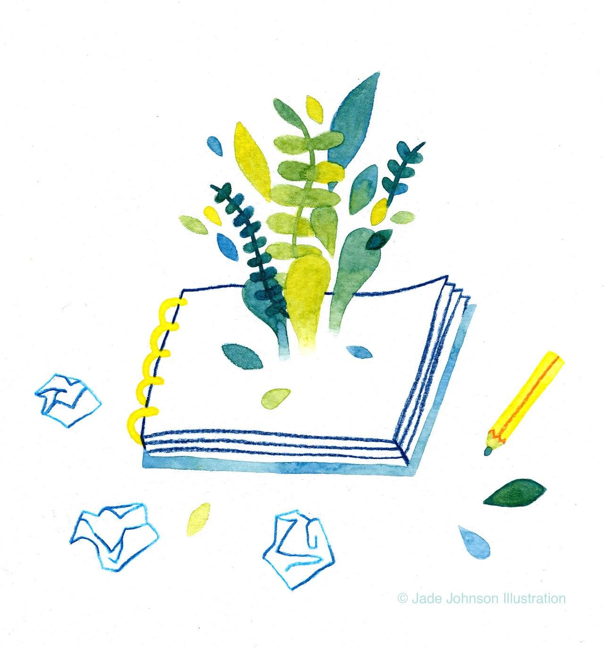

The Origin of Birds by Nicole Callihan

For hours, the flowers were enough.

Before the flowers, Adam had been enough. Before Adam, just being a rib was enough.
Just being inside Adam’s body, near his heart, enough.

Enough to be so near his heart, enough to feel that sweet steady rhythm, enough
to be a part of something bigger was enough. And before the rib, being clay was enough.
And before clay, just being earth was enough. And before earth, being nothing was enough. But then enough was no longer enough.
The flowers bowed their heads, as if to say, enough, and so Eve, surrounded by peonies, and alone enough,
wished very hard for something, and the wish was enough to make the pinecone grow wings; the wish was enough
to point to the sky, say bird, and wait for something to sing.

Up-Hill by Christina Rossetti

Does the road wind up-hill all the way? Yes, to the very end.
Will the day’s journey take the whole long day? From morn to night, my friend.

But is there for the night a resting-place?

A roof for when the slow dark hours begin. May not the darkness hide it from my face?
You cannot miss that inn.

Shall I meet other wayfarers at night? Those who have gone before.
Then must I knock, or call when just in sight? They will not keep you standing at that door.

Shall I find comfort, travel-sore and weak? Of labour you shall find the sum.
Will there be beds for me and all who seek? Yea, beds for all who come.

Caged Bird by Maya Angelou

The free bird leaps

on the back of the wind and floats downstream till the current ends and dips his wings
in the orange sun rays

and dares to claim the sky.

But a bird that stalks down his narrow cage can seldom see through his bars of rage
his wings are clipped and his feet are tied
so he opens his throat to sing.

The caged bird sings with fearful trill
of the things unknown but longed for still and his tune is heard

on the distant hill for the caged bird sings of freedom

The free bird thinks of another breeze

and the trade winds soft through the sighing trees and the fat worms waiting on a dawn-bright lawn and he names the sky his own.

But a caged bird stands on the grave of dreams his shadow shouts on a nightmare scream
his wings are clipped and his feet are tied so he opens his throat to sing

The caged bird sings with a fearful trill
of things unknown but longed for still and his tune is heard on the distant hill for the caged bird sings of freedom.

Blossom by Dorianne Laux

What is a wound but a flower dying on its descent to the earth, bag of scent filled with war, forest, torches, some trouble that befell
now over and done. A wound is a fire sinking into itself. The tinder serves only so long, the log holds on
and still it gives up, collapses

into its bed of ashes and sand. I burned my hand cooking over a low flame, that flame now alive under my skin, the smell not unpleasant, the wound beautiful as a full-blown peony.
Say goodbye to disaster. Shake hands with the unknown, what becomes
of us once we’ve been torn apart and returned to our future, naked and small, sewn back together scar by scar.

Do not go gentle into that good night by Dylan Thomas

Do not go gentle into that good night,

Old age should burn and rave at close of day; Rage, rage against the dying of the light.

Though wise men at their end know dark is right, Because their words had forked no lightning they Do not go gentle into that good night.

Good men, the last wave by, crying how bright Their frail deeds might have danced in a green bay, Rage, rage against the dying of the light.

Wild men who caught and sang the sun in flight, And learn, too late, they grieved it on its way, Do not go gentle into that good night.

Grave men, near death, who see with blinding sight Blind eyes could blaze like meteors and be gay, Rage, rage against the dying of the light.

And you, my father, there on that sad height,

Curse, bless, me now with your fierce tears, I pray. Do not go gentle into that good night.
Rage, rage against the dying of the light.

Sonnet 29 By William Shakespeare

When, in disgrace with fortune and men's eyes, I all alone beweep my outcast state,
And trouble deaf heaven with my bootless cries, And look upon myself, and curse my fate, Wishing me like to one more rich in hope,
Featured like him, like him with friends possessed, Desiring this man's art and that man's scope,
With what I most enjoy contented least;

Yet in these thoughts myself almost despising, Haply I think on thee—and then my state, Like to the lark at break of day arising
From sullen earth, sings hymns at heaven's gate; For thy sweet love rememb'red such wealth brings That then I scorn to change my state with kings.

I am by Ella Wheeler Wilcox

I know not whence I came, I know not whither I go;
But the fact stands clear that I am here In this world of pleasure and woe.
And out of the mist and murk Another truth shines plain –
It is my power each day and hour To add to its joy or its pain.

Winter
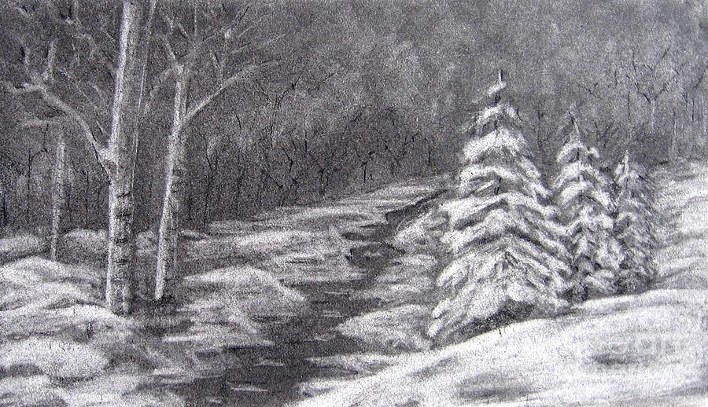

Stopping by Woods on a Snowy Evening by Robert Frost

Whose woods these are I think I know. His house is in the village though;
He will not see me stopping here

To watch his woods fill up with snow.

My little horse must think it queer To stop without a farmhouse near Between the woods and frozen lake The darkest evening of the year.

He gives his harness bells a shake To ask if there is some mistake.
The only other sound’s the sweep Of easy wind and downy flake.

The woods are lovely, dark and deep, But I have promises to keep,
And miles to go before I sleep, And miles to go before I sleep.

THOSE WINTER SUNDAYS by Robert Hayden

Sundays too my father got up early

and put his clothes on in the blueblack cold, then with cracked hands that ached
from labor in the weekday weather made banked fires blaze. No one ever thanked him.

I’d wake and hear the cold splintering, breaking. When the rooms were warm, he’d call,
and slowly I would rise and dress, fearing the chronic angers of that house,

Speaking indifferently to him, who had driven out the cold
and polished my good shoes as well.

What did I know, what did I know of love’s austere and lonely offices?

The cold earth slept below by Percy Shelley

The cold earth slept below; Above the cold sky shone;
And all around,

With a chilling sound, From caves of ice and fields of snow
The breath of night like death did flow Beneath the sinking moon.

The wintry hedge was black;

The green grass was not seen; The birds did rest
On the bare thorn’s breast, Whose roots, beside the pathway track, Had bound their folds o’er many a crack
Which the frost had made between.

Thine eyes glow’d in the glare Of the moon’s dying light;
As a fen-fire’s beam On a sluggish stream
Gleams dimly—so the moon shone there, And it yellow’d the strings of thy tangled hair,

That shook in the wind of night.

The moon made thy lips pale, beloved; The wind made thy bosom chill;
The night did shed On thy dear head
Its frozen dew, and thou didst lie

Where the bitter breath of the naked sky Might visit thee at will.

The Darkling Thrush by Thomas Hardy

I leant upon a coppice gate When Frost was spectre-grey,
And Winter's dregs made desolate The weakening eye of day.
The tangled bine-stems scored the sky Like strings of broken lyres,
And all mankind that haunted nigh Had sought their household fires.

The land's sharp features seemed to be The Century's corpse outleant,
His crypt the cloudy canopy, The wind his death-lament.
The ancient pulse of germ and birth Was shrunken hard and dry,
And every spirit upon earth Seemed fervourless as I.

At once a voice arose among The bleak twigs overhead
In a full-hearted evensong

Of joy illimited;

An aged thrush, frail, gaunt, and small, In blast-beruffled plume,
Had chosen thus to fling his soul Upon the growing gloom.

So little cause for carolings Of such ecstatic sound
Was written on terrestrial things Afar or nigh around,
That I could think there trembled through His happy good-night air
Some blessed Hope, whereof he knew And I was unaware.

Horses by Pablo Neruda

From the window I saw the horses. I was in Berlin, in winter. The light had no light, the sky had no heaven. The air was white like wet bread.

And from my window a vacant arena, bitten by the teeth of winter.
Suddenly driven out by a man,

ten horses surged through the mist.

Like waves of fire, they flared forward and to my eyes filled the whole world, empty till then. Perfect, ablaze,
they were like ten gods with pure white hoofs, with manes like a dream of salt.

Their rumps were worlds and oranges. Their color was honey, amber, fire.
Their necks were towers cut from the stone of pride,
and behind their transparent eyes

energy raged, like a prisoner.

There, in silence, at mid-day,

in that dirty, disordered winter, those intense horses were the blood
the rhythm, the inciting treasure of life.

I looked. I looked and was reborn:

for there, unknowing, was the fountain, the dance of gold, heaven
and the fire that lives in beauty.

I have forgotten that dark Berlin winter. I will not forget the light of the horses.

Winter Song by Wilfred Owen

The browns, the olives, and the yellows died,

And were swept up to heaven; where they glowed Each dawn and set of sun till Christmastide,
And when the land lay pale for them, pale-snowed,

Fell back, and down the snow-drifts flamed and flowed.

From off your face, into the winds of winter,

The sun-brown and the summer-gold are blowing; But they shall gleam with spiritual glinter,
When paler beauty on your brows falls snowing,

And through those snows my looks shall be soft-going.

A winter night by Sara Teasdale

My window-pane is starred with frost, The world is bitter cold to-night,
The moon is cruel, and the wind

Is like a two-edged sword to smite.

God pity all the homeless ones, The beggars pacing to and fro. God pity all the poor to-night
Who walk the lamp-lit streets of snow.

My room is like a bit of June,

Warm and close-curtained fold on fold, But somewhere, like a homeless child, My heart is crying in the cold.

