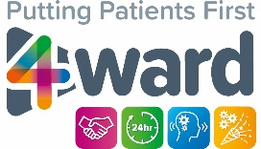**Worcestershire Health Libraries**

**The Little Library Book**

**of Nursing Revalidation**



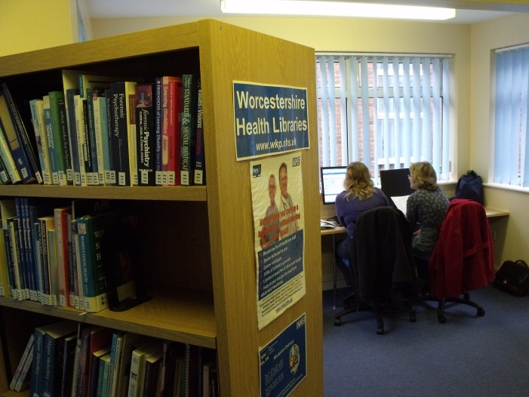**

*Evidence, Knowledge, Libraries and Learning for Worcestershire’s Health Community*

**Welcome to the**

**Little Library Book of Nursing Revalidation**

In this Little Book there are suggestions for books, websites and other resources which offer information on Nursing Revalidation and tips on how to search for relevant evidence.

If you would like help using any of the resources listed, if you would like to know about other available Nursing Revalidation resources, or you need help with finding information for your work or studies, please contact your local Worcestershire Health Libraries service.

Contact details for each library are here: <http://www.wkp.nhs.uk/our-libraries/>

**Library Rowlands Library**

Contact David Chamberlain/ Emma Gibbs/ Carly Farmer/ Paul

Sparrow

Address Charles Hastings Education Centre, Worcestershire Royal Hospital WR5 1DD

Telephone 01905 763333 ext. 33760

01905 760601 (direct)

Fax 01905 760866 (direct) 33761 (internal)

Email [wah-tr.WRH-RowlandsLibrary@nhs.net](mailto:wah-tr.WRH-RowlandsLibrary@nhs.net)

Staffed hours Monday-Friday: 08:30am-16:30pm

**Library Redditch Health Library**

Contact Muneeb Liaquat / Tina O’Toole/ Shophie Uddin/ Leanne Hudson

Address Arafa Education Centre, Alexandra Hospital, Woodrow Drive, Redditch B98 7UB

Telephone 01527 503030 ext. 45770

01527 505770 (direct)

Email [wah-tr.ALX-Library@nhs.net](mailto:wah-tr.ALX-Library@nhs.net)

Staffed hours Monday-Friday: 08:30am-16:30pm

**Library Kidderminster Health Library**

Contact Sharon Wooldridge

Address Education Centre, Treatment Centre, Bewdley Road, Kidderminster DY11 6RJ

Telephone 01562 823424 ext. 55253  
01562 512344 (direct)

Email [wah-tr.KTC-HealthLibrary@nhs.net](mailto:wah-tr.KTC-HealthLibrary@nhs.net)

Staffed hours Monday -Friday : 09:00am-16:00pm

**Library Evesham Health Library**

Contact Rowlands Library, Worcestershire Royal Hospital

Address Training & Development Centre, Evesham Community Hospital WR11 1JT

Telephone 01386 502353

Fax 01386 502542

Email [wah-tr.WRH-RowlandsLibrary@nhs.net](mailto:wah-tr.WRH-RowlandsLibrary@nhs.net)

Staffed hours Drop in only

More information can be found on the library website: [www.wkp.nhs.uk](http://www.wkp.nhs.uk)

**Books for Revalidation held in our libraries**

Here is a selection of revalidation-related titles held in our library. An expanded reading list can be found via the QR code below:

|  |  |  |  |
| --- | --- | --- | --- |
|  | [Cover] | [Cover] |  |

|  |  |  |
| --- | --- | --- |
| **Title** | **Author** | **Shelfmark** |
| Communication skills in health and social care | Moss, Bernard | **WA 270** |
| Beginning reflective practice | Jasper, Melanie | **WY 54** |
| Becoming a reflective practitioner | Johns, Christopher | **WY 54** |
| Professional development, reflection and decision-making in nursing and health care | Jasper, Melanie | **WY 54** |
| Reflection for nursing life : principles, process and practice | McKinnon, John | **WY 54** |
| Reflective practice in nursing | Bulman, Chris | **WY 54** |
| Reflective practice for healthcare professionals: a practical guide | Taylor, Beverley Joan | **WY 54** |
| Becoming a learner in the workplace: a student's guide to practice and work-based learning in health and social Care | Wareing, Mark | **WY 120** |
| Successful professional portfolios for nursing students | Reed, Suzanne | **WY 54** |

Check our online catalogue [**http://www.wkp.nhs.uk**](http://www.wkp.nhs.uk)for details of other titles.

**1000s of E-Books available to download via our website**

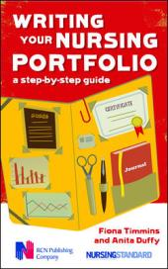 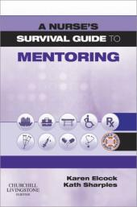 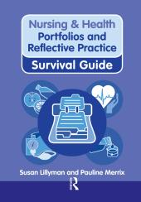 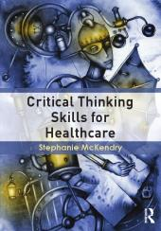

**How to find evidence to support revalidation**

**Consider your information query**

* Clinical
* Guidelines
* Evidence Summaries
* Pathways
* Research/ Audit
* Patient information

These are some examples – can you think of any others?

**Convert your question into a search**

* Identify key concepts using search tools such as PICO:

Problem/Patient/Population, Intervention, Comparison, Outcome.

* Identify all the keywords, phrases and terminology relevant for each concept.
* Use thesaurus for medical terms
* Look at broader, narrower and related concepts.
* Consider alternative spellings and truncated words.

**Consider the evidence level**

Different types of information have different levels of evidence

* Is a Google search as evidence based as a Cochrane library search?
* Is wikipedia as good a source as NHS Evidence?
* And if not why not?

****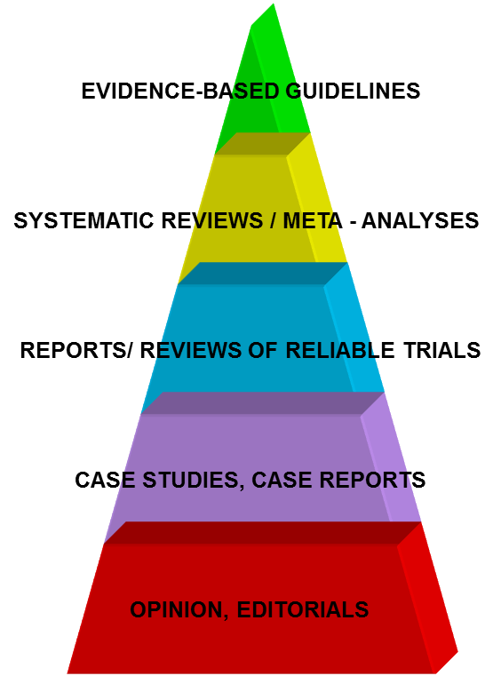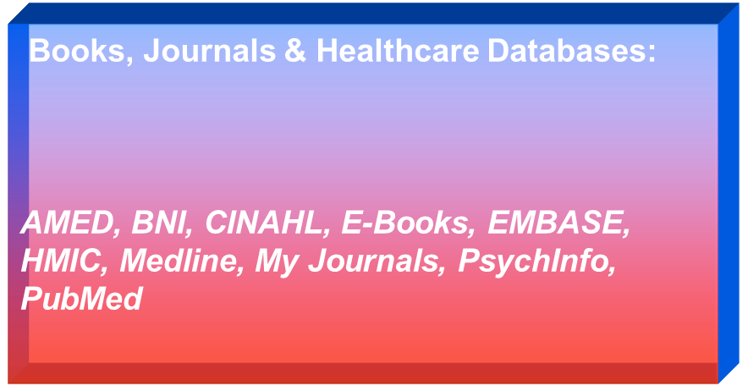

Matching the level of evidence (triangle) to resources available

**Conduct your search**

Look for high level evidence first

**How to search**

Search more than one resource

Use a mix of keyword searches and formal subject headings

Use truncation and wildcards

Carry out separate searches for each of your key concepts first

Mix and match your search results

Limit your search results by year, language, age range etc.

Explode versus focus

Use citation searches to track who has quoted a particular paper

Save your search records and search history

Use email alerts and personalisation services to keep up-to-date on a topic

Ask a Librarian

**Your Health Library is here to help**

Find guides on our “Learning Zone” tab to search databases on our webpages: <http://www.wkp.nhs.uk/learning-zone/>

We offer Training sessions in the library. Group and 1:1

Library E-Learning packages are available via [eLearning for Healthcare](https://portal.e-lfh.org.uk/Catalogue/Index)

We have an “Ask a Librarian” and enquiry service

We provide you with access to specialist databases, eJournals and eBooks from work or home using your NHS Athens Account.

All our library staff are here to help – please ask

**Producing evidence for revalidation**

You can record all your database and research activity as evidence for your CPD

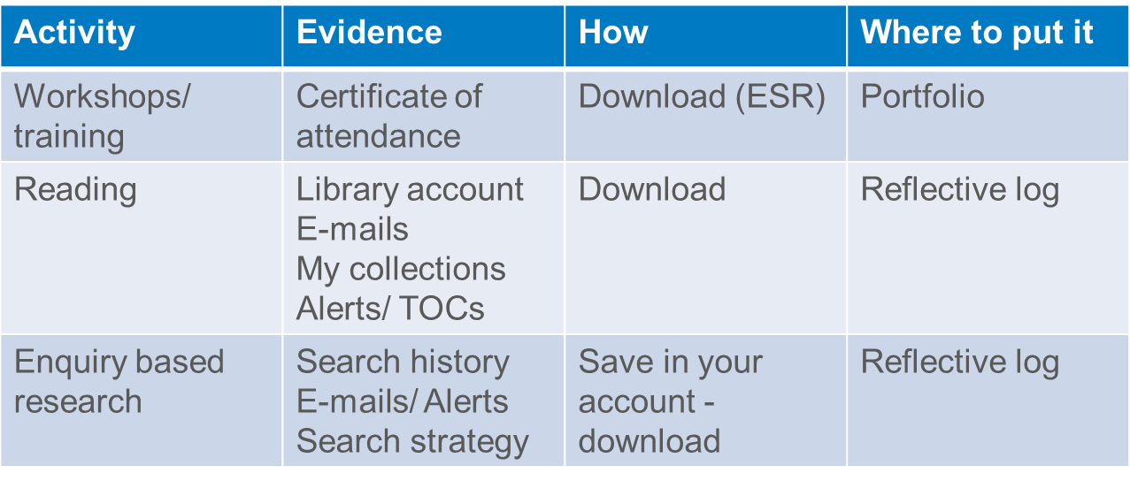

**Some advice when searching**

* Use “help” to find how the resource uses operators
* Set up passwords and register (i.e. Athens, NICE, BNF)
* “” – inverted commas allows phrase searching e.g. “spinal injury” not spinal or injury
* Look for and use filters
* Assess and evaluate the information
* Sign up for alerts
* Ask a librarian

**How to critically appraise the information?**

Use tools such as CASP checklists, to evaluate the quality of the evidence you find :

**CASP : Critical Appraisal Skills Programme** [www.casp-uk.net/checklists](http://www.casp-uk.net/checklists)

**Centre for Evidence Based Rehabilitation**   
<http://srs-mcmaster.ca/research/evidence-based-practice-research-group/>

**How to Read a Paper (BMJ series)**  
[www.bmj.com/about-bmj/resources-readers/publications/how-read-paper](http://www.bmj.com/about-bmj/resources-readers/publications/how-read-paper)

**Books (including a QR code for an expanded ‘Critical Appraisal’ reading list:**

|  |  |  |  |  |
| --- | --- | --- | --- | --- |
| Cover image | Cover image | Cover image | Cover image |  |

|  |  |  |
| --- | --- | --- |
| **Title** | **Author** | **Shelfmark** |
| Making sense of critical appraisal | Ajetunmobi, Olajide | **WB 20** |
| Critical thinking and writing for nursing students | Price, Bob; Harrington, Ann | **L 125** |
| Doing a literature review in health and social care: a practical guide | Aveyard, Helen | **L 125** |
| How to read a paper: the basics of evidence-based medicine | Greenhalgh, Trisha | **WB 20** |
| Understanding nursing research: building an evidence-based practice | Grove, Susan K. | **WY 20** |
| Clinical evidence made easy | Harris, M. | **WX 175** |
| Nursing research : methods and critical appraisal for evidence-based practice | LoBiondo-Wood, Geri | **WY 20** |
| Making sense of research in nursing, health and social care | Moule, Pam | **WY 20** |
| Succeeding in literature reviews and research project plans for nursing students | Williamson, Graham | **L 125** |

**Again – do check out our e-books – all downloadable to hand held devices and free**

**Journals to support revalidation**

Many journals are available to you electronically via the Worcestershire Health Libraries website Go to.[www.wkp.nhs.uk](http://www.wkp.nhs.uk) and then click “Journal Full Text Finder” on the left hand side

You will need an Athens account to access the full text.

**Useful articles:**

**Title: Using mentorship activities to assist nurses and midwives with their revalidation requirements.**

**Citation:** Nursing Standard; Jan 2017; vol. 31 (no. 20); p. 45-52

**Author(s):** Jolly, Sara Nicola; Hyatt, Simon Andrew; Dadge, Jean Ruth; Summerhill, Katie

**Abstract:** This article discusses how becoming a mentor and maintaining mentor status can provide registered nurses and midwives with evidence to assist them in their revalidation.

**Title: How to succeed in NMC revalidation.**

**Citation:** Occupational Health; Apr 2017; vol. 69 (no. 4); p. 17-19

**Author:** Kelsey, Catherine

**Abstract:** The article deals with how occupational health (OH) nurses can meet the requirements of the revalidation process of the NMC. Topics discussed include the challenge to make the NMC code of practice fit with the professional practice of OH nurses, the need for OH nurses to record 5 reflective accounts as a means of demonstrating what they have learned, and the requirement of undertaking 35 hours of continuing professional development every 3 years.

**Title: Reflective practice is vital to the revalidation process.**

**Citation:** Emergency Nurse, 2016, vol./is. 24/1(8-9)

**Author:** Dean, Erin

**Abstract:** As the first tranche of staff renew registration this month, emergency nurses explain why a new system was needed.

**Title: Leadership skills: The ethically active manager**

**Citation:** Wounds UK, March 2016, vol./is. 12/1(58-60)

**Author:** Ellis P.

**Abstract:** With an eye to contemporary topics of interest to today's nurse managers, this series explores the issues and challenges associated with becoming a leader. In this article we explore revalidation for nurses, giving advice to managers on how to support their staff through the process.

**Title: Personal reflection: Going through the revalidation pilot**

**Citation:** British Journal of Midwifery, 2016, vol./is. 24/4(242)

**Author:** Smart, Mark

**Abstract:** Mark Smart is a dual-registered nurse and midwife, who works on a busy labour ward at a hospital in Wales. He took part in the revalidation pilot in 2015.

**Don’t forget**: to find articles on a topic, you can also search Royal Marsden Manual, Cochrane Library, Medline, CINAHL, BNI, TRIP etc. with your Athens account.

Contact the library for further information.

**Useful websites to support revalidation**

**Apollo Nursing Resource** (specialist nursing resource)[www.apollonursingresource.com/](http://www.apollonursingresource.com/)

**Behind the headlines** (health stories in the news) <http://www.nhs.uk/News/Pages/NewsIndex.aspx>

**Biomed Central** (clinically relevant Open Access research) [www.biomedcentral.com](http://www.biomedcentral.com)

**Chief Nursing Officer England Bulletin** <https://www.england.nhs.uk/email-bulletins/cno-bulletin/>

**Clinical Trials Toolkit** (NIHR) [www.ct-toolkit.ac.uk/](http://www.ct-toolkit.ac.uk/)

**Evidently Cochrane** (blog discussing Cochrane reviews) <http://www.evidentlycochrane.net/>

**Health and Care Professions Council** [www.hpc-uk.org/](http://www.hpc-uk.org/)

**NHS Employers Revalidation Resources** <http://tinyurl.com/j3kxvaz>

**NICE evidence** <https://www.evidence.nhs.uk/>

**NMC Revalidation resource from the RCN** (password needed)<https://www.rcn.org.uk/professional-development/revalidation>

**Nursing & Midwifery Council** [www.nmc.org.uk/standards/revalidation](http://www.nmc.org.uk/standards/revalidation)

**Office of National Statistics**  [www.ons.gov.uk](http://www.ons.gov.uk)

**Patient.co.uk** <http://patient.info/education>

**Royal College of Midwives** [www.rcm.org.uk/watch-our-revalidation-video](http://www.rcm.org.uk/watch-our-revalidation-video)

**Royal College of Nursing** <http://rcni.com/workplace/revalidation>

**Royal College of Nursing Learning Zone Resources**

<https://www.rcn.org.uk/professional-development/learning-zone>

**Skills for Health** (organisational and personal development solutions)[www.skillsforhealth.org.uk](http://www.skillsforhealth.org.uk)

**Social Care Institute for Excellence** e-learning programmes (including Dementia)

[www.scie.org.uk/publications/elearning/index.asp](http://www.scie.org.uk/publications/elearning/index.asp)

**Social care online** (information and research about social care/work) <http://www.scie-socialcareonline.org.uk/>

**@WeCommunities** (networking community run by health professionals) [www.wecommunities.org](http://www.wecommunities.org)

**@WeNurses on Twitter** <https://twitter.com/> regular live chats on subjects related to nursing, including revalidation.

**Youtube** [www.youtube.com](http://www.youtube.com): search for nursing revalidation or midwifery revalidation

**Key documents for nursing revalidation**

**NMC: The Code: Professional standards of practice and behaviour for nurses and midwives**

<https://www.nmc.org.uk/globalassets/sitedocuments/nmc-publications/nmc-code.pdf>

**NMC: Revalidation Workshop** (completed templates and forms)   
<https://www.nmc.org.uk/globalassets/sitedocuments/revalidation/completed-templates-and-forms-revalidation.pdf>

**RCN: NMC Revalidation: An update from the RCN on NMC revalidation plus FAQs**

<https://www.rcn.org.uk/-/media/royal-college-of-nursing/documents/publications/2016/june/005645.pdf>

**Apps and E-Learning resources for revalidation**

**BBC Webwise** [www.bbc.co.uk/webwise](http://www.bbc.co.uk/webwise)

**Cochrane Learning** [www.wileyhealthlearning.com/cochrane.aspx](http://www.wileyhealthlearning.com/cochrane.aspx)

**Cochrane Journal Club** [www.cochranejournalclub.com/](http://www.cochranejournalclub.com/)

**Dignity in Care** [www.dignityincare.org.uk/Resources/Training_resources/](http://www.dignityincare.org.uk/Resources/Training_resources/)

**E-Learning for Healthcare** [www.e-lfh.org.uk](http://www.e-lfh.org.uk)

**FutureLearn** <https://www.futurelearn.com/>

**Health Education England** <https://hee.nhs.uk>

**National Patient Safety Suite** <https://nationalpatientsafetysuite.virtual-college.co.uk/>

**NHS Choices Apps Library** [www.nhs.uk/tools/pages/toolslibrary.aspx](http://www.nhs.uk/tools/pages/toolslibrary.aspx)

**NICE Guidelines app** [www.nice.org.uk](http://www.nice.org.uk)

**Open University Open Learn** [www.open.edu/openlearn/](http://www.open.edu/openlearn/)

Adapted by M Liaquat from an original booklet created by Sarah George (NHS Wales) 2016 – second edition 2017

**Fiction**

**Training – group/ 1:1**

**Scanning documents**

**E-Learning**

**Electronic Resources**

**Literature Searching**

**Library registration**

**Helping you find books and articles**

**Introduction to library resources**

**Smartcard queries**

**Emailing Journal table of contents**

**General library enquiries**

**Article requests**

***Worcestershire Health Libraries***

**We can help with…………**

**Different Information Resources**

**for your**

**Different Information Needs**





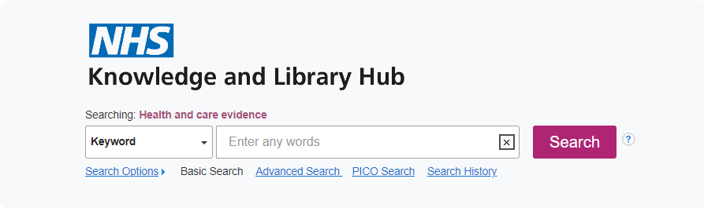 



[](http://www.google.co.uk/url?url=http://www.cochrane.org/about-us/history/our-logo&rct=j&frm=1&q=&esrc=s&sa=U&ei=FPGaU461Aeig7AbY-oGwBQ&ved=0CBYQ9QEwAA&usg=AFQjCNEpSP5ImR3s-wpwqbiimOeieTAFuQ)[](http://www.google.co.uk/url?url=http://scholar.google.com/&rct=j&frm=1&q=&esrc=s&sa=U&ei=PvGaU8TpOpGV7AaY6oG4BQ&ved=0CBgQ9QEwAA&usg=AFQjCNHgpLKUdaQdyYUteyEwDl48NgXS3A)

**Journal full text finder**

**Free for you, ask at any Library desk**